

**Environment Protection and Biodiversity Conservation (Recovery Plan— Dasyornis brachypterus) Instrument 2023**

We jointly make a recovery plan under subsection 269A(3) of the *Environment Protection and Biodiversity Conservation Act 1999,* titled:

National Recovery Plan for Eastern Bristlebird *(Dasyornis brachypterus),* Commonwealth of Australia 2022

Dated 4/2/23

Tanya Plibersek

Minister for the Environment and Water (Commonwealth)

Dated 8/3/23

Meaghan Scanlon

Minister for the Environment and the Great Barrier Reef (Queensland)

1. **Name**

This instrument is the *Environment Protection and Biodiversity Conservation*

*(Recovery Plan— Dasyornis brachypterus) Instrument 2023.*

1. **Commencement**

This instrument commences on the day after it is registered.

1. **Authority**

This instrument is made under section 269A(3) of the *Environment*

*Protection and Biodiversity Conservation Act 1999.*

*Environment Protection and Biodiversity Conservation (Recovery Plan—*

*1*

*Dasyornis brachypterus) Instrument 2023*

Australian Government Text

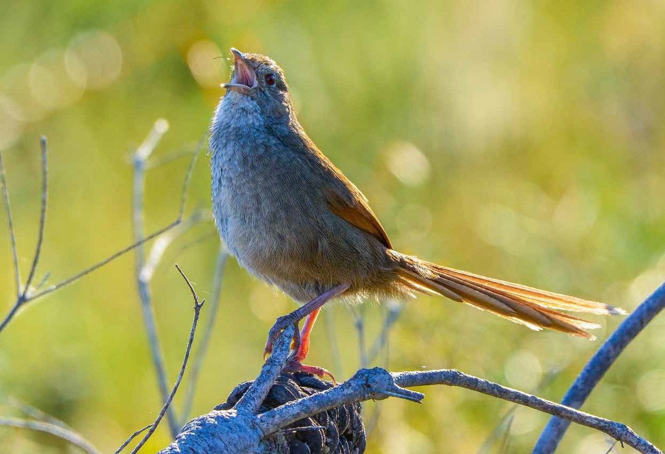

National Recovery Plan for Eastern Bristlebird *(Dasyornis brachypterus)*



The Species Profile and Threats Database pages linked to this Recovery Plan is obtainable from: <http://www.environment.gov.au/cgi-bin/sprat/public/sprat.pl>

**Dedication**

This Recovery Plan is dedicated to the memory of the much-loved Dr Jack Baker, who was instrumental in the research and conservation of the Eastern Bristlebird for 30 years, and mentored and befriended many contemporary threatened species conservationists.

© Copyright Commonwealth of Australia, 2022.



Recovery Plan for the Eastern Bristlebird (*Dasyornis brachypterus*) is licensed by the

Commonwealth of Australia for use under a Creative Commons Attribution 4.0 International licence with the exception of the Coat of Arms of the Commonwealth

of Australia, the logo of the agency responsible for publishing the report, content supplied by third parties, and any images depicting people. For licence conditions see: https://creativecommons.org/licenses/by/4.0/.

This report should be attributed as ‘Recovery Plan for Eastern Bristlebird (*Dasyornis brachypterus*) Commonwealth of Australia 2022’.

The Commonwealth of Australia has made all reasonable efforts to identify content supplied by third parties using the following format ‘© Copyright,

<name of third party> ’.

**Disclaimer**

While reasonable efforts have been made to ensure that the contents of this publication are factually correct, the Commonwealth does not accept responsibility for the accuracy or completeness of the contents, and shall not be liable for any loss or damage that may be occasioned directly or indirectly through the use of, or reliance on, the contents of this publication.

**Images credits**

Cover page: Eastern Bristlebird *Dasyornis brachypterus*

(© Chris Grounds).

Contents

1. Summary 6

Eastern Bristlebird (Dasyornis brachypterus) 6

* 1. Distribution and habitat 6
  2. Recovery Plan vision, objectives, and strategies: 7
     1. Long-term vision 7
     2. Recovery Plan objectives and strategies 7
  3. Criteria for success 8
  4. Recovery team 8

1. Introduction 9
   1. Conservation status 11
   2. Taxonomy 11
   3. Species description 11
   4. Species distribution 13
   5. Population trends 15
   6. Cultural and community significance 17
   7. Relevant biology and ecology 18
      1. Habitat requirements 18
      2. Diet and foraging ecology 24
      3. Breeding ecology 24
      4. Movement patterns 25
   8. Key Biodiversity Areas 26
   9. Habitat critical to survival 28
      1. Key considerations for decision makers 29
2. Threats 30
   1. Historical causes of decline 30
   2. Current threats 30
      1. Threat assessment and prioritisation 30
      2. Summary of current threats 31
      3. Inappropriate fire regimes 32
      4. Climate change 35
      5. Lack of genetic diversity 36
      6. Dieback and invasive weeds 37
      7. Drought 39
      8. Predation by foxes 39
      9. Predation by feral cats 40
      10. Disease in captive populations 40
      11. Disease in wild populations 40
      12. Clearing of habitat 41
      13. Feral pigs 41
      14. Overabundant non-native herbivores 41
      15. Human disturbance 42
3. Populations under particular pressure 43
4. Vision, objectives and strategies 44
   1. Long-term vision 44
   2. Recovery Plan objectives and strategies 44
5. Actions to achieve the specific objectives 46
6. Duration and cost of the recovery process 66
7. Effects on other native species and biodiversity benefits 67
8. Social and economic considerations 68
9. Affected interests 69
10. Consultation 73
11. Organisations and persons involved in evaluating the performance of the plan 74
12. References 76

Appendix 1: Threat assessment criteria 85

Appendix 2: Spatial distribution of current threats 87

# Acronyms

|  |  |
| --- | --- |
| AOO | Area of occupancy |
| CFA | Country Fire Authority |
| DCCEEW | Department of Climate Change, Energy, the Environment and Water  (Australian Government) |
| DES | Department of Environment and Science (Queensland Government) |
| DELWP | Department of Environment, Land, Water and Planning  (Victorian Government) |
| DPE | Department of Planning and Environment  (New South Wales Government) |
| EOO | Extent of occurrence |
| EPBC Act | *Environment Protection and Biodiversity Conservation Act*  *1999* (Commonwealth) |
| IUCN | International Union for Conservation of Nature |
| NESP | National Environmental Science Program |
| NGO | Non-government organisation |
| NP | National park |
| NR | Nature reserve |
| NRM | Natural resource management |
| OEH | Office of Environment and Heritage, New South Wales |
| RFS | Rural Fire Service |
| RSPCA | Royal Society for the Prevention of Cruelty to Animals |
| TO | Traditional Owners |
| TSSC | Threatened Species Scientific Committee |

# Summary

**Eastern Bristlebird (*Dasyornis brachypterus*)**

**Family:** Dasyornithidae

##### Current status of taxon:

* *Environment Protection and Biodiversity Conservation Act 1999* (Commonwealth): Endangered
* *Biodiversity Conservation Act 2016* (New South Wales): Endangered
* *Nature Conservation (Animals) Regulation 2020* (Queensland): Endangered
* *Flora and Fauna Guarantee Act 1988* (Victoria): Critically Endangered
* IUCN Red List of Threatened Species: Endangered

## Distribution and habitat

The historical distribution of the Eastern Bristlebird has contracted to three geographically separate areas of south-eastern Australia: south-eastern Queensland/ north-eastern NSW (hereafter northern population), central NSW (Illawarra and Jervis Bay region, hereafter central population) and the coastal regions of the southern NSW/eastern Victorian border (hereafter southern population).

The current northern population occurs in habitat characterised by open forest with a dense tussocky grass understorey and sparse mid-storey near rainforest ecotone. Northern populations sometimes occur in other vegetation types such as heathland with stunted shrubs, or swampland with dense ferns and sedge tussocks.

In contrast, habitats occupied by Eastern Bristlebirds in the central and southern populations are characterised by dense, low vegetation including heath and open woodland with a heathy understorey. All habitat occupied by the Eastern Bristlebird before and after the 2019–2020 wildfires is critical to its survival.

Due to the large geographic distribution and distinct habitat requirements between the northern and central/southern populations, they have typically been grouped into two groups by species experts. For the purposes of this recovery plan, central/ southern populations have been grouped together in some sections for consistency with other conservation planning documents (e.g., NESP 2018; Garnett & Baker 2021).

## Recovery Plan vision, objectives,

**and strategies:**

### Long-term vision

Eastern Bristlebird populations are *genetically diverse and self-sustaining*, and the species is resilient to impacts of climate change. Eastern Bristlebird recovery has been informed by comprehensive knowledge of Eastern Bristlebird ecology and best practice methods for conserving the species and its habitat. Eastern Bristlebird

habitat is protected, and Traditional Owners and the broader community are engaged

in habitat management.

### Recovery Plan objectives and strategies

|  |  |
| --- | --- |
| Objective 1 | By 2032, Eastern Bristlebird population *viability* is improved in the northern, central and southern populations, compared to baselines (see section 1.3).  *Strategy 1:* Population enhancement and augmentation. |
| Objective 2 | By 2032, levels of priority threats on the Eastern Bristlebird are reduced, compared to baselines.  *Strategy 2:* Threat management. |
| Objective 3 | By 2032, Eastern Bristlebird habitat extent and condition are maintained or improved, compared to baselines.  *Strategy 3:* Habitat protection, enhancement, and augmentation. |
| Objective 4 | By 2032, Eastern Bristlebird population assessments are enhanced by addressing data and knowledge gaps and viable Eastern Bristlebird population sizes and trends are determined.  *Strategy 4:* Biology and ecology knowledge enhancement. |
| Objective 5 | By 2032, targeted stakeholder engagement has:   * increased collaboration with private landholders to expand or strengthen involvement in Eastern Bristlebird conservation e.g., areas available for surveys, potential release sites, and active habitat management; * increased engagement of Traditional Owners in Eastern Bristlebird recovery decision-making processes; and * extended community/volunteer involvement in Eastern Bristlebird surveys.   *Strategy 5:* Stakeholder engagement and participation. |
| Objective 6 | By 2032, Eastern Bristlebird:   * recovery priorities are incorporated within relevant policies, management plans, regulations, codes of practice and planning tools; * recovery actions are implemented and reviewed across tenures and jurisdictions; * recovery planning and implementation is underpinned by an adaptive-management framework; and * data and meta data are available (within permissibility requirements) from a centralised repository.   *Strategy 6:* Coordinate, review and report on recovery progress. |

## Criteria for success

This Recovery Plan will be deemed successful if, within 10 years of the date of its adoption, the objectives have been achieved. Specific performance criteria are outlined in Section 6.

The evaluation of Recovery Plan objectives and performance criteria rely on measurable indicators. Recovery management processes should identify appropriate indicators and collect baseline data to facilitate measurement of progress

towards objectives.

## Recovery team

Recovery teams provide advice and assist in coordinating actions described in recovery plans. They include representatives from organisations with a direct interest in the recovery of the species, including those involved in funding and those participating in actions that support the recovery of the species. The National Eastern Bristlebird Recovery Team has the responsibility of providing advice, coordinating and directing the implementation of the recovery actions outlined in this Recovery Plan. The membership of the Recovery Team includes individuals from relevant government agencies, non-government organisations, Traditional Owners, industry groups and expertise from independent researchers and community groups.

# Introduction

The Recovery Plan considers the conservation requirements of the species across its range and identifies the actions to be taken to ensure the species’ long-term viability in the wild, and the parties that will undertake those actions.

The Recovery Plan replaces the National Recovery Plan for Eastern Bristlebird *Dasyornis brachypterus* (OEH 2012) that was adopted under the EPBC Act in 2014. The previous Eastern Bristlebird recovery plan was reviewed in January 2021 by an expert panel that included representatives from the New South Wales Department of Planning, Industry and Environment, Queensland Department of Environment and

Science, Victoria Government Department of Environment, Land, Water and Planning, Parks Australia, BirdLife Australia, the Australian National University, the University of Wollongong and others.

The review noted:

* The National Recovery Plan for Eastern Bristlebird *Dasyornis brachypterus* had provided a strong basis for research, engagement and policy initiatives since 2012. All Eastern Bristlebird populations continued to be vulnerable to a range of threats, but active management (targeted weed control, feral predator animal control and prescribed burns) had aided the recovery of the species.
* Since the adoption of the plan, the Australian Government, states and territories have invested more than $2,835,000 into the conservation of Eastern Bristlebird, including the restoration of important habitats. Governments, NGOs, university researchers and private groups continued to work collaboratively to identify and manage key bristlebird habitat proactively and reactively. Population-specific studies had provided information on each population’s optimal habitat needs, though the southern population is less well understood than the northern

and central populations. Positively, information on conservation genetics had been gathered for some populations, and robust monitoring programs had established excellent baseline data for most populations, and trend data informed management.

* At the time of the review, the central population was stable, however, the full impacts of the large 2019–2020 wildfire events on the northern and southern populations were still being assessed. These populations in particular were of great concern due to low numbers of mature individuals and loss of habitat. Recovery efforts for these populations will require targeted strategies at different temporal and spatial scales and robust monitoring to inform management over the next decade.
* It remained a priority to identify and protect important Eastern Bristlebird habitat, restore degraded habitats and mitigate threats where possible. These actions will be guided by applied research, stakeholder needs and community engagement.
* Suggested future recovery actions include:
  + All populations: addressing the impacts of climate change and the

2019–2020 fires.

* + Northern population: supporting the reintroduction of captive-bred Eastern Bristlebirds within the northern population’s historic range; undertaking weed control (Lantana); managing native canopy overgrowth; and addressing Bell Miner associated forest dieback.
  + Southern population: establishing a second population in Victoria was identified as a high priority, as well addressing the emerging threat of invasive deer.
* Research and monitoring by a range of dedicated stakeholder groups underpins much of the on-ground efforts and management interventions. Continuing to improve our understanding of Eastern Bristlebird ecology and management

is crucial. Monitoring Eastern Bristlebird populations and their response to management interventions is also critically important to maintain over the next decade. Without research and monitoring, the decision makers and land managers cannot choose the appropriate course of action when challenges emerge. It is also difficult to determine whether there is a return on investment or whether threat abatement is resulting in intended outcomes.

The review concluded that a National Eastern Bristlebird Recovery Plan is a priority for allocation of resources. Given the large number of stakeholders involved in Eastern Bristlebird recovery, the plan helps relevant State Government agencies, as well

as academic researchers and NGOs, to prepare and coordinate Eastern Bristlebird conservation management actions and strategically address knowledge gaps, and recommended that a new recovery plan be developed for the Eastern Bristlebird.

Accompanying Species Profile and Threats Database (SPRAT) pages provide background information on the biology, population status and threats to the species. SPRAT pages are available from: <http://environment.gov.au/cgi-bin/sprat/public/> publicspecies.pl?taxon_id=533.

## Conservation status

The Eastern Bristlebird was listed as a threatened species under the *Environment Protection and Biodiversity Conservation Act 1999* (Commonwealth) in 2000. The species is also listed under state legislation (Table 2).

**TABLE 1:** National and state conservation status of the Eastern Bristlebird.

|  |  |
| --- | --- |
| Legislation | Conservation Status |
| *Environment Protection and Biodiversity Conservation Act 1999*  (Commonwealth) | Endangered |
| *Biodiversity Conservation Act 2016* (New South Wales) | Endangered |
| *Nature Conservation (Animals) Regulation 2020* (Queensland) | Endangered |
| *Flora and Fauna Guarantee Act 1988* (Victoria) | Critically Endangered |

## Taxonomy

Conventionally accepted as *Dasyornis brachypterus* (Latham 1802).

Based on morphological evidence, Schodde and Mason (1999) proposed the northern population should be recognised as a distinct subspecies. Although the *Action Plan for Australian Birds 2020* (Charley et al. 2021; Bain et al. 2021) notes the split proposed by Schodde and Mason (1999), separation into subspecies is not supported by one analysis of genetic data (Roberts et al. 2011) and the species is not listed at the subspecies level under state or Commonwealth legislation.

## Species description

The Eastern Bristlebird is a small, well-camouflaged, ground-dwelling bird. It is dark cinnamon-brown above, with pale colouring around the eyes and base of the bill, an off-white chin and throat, and a rufous-brown panel on each wing (Higgins & Peter 2002). It is greyish-brown below, with an off-white centre to the belly. It has red to red-brown irises, an off-white to pinkish-white gape, and pinkish-brown legs and feet (Higgins & Peter 2002).

Body length is between 18 and 21 centimetres with the broad tail accounting for about half the bird’s length (Higgins & Peter 2002). Adults weigh approximately 42 g (range 35 to 50 g) (Baker 1998; Bramwell 1990; Higgins & Peter 2002). The wings are small (23 to 24 cm wingspan), and the legs are long and strong. The sexes are alike, but females are slightly smaller than males (Bain 2007). Juveniles are similar to the adults, but can be identified, if viewed at close range, by their pale brown or brown irises, and pale yellow gape (Higgins & Peter 2002).

The species spends most of its time in low, dense vegetation, rarely appearing in the open or flying (Higgins & Peter 2002). Due to its small wings the Eastern Bristlebird flies weakly, but sturdy feet and legs help it move through dense habitat. While its plumage provides excellent camouflage, other adaptations to its habitat include a low forehead profile with bristles near the eyes. The rictal bristles which project from the beak are modified contour feathers that are thought to play a part in prey

capture. The bristles may also provide protection for the bird’s eyes as it consumes its struggling prey (Cornell Lab of Ornithology 2013). Another theory is that the bristles may function as sensors, providing tactile feedback, like the whiskers on a dog or cat to facilitate obstacle avoidance (Lederer 1972).

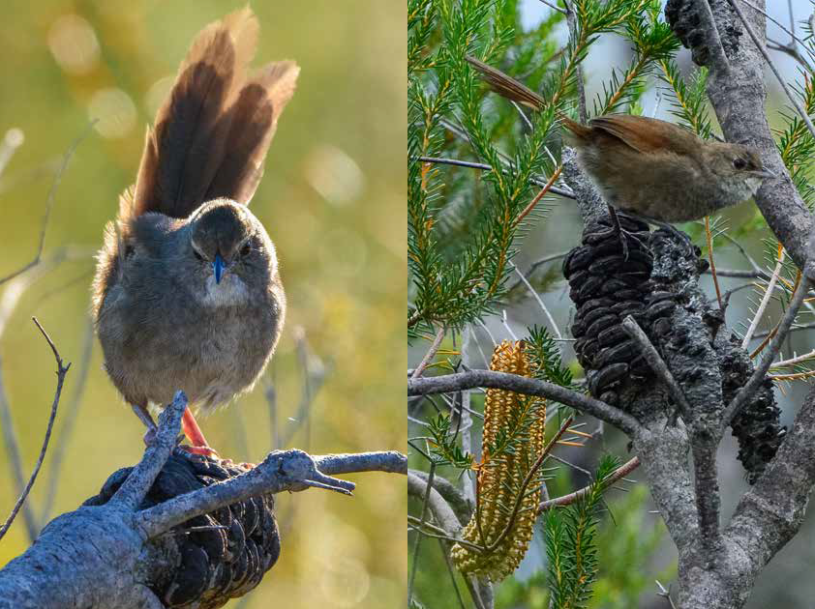

Adult Eastern Bristlebird photographed at Booderee National Park © Copyright, Chris Grounds

Adult Eastern Bristlebird photographed at Jervis

Bay National Park © Copyright, Chris Grounds

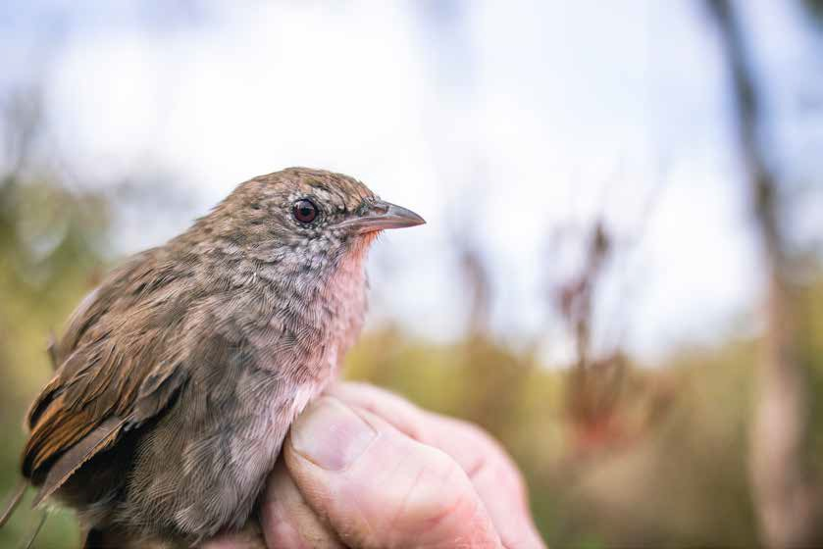

Eastern Bristlebird © Copyright, Alex Pike from NSW Department of Planning and Environment

## Species distribution

The Eastern Bristlebird is endemic to Australia and is currently distributed as three populations across three geographically separate areas of south-eastern Australia (Map 1):

* Northern population: Main Range NP (Qld), Lamington NP (Qld), Mt Barney NP (Qld), Border Ranges NP (NSW), private land.
* Central population (NSW/ACT): Barren Grounds NR, Budderoo NP, Bellawongarah,

Woronora Plateau (Cataract Dam), Bherwerre Peninsula (Jervis Bay NP, Booderee NP, Australian Department of Defence land, private land), Beecroft Peninsula (Australian Department of Defence land, Crown land, private land), Morton NP, Red Rocks NR.

* Southern population: Nadgee NR (NSW) and Croajingolong NP (Vic).

Due to the large geographic distribution and distinct habitat requirements between the northern and central/southern populations, the species has typically been split into these two groups by species experts. For the purposes of this recovery plan, central/southern populations have been grouped together in some sections for consistency with other conservation planning documents (e.g., Garnett & Baker 2021).

###### Northern population

The northern population has undergone a dramatic population decline and range contraction (e.g., Holmes 1989, 1998; Sandpiper Ecological Surveys 2000b, 2003, 2005a, 2008). Historically the distribution of the northern population extended much further south, to the Dorrigo Plateau and possibly to Wootton near the Myall Lakes (Chisholm 1958; Holmes 1982, 1989). Eastern Bristlebirds are presumed to be locally extinct from Conondale Ranges, Razorback Mountains, Mt Burrell, Big Scrub, Mt Richmond and the Dorrigo Plateau; in none of these areas have there been confirmed records for over a decade despite searching.

Northern Eastern Bristlebirds are now confined to the mountain ranges of south-east Queensland and north-east New South Wales. In Queensland, they are currently known from one site near Mt Gipps on the Queensland/New South Wales border and possibly one at Mt Barney (DES 2018), though a long-term (minimum three-years) expanded survey program is needed to confirm current distribution (L Gould pers. comm. 2021). In New South Wales, they occur at several sites near Kyogle in the Border Ranges (NESP 2019). Fires in 2019–2020, initially thought to have burnt out some subpopulations, appear to have missed all with the exception of the possible

Mt Barney subpopulation (D Charley unpublished cited in Charley et al. 2021).

The extent of occurrence (EOO) and area of occupancy (AOO) for the northern population are estimated at 140 km² (100–200 km²) and 20 km² (range 16–24 km²), respectively (Charley et al. 2021). Both the EOO and AOO have stable trends

(high reliability). The population is not considered to be highly fragmented (Charley et al. 2021).

###### Central and southern populations

Today, central Eastern Bristlebirds occur in central coastal New South Wales at Barren Grounds Nature Reserve, Budderoo National Park, the Jervis Bay area, near Cataract Dam and at Red Rock Nature Reserve (Baker 1997, 1998; Bramwell 2008; OEH 2012; BirdLife International 2021; Bain et al. 2021). Subpopulations on Beecroft Peninsula, and Cataract on the Woronora Plateau, were reintroduced for conservation purposes (Baker et al. 2012). In the central populations, there are historical records

of the species at several locations between Sydney and Ulladulla where the species is thought to now be extinct.

The southern population occurs in Victoria at Howe Flat in Croajingolong National Park and in southern New South Wales at Nadgee Nature Reserve. Southern Eastern Bristlebirds have also undergone a significant population decline and range contraction in Victoria. Surveys in the late 1990s failed to locate the species at nine confirmed former sites and two unconfirmed sites in Victoria (Baker 1998; Clarke &

Bramwell 1998). There are historical records at scattered sites from the NSW border to near Lake Tyers (White 1915; Clarke & Bramwell 1998), unconfirmed reports from Wilsons Promontory and Tarwin Lower-Walkerville (Cooper 1975; Emison et al. 1987; Mitchell 1995), and subfossil deposits indicating that the distribution once extended west at least as far as Nelson in far south-western Victoria (Blakers et al. 1984;

Baird 1992).

Current EOO and AOO for the central and southern populations are estimated at 8,150 km² (range 8,000–8,300 km²) and 200 km² (range 180–250 km²), respectively (Bain et al. 2021). These populations are not severely fragmented (Bain et al. 2021).

#### Map of species distribution in New South Wales**MAP 1:** Modelled distribution of the Eastern Bristlebird.

**Source:** Base map Geoscience Australia; species distribution data [Species of National Environmental](http://www.environment.gov.au/science/erin/databases-maps/snes)

[Significance](http://www.environment.gov.au/science/erin/databases-maps/snes) database.

**Caveat:** The information presented in this map has been provided by a range of groups and agencies. While every effort has been made to ensure accuracy and completeness, no guarantee is given, nor responsibility taken by the Commonwealth for errors or omissions, and the Commonwealth does not accept responsibility in respect of any information or advice given in relation to, or as a consequence of, anything contained herein.

**Species distribution mapping:** The species distribution mapping categories are indicative only and aim to capture (a) the habitat or geographic feature that represents to recent observed locations of the species (known to occur) or habitat occurring in close proximity to these locations (likely to occur); and (b) the broad environmental envelope or geographic region that encompasses all areas that could provide habitat for the species (may occur). These presence categories are created using an extensive

database of species observations records, national and regional-scale environmental data, environmental

modelling techniques and documented scientific research.

## Population trends

###### Northern population

In 2020, 43 northern Eastern Bristlebirds were known to be alive in the wild, with another two sites having recent possible sightings, suggesting in total 45–46 birds were present (D Charley unpublished, cited in Charley et al. 2021). Of these, four were confirmed in Queensland and 39 confirmed in NSW. There were a further

19 individuals in captivity.

Numbers have been stable or slightly increasing in the last decade, despite ongoing declines in Queensland suggesting ongoing southward contraction in distribution: in 2014, 11 birds were recorded, suggesting 13–30 birds present; in 2016, 18 birds

were recorded (suggesting 20 to 30 birds present; NESP 2019); and in 2018, 25 birds

were present suggesting 30–40 birds were present (D Charley pers. comm. 2018, cited in Charley et al. 2021). However, this was preceded by a long history of attrition: in 1988, 154 individuals were located in 103 territories; in 1996, there were 36 birds in

30 territories; in 1997–1998, there were 26 birds in 16 territories; and, in 2010, there

were 25 to 30 individuals (Garnett et al. 2011).

For the northern Eastern Bristlebird population, extinction is likely unless serious consideration is given to genetic rescue of the population (Stone 2018b). Fire management, weed control and translocation are also necessary to ensure the persistence of these birds.

###### Central and southern populations

The population estimate for the central and southern populations is 3,000 (range 2,500–3,500) mature individuals (Bain et al. 2021). Recent declines have occurred at Barren Grounds/Budderoo (78% decline; unburnt habitat) and Nadgee (81% decline; burnt habitat) indicating >30% overall population decline (D Bain pers. comm. 2022;

IUCN Red List Forum 2022). This new information has important implications for the status of the Eastern Bristlebird. The Barren Grounds/Budderoo subpopulation was one of the largest so a decline of 78% in the last three generations (11 years) from unknown causes (since the area was not burnt), combined with losses from Nadgee/Howe Flat from the 2020 fires is significant (IUCN Red List Forum 2022).

There are estimated to be 6 (range 5–7) subpopulations. Subpopulations at Nadgee and Howe Flat are separate and genetically distinct from those at Jervis Bay, Red Rock, Budderoo/Barren Grounds and Cataract, all of which are thought to be relatively isolated from each other (Bain et al. 2021). The largest subpopulation is estimated to have 1,250 (range 1,200–1,300) mature individuals.

There were estimated to be up to 2,700 mature central and southern

Eastern Bristlebirds (combined) in 2010 including 1,250 at Barren Grounds/Budderoo, 1,100 at Jervis Bay, 50 at Cataract, about ten at Red Rocks and 300 at Nadgee and

Howe Flat (NESP 2019) with 140–160 birds at Howe Flat in 2020 (Clarke et al. 2020; M Bramwell unpublished cited in Bain et al. 2021). An unknown number occur on the Beecroft Peninsula, but they are at all 40 monitoring sites established there (Lindenmayer et al. 2016). Until recently, the population at Nadgee had increased steadily to about 400 (NESP 2019) before fire in 2020 burnt most of the suitable habitat (Oliver & Malolakis 2020).

Elsewhere in New South Wales, annual monitoring demonstrated steady increases at Cataract and Budderoo, probable increases at Beecroft Peninsula, stability at Jervis Bay and fluctuations at Barren Grounds (OEH 2018, 2019). Average densities of

bristlebirds detected along transects in Booderee National Park during annual spring surveys since 2015 have been fairly constant across years, though with a sharp drop in 2018 followed by the highest density so far recorded in 2019 (Director of National Parks unpublished). At Beecroft Peninsula, they were detected at 337 times on

152 surveys, at least twice the detection rate of any other species except New Holland Honeyeaters *Phylidonyris novaehollandiae*, with effects of bombardment during military training having no impact on detection frequency (Lindenmayer et al. 2016). In Victoria, numbers at Howe Flat in 2008 (120–160; Bramwell 2008) differed little from those in 2020.

## Cultural and community significance

Eastern Bristlebird populations and their habitat occur across areas of cultural significance to numerous Traditional Owner groups. The landscape, and the plants, animals and physical features within the landscape, are all an integral part of Aboriginal cultural heritage. The small areas occupied by the Eastern Bristlebird are part of a larger landscape which is recognised for its significance and connectivity to people and places beyond the scope of this recovery plan.

###### Northern population

Northern Eastern Bristlebirds are known to occur on the lands of the Bundjalung, Githabul, Gugin Gudduba and Yugambeh Indigenous Peoples (Charley et al. 2021). Northern birds are adapted to habitats shaped by traditional burning practices (frequent, low intensity fires) that maintain open grassy forests that prevent transition to rainforest (Stone 2018a). The population depends on this burning regime to maintain breeding habitats. As such, the restoration of the adaptive Aboriginal

fire practices needs to be encouraged to help manage grassy forests appropriately (Stone 2018a). Additionally, grazing land management by private landowners in Queensland has helped maintain grassy open forest and provide breeding habitat for Eastern Bristlebird and productive pasture.

All habitat for the northern population occurs within the Gondwana Rainforests World Heritage Area (WHA) and buffering landscapes, and Eastern Bristlebird are recognised within the WHA’s Outstanding Universal Values. Further, Eastern Bristlebird habitats provide scenic amenity, nature-based recreation and ecotourism opportunities.

###### Central population

Within the central population, the Eastern Bristlebird is of high cultural significance for the Dharawal and Dhurga people from southern Botany Bay to Wreck Bay.

*“For the Dharawal and Dhurga the Eastern Bristlebird indicates extreme weather can be on its way, such as fire. We have always known the Eastern Bristlebirds make their nests in the old native sedge and lomandra gardens where our people once gathered seasonal plant seeds for food, such as bush rice from the lomandra species and other local grass seeds and also hard seed local fruits”* (R Mason pers. comm. cited in OEH 2012).

Jervis Bay has been a focus of human activity for at least 7,000 years and has an Aboriginal cultural heritage that is remarkable for its diversity; richness and significance to Aboriginal people (DAWE 2021b). Occupation of the area by Aboriginal people in traditional and recent times and continuing use today for food gathering, educational and ceremonial activities has given the area high Aboriginal social value. Many of the traditional storylines linking different elements of the landscape are still recounted and spiritual ties to the land are maintained through stories, on-going use and the passing on of knowledge through the generations.

Through their cultural traditions, the South Coast (Yuin) Aboriginal people of the Dharawal-Dhurga language group and the Jerrinja community identify the Jervis Bay area as their Traditional Country. Booderee National Park and Booderee Botanic

Gardens have been jointly managed by the Wreck Bay Aboriginal Community Council and the Australian Government since 1995 in accordance with the EPBC Act.

###### Southern population

In Victoria, habitat for the extant Eastern Bristlebird population and potential reintroduction sites are known to be of cultural significance and interest to Traditional Owners and Aboriginal communities.

Additionally, Nadgee NR is highly culturally significant, with numerous stone arrangements, burials and middens (G Moore pers. comm. 2010 cited in OEH 2012). The abundance of artefacts and middens within the Croajingolong Biosphere Reserve (including Nadgee NR) indicates a history of occupation by fairly large populations

of Indigenous communities, who were probably concentrated around the inlets, estuaries and wetlands (UNESCO 2016).

*“The Eastern Bristlebird was well known by Aboriginal people on the Far South Coast of NSW in the past. This bird was the skin of a local group. When European settlers moved into the area and cleared the land for farming, both the bird and the people disappeared from*

*the area”* (G Moore pers. comm. 2010 cited in OEH 2012).

This statement of significance is not intended to be comprehensive, applicable to,

or speak for, all Indigenous Australians and it is acknowledged that Indigenous groups and individuals are the custodians of this knowledge.

## Relevant biology and ecology

### Habitat requirements

The habitat of the Eastern Bristlebird is defined by a similar structure of low, dense, ground or understorey vegetation (Lamb et al. 1993; Clarke & Bramwell 1998; Chapman 1999; Baker 2000), within a broad range of vegetation types with a variety of species compositions, including grassland, sedgeland, heathland, swampland, scrubland, grassy sclerophyll forest and woodland, and rainforest (e.g., Smith

1977, 1987; Holmes 1989, 1998; Baker 1997, 2000; Chapman 1999; Miles 2004; Bramwell 2008; Baker 2009; Baker et al. 2012; Stone et al. 2018). Eastern Bristlebird habitat primarily occurs as coastal, subcoastal and coastal escarpment scrubland/ grassland/sedgeland and as open grassy forest on inland ranges (Blakers et al. 1984; Holmes 1989).

Eastern Bristlebirds inhabit fire-prone habitats and the relationship between the species and fire has been well studied (e.g., Holmes 1989, 1998; Lamb et al. 1993; Baker 1997, 1998, 2000, 2003; Bramwell et al. 1992; Hartley & Kikkawa 1994; Clarke & Bramwell 1998; Bain & McPhee 2005; Bain et al. 2008; Lindenmayer et al. 2009;

Stone et al. 2018). The response of Eastern Bristlebird populations to fire is highly variable and strongly context-dependent (Bradstock et al. 2005; Bain et al. 2008), but they are particularly vulnerable to large-scale, intense fires (e.g., Clarke & Bramwell 1998; Baker 2000). The extent, intensity and frequency of fires are all important in determining habitat suitability.

Small-scale or low-intensity fires may leave small patches of unburnt habitat that provide refuge during fire and a base for the recolonisation of burnt areas post-fire. The presence of nearby unburnt habitat as a refuge is an important landscape component for the survival of Eastern Bristlebirds following fire (Holmes 1989; Pyke et al. 1995; Baker et al. 1997; Baker 1997, 2000; Bain et al. 2008). Birds may escape fire by temporarily moving to nearby unburnt vegetation and then return when conditions are suitable (Bain et al. 2008).

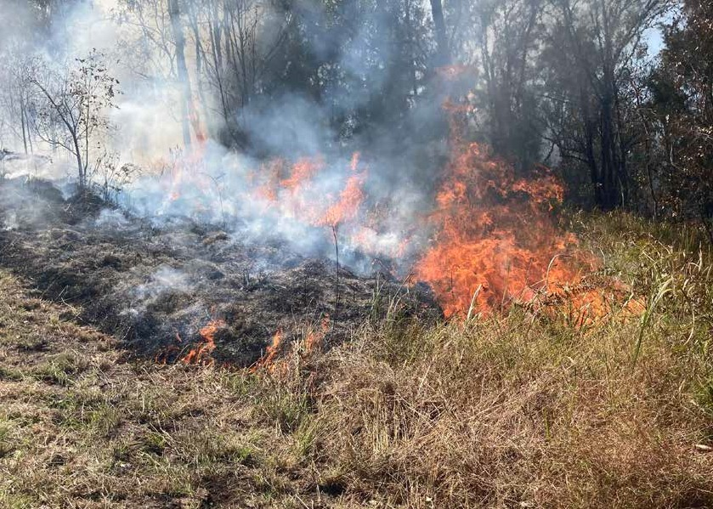

Example of an optimal prescribed burn (low flame height moving slowly downhill) to maintain northern

Eastern Bristlebird habitat © Copyright, Kelly Roche for NSW Department of Planning and Environment

###### Northern population

The habitat of northern populations of Eastern Bristlebird is characterised by open forest with dense tussocky grass understorey and sparse mid-storey near rainforest ecotone.

The northern population mainly occurs in scattered areas of montane open forest where the undergrowth is dense and grassy, and contains diverse structural features which provide the birds with protection and nesting locations. The ground-layer vegetation is usually about 1.0–1.5 m tall, providing about 65–90% ground cover.

Typical ground cover includes tussock-grasses such as *Sorghum leiocladum*, and other grasses, with a variety of scattered small shrubs, woody herbs, patches of ferns and vine tangles (Holmes 1989, 1998; Lamb et al. 1993; Hartley & Kikkawa 1994; Sandpiper Ecological Surveys 2000; DES 2018; Stone et al. 2018a, 2018b).

Northern populations sometimes occur in other vegetation types such as heathland

with stunted shrubs, or swampland with dense ferns and sedge tussocks. Habitat is typically either interspersed with, or adjacent to, mature subtropical rainforests, although some birds live up to 750 metres away from rainforest (Holmes 1989; Sandpiper Ecological Surveys 2000; OEH 2012; DES 2018; Stone et al. 2018b; Stone

et al. 2019). Adjacent rainforest or damp gullies are likely to be refuge areas for the birds during and after fires. In the more exposed situations, suitable habitat tends to be confined to intermittent watercourses (Holmes 1989; Hartley & Kikkawa 1994; OEH 2012).

A fire regime that is too infrequent in the northern population could allow vegetation to become unsuitable for nesting through trees and shrubs becoming established and shading the growth of suitable grassy ground cover, grassy tussocks becoming too long and collapsing or weeds invading (Sandpiper Ecological Surveys 2000). Different studies have proposed different fire intervals to maintain suitable habitat: 10–20 years (Holmes 1989); 5–15 years (Lamb et al. 1993); 4–5 years (Sandpiper Ecological

Surveys 2007); and 4–5 years (Stone et al. 2018). The northern population also utilises rainforest as a refuge from fire (Holmes 1989).

The tussock grass habitat of the northern population may be suitable for breeding at two years post fire (Hartley & Kikkawa 1994). Grass cover exceeded pre-fire levels two years post fire at both Richmond Gap and Grassy Spur and declined 4–5 years after fire at both sites (Sandpiper Ecological Surveys 2007). To manage bristlebird habitat, it is important to understand the relationship between tussocks, which are used for nesting, and other ground vegetation such as Kangaroo Grass (*Themeda triandra*), which provide cover for foraging and shelter. Frequent fires have been shown to increase Kangaroo Grass cover at the expense of tussocks (Sandpiper Ecological Surveys 2007).

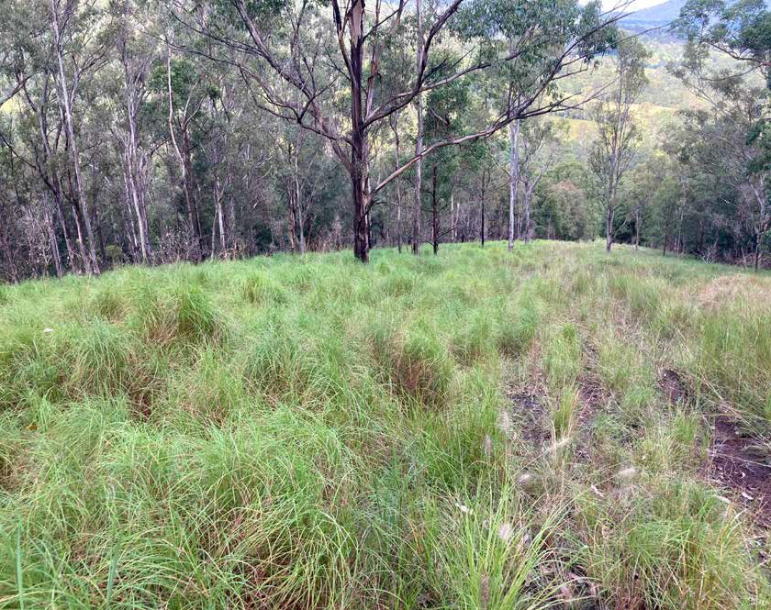

Characteristic habitat for northern Eastern Bristlebirds © Copyright, Kelly Roche from NSW Department

of Planning and Environment

###### Central and southern populations

Central and southern Eastern Bristlebird habitat is characterised by dense, low

vegetation including heath and open woodland with a heathy understorey.

Birds in the central and southern populations have been recorded in a variety of vegetation communities with dense understorey. They often occur in low heathland, sometimes interspersed with thickets of taller shrubs or small trees (Loyn 1985; Pyke et al. 1995; Gosper & Baker 1997; Clarke & Bramwell 1998; Baker 1998, 2000; Bain & McPhee 2005; Bramwell 2008). The species also occurs in Gahnia sedgeland (Baker 1998) and in dense swamp shrubland or in coastal or riparian scrub and often with tussock-grasses or sedges in the understorey (Pyke et al. 1995; Gosper & Baker 1997; Clarke & Bramwell 1998; Baker 1998, 2000; Higgins & Peter 2002; Bramwell 2008).

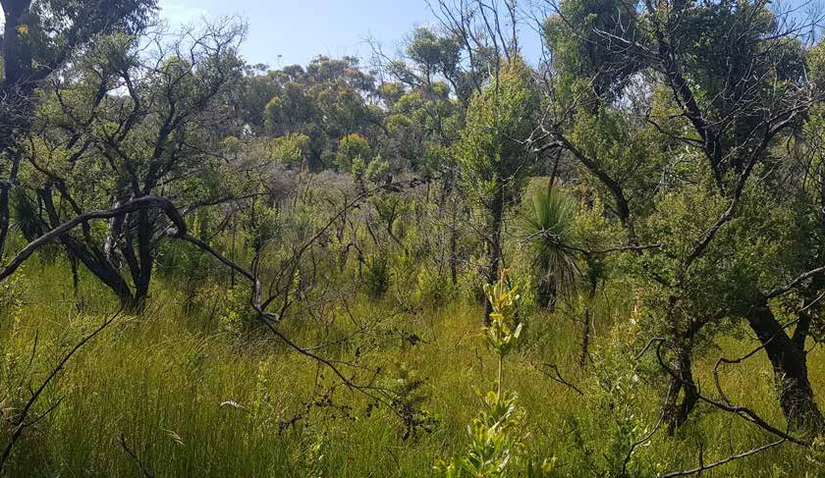

Open healthy woodland, Nadgee NP © Copyright, BirdLife Australia

Birds sometimes occur in open sclerophyll woodland or forest, with a shrubby understorey and a dense ground layer of grasses or bracken (Emison et al. 1987; Bramwell et al. 1992; Pyke et al. 1995; Gosper & Baker 1997; Clarke & Bramwell 1998; Baker 1998, 2000; Bain & McPhee 2005; Bramwell 2008;). They occasionally occur in temperate rainforest that contains *Acmena smithii* (syn. *Acmena smithii*) (Emison et al. 1987; Clarke & Bramwell 1998; Baker 2000). In Croajingolong NP, Eastern Bristlebirds have also been recorded in rainforest along creeks and lowland forest dominated by Red Bloodwood (*Corymbia gummifera*) (DSE 1999; DSE 2018).

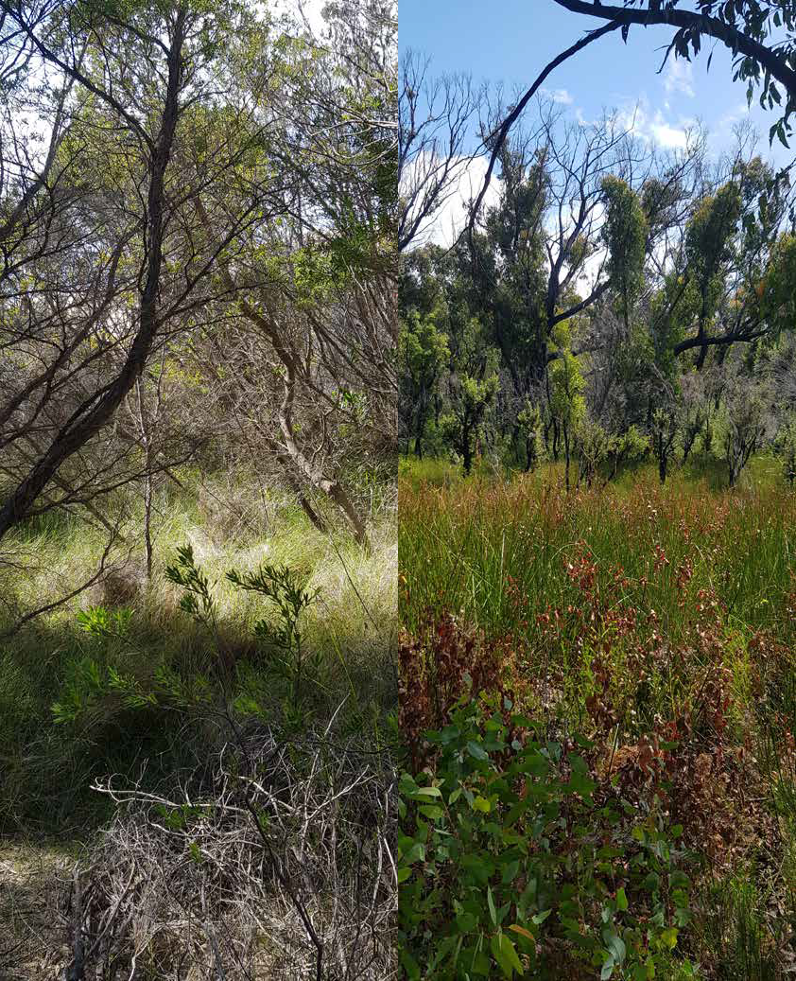

Sedge dominated drainage line, Croajingolong ©

Copyright, BirdLife Australia

Wet depression in regenerating heathy woodland,

Croajingolong © Copyright, BirdLife Australia

Baker (2009) found that while heathland to woodland ecotones may provide suitable habitat for some individual Eastern Bristlebirds, the species is neither dependant on, nor confined to, heathland to woodland ecotones.

The central and southern populations may reach maximum densities in habitat that has not been burnt for at least 15 years (Baker 1997). In Booderee NP, the recolonisation of burned habitat within two years of fire was attributed to the patchiness of the 2003 fire (leaving unburnt refuges) and the intensive fox control program (Lindenmayer et al. 2009; Lindenmayer et al. 2010). Lindenmayer et al.

(2010) concluded that the decline of Eastern Bristlebirds after fire is largely due to the exposure to exotic predators following the loss of dense protective cover during a fire.

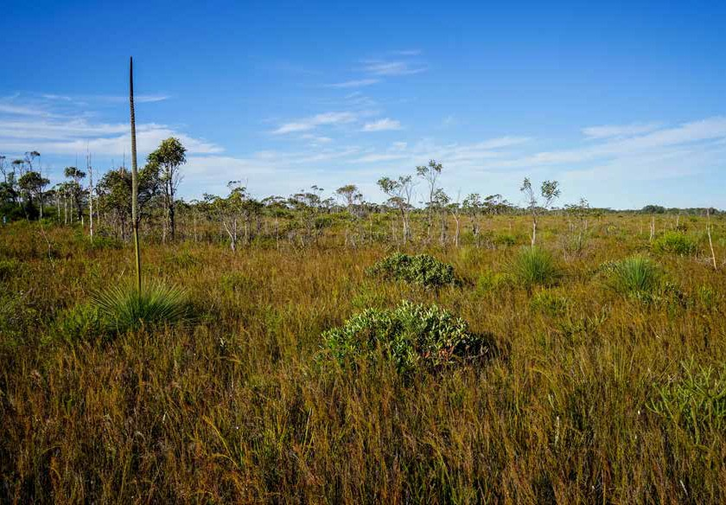

Eastern Bristlebird habitat at Jervis Bay National Park © Copyright, Chris Grounds

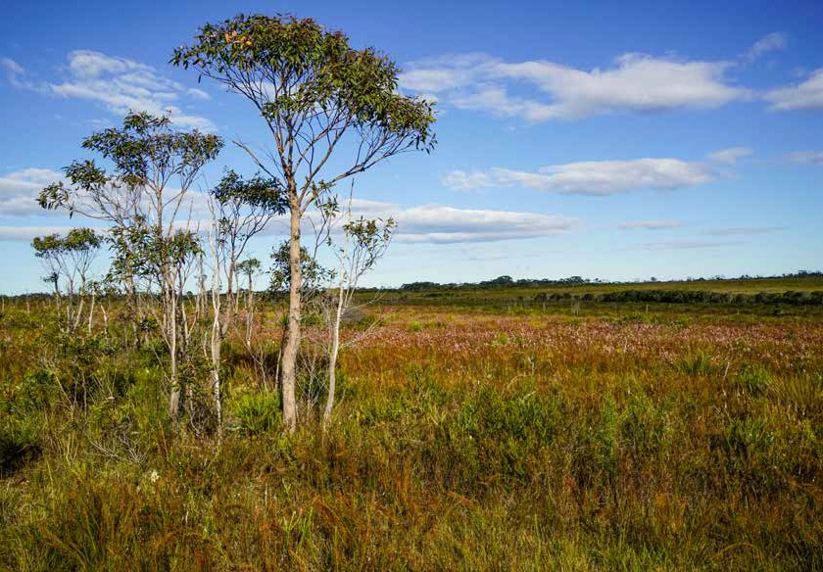

Eastern Bristlebird habitat at Jervis Bay National Park © Copyright, Chris Grounds

### Diet and foraging ecology

The Eastern Bristlebird feeds mainly on invertebrates (ants, beetles, flies, cockroaches, true bugs (hemipterans), cicadas, grasshoppers, crickets, mantids and caterpillars, but also earthworms and spiders), seeds and small fruits of grasses and other plants including Acacia, Carex, Exocarpos and, possibly, *Lycium ferocissimum* (African Box-thorn), but may also take fungi and occasionally nectar from *Banksia ericifolia*, food scraps and tadpoles (Gould 1865; Lea & Gray 1935; Barker & Vestjens 1990; Holmes 1998; Chapman 1999; Gibson 1999; Gibson & Baker 2004).

Eastern Bristlebirds forage mostly on the ground, where they toss aside leaf litter with their bill, peck food items from the surface and probe into soil, but they do not use their feet to scratch the ground. They occasionally glean food items from foliage or branches, or capture insects in flight (Blakers et al. 1984; Hartley & Kikkawa 1994; Baker 1998; Holmes 1998; Chapman 1999; Gibson & Baker 2004).

### Breeding ecology

Eastern Bristlebirds breed from August to February (Campbell 1900; Chaffer 1954; Morris et al. 1981; Higgins & Peter 2002). Females build a small, globular nest that has a side entrance and is made from grass, bark, sedges or reeds, and sometimes leaves (McNamara 1946; Chaffer 1954; Holmes 1989, Higgins & Peter 2002; Booth 2009). The nest is generally constructed at 10 to 45 cm above the ground in low dense vegetation, in grass tussocks, sedges, ferns and shrubs (Campbell 1900; McNamara 1946; Holmes 1989; Chapman 1999; Baker 2000; Higgins & Peter 2002). Occasionally, nests are built in lower branches of shrubs (Holmes 1998).

Birds in the northern population nest in large living grass tussocks, in clearings not shaded by trees (J. Young unpublished data). In north-eastern NSW in the 2009 breeding season, most nests were located in *Poa* sp. tussocks, even where other tussock grass species were present (J. Young unpublished data). In previous

studies nesting has been observed most frequently in *Sorghum leiocladum*, and less often in *Poa sieberiana*, *P. labillardierei* and *Cenchrus purpurascens* (Holmes 1989; Chapman 1999). Birds in the central population nest in grasses, in sedges such as *Gymnoschoenus sphaerocephalus*, *Gahnia* spp. and *Lepidosperma laterale*, and in the rush *Leptocarpus tenax* (McNamara 1946; Chaffer 1954; Baker 2000; Higgins & Peter 2002). There are no nest data for Howe Flat or Nadgee NR (L Evans & M Bramwell pers. comm. 2010 cited in OEH 2012).

Eastern Bristlebirds usually lay one clutch, consisting of one to two eggs

(Campbell 1900; Chaffer 1954; Holmes 1989; Higgins & Peter 2002). The eggs are creamy-white and speckled with brownish or greyish spots, darker at the blunt end (McNamara 1946; Chaffer 1954; Booth 2009). The eggs are incubated by the female (Booth 2009), for a period of at least three weeks (Chaffer 1954). The nestlings are fed by both parents (Chapman 1999) during the nestling period of at least 16 days (Chapman 1999; Higgins & Peter 2002). It is thought that pairs probably rear only one brood per season, and that usually only one young is fledged per successful breeding attempt (Chaffer 1954; Holmes 1989, 1998; Baker 1998).

Field studies in south east Queensland have identified that birds can re-clutch following the failure of a first nesting attempt, and in captivity re-laying has occurred in four cases after an average of 17 days since egg removal (Booth 2009). Breeding failure is common. Nest and/or chick desertion is known to occur after human

interference (Chaffer 1954; Hartley & Kikkawa 1994), and may also occur after other disturbances such as intrusion by potential predators or storm damage. Hartley and Kikkawa (1994) suggested that drought may impact heavily on Eastern Bristlebird breeding through a reduction in invertebrates suitable for feeding nestlings.

Eastern Bristlebirds raised in captivity reach sexual maturity at approximately 317 days (Booth 2009). Generation length for the species is estimated at 3.8 years (Bird et al. 2020).

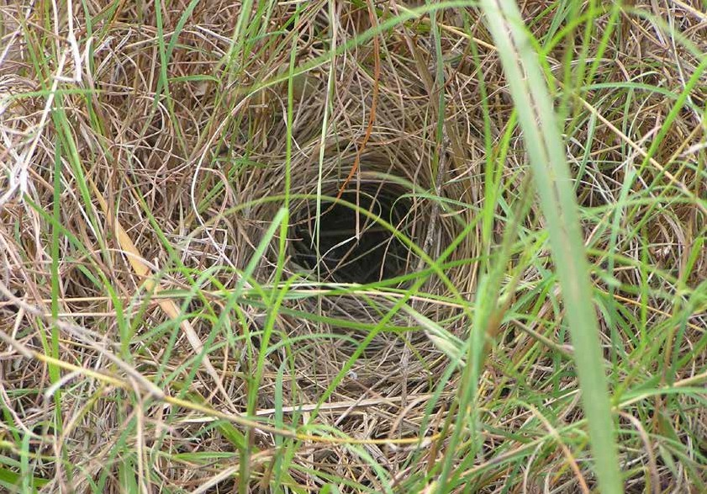

Eastern Bristlebird nest Park © Copyright, Stephen King from NSW Department of Planning

and Environment

### Movement patterns

The Eastern Bristlebird is a sedentary (McNamara 1946; Gibson 1977; Blakers et al. 1984; Holmes 1989; Lamb et al. 1993; Hartley & Kikkawa 1994) or resident (Morris et al. 1981; Cooper 1991) species that undertakes some local movements (Baker 1998; Baker & Clarke 1999) and can recolonise some areas after being displaced by fire (Bramwell & Baker 1990; Hartley & Kikkawa 1994; Jordan 1984; Pyke et al. 1995). The birds are only capable of making weak, low, short-range flights (Chaffer 1954; Holmes 1989; Bramwell & Baker 1990; Lamb et al. 1993; Hartley & Kikkawa 1994; Baker 1998; Chapman 1999), which suggests that dispersal is likely to be mostly through ground movements (Higgins & Peter 2002) and, consequently, that they have a limited ability to disperse (Clarke & Bramwell 1998).

Studies of radio-tagged birds indicate that Eastern Bristlebirds are capable of travelling a total distance of at least 1.5 km during the course of a day (Baker & Clarke 1999). In 2009, Eastern Bristlebirds were recorded two to four kilometres from Howe Flat in heathland where they had previously not been detected, requiring a 2 km movement through coastal forest vegetation (M Bramwell pers. comm. 2010 cited

in OEH 2012). Translocated birds at Cataract Dam dispersed 5 km in 3 years, and at Beecroft Peninsula a maximum dispersal distance of 6 km was recorded after 6 years (Baker et al. 2012).

Male Eastern Bristlebirds are territorial, although territorial behaviour may decline during the non-breeding season (Hartley & Kikkawa 1994; Chapman 1999; Higgins & Peter 2002). The results of one study suggest that the territory is a core-area within the home range that is defended from conspecifics and advertised by loud directional song (Holmes 1989). Territories, some of which are probably permanent (Chapman 1999; Higgins & Peter 2002), range in size from about 1–4 ha (McNamara 1946; Holmes 1989; Bramwell & Baker 1990; Hartley & Kikkawa 1994). Home ranges are estimated to be about 10 ha (Baker 2001).

Population densities within suitable habitat are low compared to those of other heathland birds (Gosper & Baker 1997). Within coastal heathland habitats population densities of 3–4 birds per 10 ha have been estimated (Holmes 1989; Hartley & Kikkawa 1994; Baker 2001). Maximum densities of 4 birds per 10 ha recorded at Barren Grounds NR (Baker 1998). In the Howe Flat population, 1.5–2 birds per 10 ha were recorded (Bramwell 2008).

## Key Biodiversity Areas

The Key Biodiversity Area (KBA) programme aims to identify, map, monitor and conserve the critical sites for global biodiversity across the planet. This process is guided by a Global Standard for the Identification of Key Biodiversity Areas, the KBA Standard (IUCN 2016). It establishes a consultative, science-based process for

the identification of globally important sites for biodiversity worldwide. Sites qualify as KBAs of global importance if they meet one or more of 11 criteria in five categories: threatened biodiversity; geographically restricted biodiversity; ecological integrity; biological processes; and, irreplaceability. The KBAs programme is the successor

and extension of BirdLife Australia’s Important Bird and Biodiversity Areas (IBAs). Critically, the KBA Standard provides consistency to assist governments meeting their conservation obligations under various international treaties. For more information on KBAs visit – <http://www.keybiodiversityareas.org/home>

The global KBA partnership currently recognises five Key Biodiversity Areas as important for Eastern Bristlebird conservation and to support the long-term persistence of the species. KBAs are also undergoing a regular revision to ensure changes in IUCN red list status, taxonomic changes, local population trends as well as increased knowledge of the species are reflected accurately in the KBA network. As such, over time, additional KBAs may be recognised for their importance for Eastern Bristlebirds or new KBAs may be declared for this and other taxa. Detailed KBA Factsheets, including boundary maps, population estimates of trigger species and scientific references are available from the World Database of Key Biodiversity Areas (Key Biodiversity Areas Partnership 2020). They include:

* [Conondale Range](http://www.keybiodiversityareas.org/site/factsheet/24812) (QLD): centred approximately 125 km north-north-east of Brisbane in the Sunshine Coast hinterland. It comprises a series of protected areas and forest reserves that support either Black-breasted Button-quail or Eastern Bristlebird. National Parks include: Amamoor, Conondale, Glastonbury and Maleny; and King Conservation Park; and Forest Reserves: Conondale, Elgin, Glastonbury, Imbil 1 & 2, Jimna, Kandanga, Kenilworth, Oakview, Wrattens, Yabba 1 & 2; and

State Forests: Amamoor, Brooyar 1 & 2, Conondale, Diaper, Elgin Vale, Gallangowan,

Glastonbury, Imbil 1 & 2, Jimna, Jimmys Scrub, Kabunga, King, Marys Creek, Mount Stanley 1, Oakview, Schact Creek, Squirrel Creek, Sunday Creek, Upper Kanganga,

Wrattens, Yabba; and Conondale Resources Reserve. These areas are largely but not entirely connected and, as a whole, are surrounded by land cleared for agriculture and farming.

* + [Scenic Rim](http://www.keybiodiversityareas.org/site/factsheet/24332) (QLD/NSW): consists of a series of protected areas along the Queensland and New South Wales border, the majority of which are included in the Gondwana Rainforests World Heritage Area. This KBA is comprised of the following protected areas, which support populations of threatened species: Main

Range National Park, Glen Rock Regional Park, Mount Barney National Park, Mount Chinghee National Park, Lamington National Park and Springbrook National Park, Border Ranges National Park, Koreelah National Park, Mebbin National Park, Wollumbin National Park, Mount Clunie National Park, Mount Nothofagus National Park, Mount Warning National Park, Limpinwood Nature Reserve and Numinbah Nature Reserve. The KBA also includes private properties which support

Eastern Bristlebirds.

* + [Budderoo and Barren Grounds](http://www.keybiodiversityareas.org/site/factsheet/23834) (NSW): The heathland of Barren Grounds, Budderoo and Red Rocks is one of only four large areas of heath along this section of coast. The heaths and sedgelands of the plateau grade into warm temperate rainforest and subtropical rainforest on the slopes, gullies and ridges below the escarpment. The area is a typical hanging swamp plateau, dominated by heathland and almost completely encircled by sheer cliffs. Red Rocks is a nearby area of heath and this IBA may warrant expansion if Eastern Bristlebirds establish themselves

in other pockets of habitat in the vicinity. The climate is temperate with damp winters and warm, humid summers moderated by proximity to the coast.

* + [Jervis Bay](http://www.keybiodiversityareas.org/site/factsheet/23840) (NSW): The peninsula from Huskisson south to St Georges Basin includes Jervis Bay NP, Booderee NP and patches of public/private land at Vincentia, Hyams Beach, Jervis Bay and Wreck Bay. It consists of coastal heath and eucalypt woodlands in patchy mosaics around some developed areas. It contains a sub-population of Eastern Bristlebird, isolated from those in the Budderoo NP/Barren Grounds NR and Nadgee NP. The northern and western boundaries are unclear as bristlebirds disperse out, but the viability of any range extensions is unknown.
  + [Nadgee to Mallacoota Inlet](http://www.keybiodiversityareas.org/site/factsheet/23844) (NSW/VIC): includes all of Nadgee National Park in NSW and the eastern section of the 87,500 hectare Croajingolong National Park in Victoria. The key bird species, Eastern Bristlebird, is no longer found west

of Mallacoota inlet in Victoria so this section of Croajingolong is excluded. The habitat is largely a patchy mosaic of coastal heath and eucalypt woodlands. This includes Nadgee Coastal Heath Complex and Nadgee Coastal Heath/Woodland, which occurs in exposed situations along the coast. There is a diverse range

of structurally complex wet heath, mainly occurring in poorly drained areas, including Nadgee Lowland Sedge Swamp, Nadgee Tall Wet Shrub Heath and Nadgee Wet Shrub Heath. A unique wetland type occurs within the dune swales surrounding Cape Howe (Cape Howe Dune Swale). Dry Scrub occurs along the length of the proposed KBA coastline, and includes Headland Scrub and Dune. The KBA occurs within one of the least disturbed areas of temperate coastal vegetation on the Australian mainland. This has resulted in a very high level of floristic and structural integrity, which is considered significant at the national level.

## Habitat critical to survival

Habitat critical to the survival or important habitats of a species or ecological community refers to areas that are necessary:

* for activities such as foraging, breeding, roosting, or dispersal;
* for the long-term maintenance of the species or ecological community (including the maintenance of species essential to the survival of the species or ecological community, such as pollinators);
* to maintain genetic diversity and long-term evolutionary development; or
* for the reintroduction of populations or recovery of the species or

ecological community.

Such habitat may be, but is not limited to: habitat identified in a recovery plan for

the species or ecological community as habitat critical for that species or ecological community; and/or habitat listed on the Register of Critical Habitat maintained by the Minister under the EPBC Act.

Habitat critical to the survival of the Eastern Bristlebird includes:

###### Breeding and foraging habitat

* Northern population: within the known or likely range and in habitat that occurs in open forest with dense tussocky grass understorey and sparse mid-storey near rainforest ecotone. The northern fire regime is between 3–6 years and of variable intensity depending on the habitat condition.
* Central and southern populations: within the known or likely range and in habitat that includes low vegetation including heath and open woodland with a heathy understorey. Birds reach maximum densities of 3–4 birds per 10 ha in habitat that has not been burnt for at least 15 years.

###### Habitat for the long-term maintenance of the species

* All Key Biodiversity Areas with Eastern Bristlebird as a Trigger species.

Additionally, all suitable habitat occupied by the Eastern Bristlebird before and after the 2019–2020 wildfires is considered habitat critical to survival. It is also important to consider and maintain connectivity, buffer zones, and refugia habitat – especially in the context of wildfire – for the species. Potential or planned release sites are

also considered habitat critical to the survival of Eastern Bristlebirds and should be afforded the same level of protection and conservation management as known sites. Sympathetic management of areas adjoining Eastern Bristlebird habitats is important. Habitat connectivity is important for maintaining or enhancing species genetic diversity and long-term evolutionary potential.

Habitat critical to the survival of Eastern Bristlebird occurs across a wide range of land tenures, including freehold land and reserves, defence land (e.g., Beecroft), publicly owned forests and state reserves, and national parks (e.g., Booderee NP). It is essential that the locations where the species regularly occurs is given the highest protection and conservation measures target these productive habitats.

No Critical Habitat as defined under section 207A of the EPBC Act has been identified

or included in the Register of Critical Habitat

### Key considerations for decision makers

Habitat critical to the survival of Eastern Bristlebirds occurs across a range of land tenures should not be destroyed or modified. Actions that have indirect impacts on habitat critical to the survival (e.g., native vegetation removal) should be avoided. Actions that compromise adult and juvenile survival should also be avoided.

When considering developments in any part of the Eastern Bristlebird’s range, including in areas where the species ‘may occur’, surveys for occupancy that consider detectability and are undertaken at the appropriate times of the year remain an important tool in establishing the areas of importance to the Eastern Bristlebird. In addition, it is important to note that the Eastern Bristlebird may opportunistically use areas depending on the occurrence of suitable habitat following fire. Areas that may be important habitat over time might not have birds in any given year. This pattern

of habitat use means that recent survey data and historical records and presence of suitable habitat need to be considered when assessing the relative importance of a site or region for the Eastern Bristlebird.

Actions that remove habitat critical to the survival will interfere with the recovery of Eastern Bristlebird and reduce the area of occupancy of the species. If removal of habitat critical to the survival cannot be avoided or mitigated, then an offset should be provided.

# Threats

## Historical causes of decline

Habitat loss, due to urbanisation, agriculture and inappropriate fire regimes, is recognised as the main process that has reduced the distribution and abundance of the Eastern Bristlebird in the last 150 years. This resulted in a dramatic reduction in the distribution of the species and the local extinction of Eastern Bristlebird populations (Baker 1997).

## Current threats

### Threat assessment and prioritisation

The approach to assessing current threats was taken from the Conservation Standards (CMP 2020), an internationally adopted set of principles and practices for conservation project design, management, and monitoring developed by

the Conservation Measures Partnership. An assessment of scope, severity, and irreversibility (see Appendix 1 for detailed criteria) was undertaken for each threat and then used to determine overall threat ratings, based on an algorithm in Miradi Share 2.0 (Miradi 2020). Threat rankings are based on overall threat ratings.

Threats were considered in the context of the current management regimes. Threat impacts have been assessed assuming that existing management measures continue to be applied appropriately. If management regimes change then the threat rating and ranking may also change.

Threats may act differently in different parts of the species’ range and at different times of year, but the precautionary principle dictates that the threat rating is determined by the population for which the threat impact is greatest. Population-wide threats are generally considered to present a higher threat to species recovery.

### Summary of current threats

Current threats to the Eastern Bristlebird are summarised in Table 2 and are outlined below in priority order (3.2.3–3.2.15).

The ratings of four current threats vary among populations (see Table 2 and Appendix 2). Seven key threatening processes listed under the EPBC Act are associated with current threats to the Eastern Bristlebird:

* Dieback caused by plant pathogens (*Phytophthora cinnamomi*).
* Loss of climatic habitat caused by anthropogenic emissions of greenhouse gases
* Predation by European red fox.
* Predation by feral cats.
* Predation, habitat degradation, competition, and disease transmission by

feral pigs.

* Novel biota and their impact on biodiversity.
* Land clearance.

In addition, some current threats to the Eastern Bristlebird are reflected in state-listed key threatening processes.

#### **TABLE 2:** Current threats to the Eastern Bristlebird, ranked according to an overall threat rating derived from an assessment of scope, severity, and irreversibility.

|  |  |  |  |  |  |
| --- | --- | --- | --- | --- | --- |
| Threat | | Scope | Severity | Irreversibility | Overall rating |
| Inappropriate fire regimes | Wildfire | Very High | Very High | High | **Very High** |
| Management* | Very High | High | Medium | **High** |
| Climate change | | Very High | Medium | High | **Medium** |
| Lack of genetic diversity* | | High | Medium | Medium | **Medium** |
| Dieback and invasive weeds* | | High | Medium | Medium | **Medium** |
| Drought | | High | Medium | Medium | **Medium** |
| Predation by foxes* | | High | High | Low | **Medium** |
| Predation by cats* | | Medium | Medium | High | **Medium** |
| Disease (wild populations) | | Medium | High | Medium | **Medium** |
| Clearing of habitat | | Low | **Very High** | High | **Low** |
| Disease (captive populations) | | Low | High | Medium | **Low** |
| Pigs * | | Low | Medium | Medium | **Low** |
| Overabundant herbivores | | Low | Low | Medium | **Low** |
| Human disturbance | | Low | Low | Low | **Low** |

* Threat rating varies among populations (see Appendix 2 for detail)

### Inappropriate fire regimes

###### Wildfire

A fire regime includes scale, intensity, frequency, seasonality, and patchiness, whether arising from wildfire (this section) or management (section 3.2.3.2). Inappropriate fire regimes (too frequent or infrequent) arising from wildfire or management, and interactions between the two, are a threat to all Eastern Bristlebird populations.

The Eastern Bristlebird is a cover-dependent and fire-sensitive species (Baker 2000). Ground dwelling and weak fliers, Eastern Bristlebirds are vulnerable to fire. In particular larger and more intense fires which travel quickly may be difficult for birds to escape. Inappropriate fire regimes arising from wildfire may threaten Eastern Bristlebird population viability through direct and indirect impacts and synergisms with other threats, which could ultimately result in localised extinctions (as is thought to have occurred historically, Baker 2003 in Bain et al. 2008).

Fires that are too infrequent are a major threat to the northern population. Infrequent fires lead to recruitment and/or growth of shrubs and trees resulting in higher canopy cover that has a negative influence on grass cover, reducing habitat quality and ultimately converting suitable habitat to unsuitable habitat. Too frequent or extensive fires are a threat to the central and southern populations, where Eastern Bristlebird density generally increases with time since fire (OEH 2012, DPIE 2018).

Although Eastern Bristlebirds may be able to avoid fire by moving to unburnt areas and returning when conditions are suitable, the immediate threat of fire may be exacerbated if there is a lack of connecting habitat to enable birds to seek refugia. Therefore, buffer zones, connecting habitat, and unburnt refugia are important for species persistence during and after fire (Bain et al*.* 2008, Hartley & Kikkawa 1994; Lindenmayer et al. 2009). Rainforest gullies adjacent to grassland are likely to be important for local persistence within the northern population during and after fire.

The 2019–2020 bushfire season, known as ‘Black Summer’, was catastrophic. It started in the winter of 2019, which was both Australia’s warmest and driest year on record (BOM 2020). These bushfires were unprecedented in the area of land they covered, much of it at high severity (Collins et al 2021), and they are estimated to have burned over 103,000 km² of habitat for native species (Legge at al. 2021; 2022). Bain et al. (2021) estimated 9% of the central and southern Eastern Bristlebird populations are thought to have been killed by the 2019–2020 wildfires; while a separate analysis by Legge et al. (2022) estimated an 11% (80% confidence limits: 0.5–28%) loss.

At the time of preparing this Recovery Plan, population and habitat assessments in response to the 2019–2020 wildfires were incomplete. However, preliminary assessments for the fire-affected Nadgee subpopulation showed signs of habitat

recovery and detected the presence of Eastern Bristlebirds (Oliver & Malolakis 2020; Oliver et al. 2021).

*The Action Plan for Australian Birds 2020* (Bain et al. 2021; Charley et al. 2021) and Legge et al (2022) reports the following overlaps of subspecies ranges with the 2019–2020 wildfires:

*2019–2020 wildfires: Northern population:*

* Except for the possible Mt Barney subpopulation, the fires appear to have missed all Eastern Bristlebird subpopulations (D Charley unpublished cited in Charley et al. 2021; Legge et al 2022). However, it has been noted that the impact of the 2019–2020 wildfires on Queensland subpopulations has likely

been underestimated due to limited survey effort (L Gould pers. comm. 2022). A minimum three-year expanded survey program is needed to gain confidence of current abundance and distribution.

*2019–2020 wildfires: Central and southern populations:*

* 15% of all 1x1 km squares from which Eastern Bristlebird have been recorded since 1990 were burnt (G Ehmke, unpublished cited in Bain et al. 2021). Legge et al (2022) found that 23% of the range of this subspecies was burnt, including 7% burnt at high severity.
* Less than 10% of the habitat is remaining at Nadgee (NSW, southern population) (Oliver & Malolakis 2020).

The development of emergency response protocols may assist during future wildfire events (see Selwood et al. 2021).

Wildfire regimes interact with other threats. For example, the risk of predation by foxes (Lindenmayer et al. 2009) and cats may increase after fire due to reduced cover to elude or evade predators, increased access to unburnt sites by predators, and concentration of Eastern Bristlebirds in refugia.

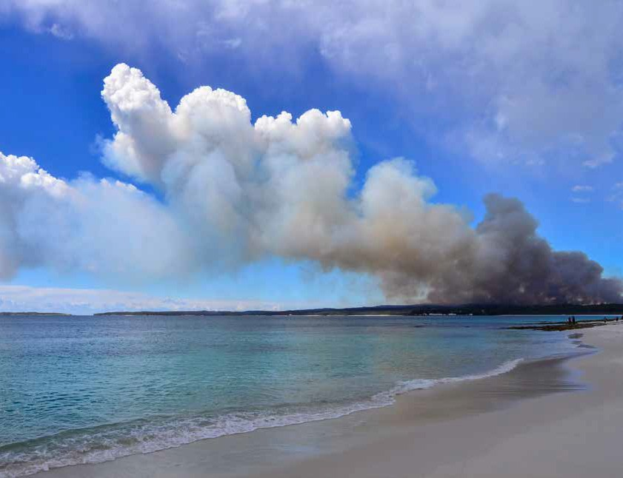

2019/2020 wildfires photographed from Jervis Bay, NSW © Copyright, Chris Grounds

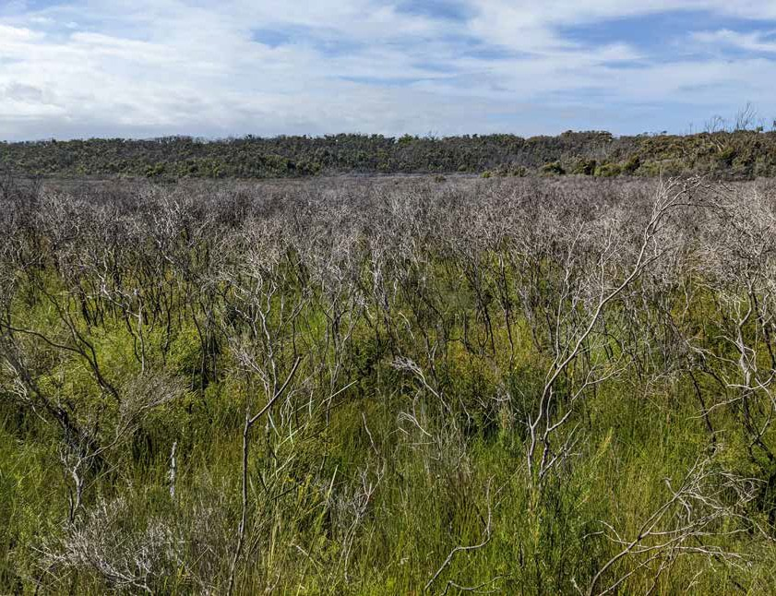

Regenerating heath at Nadgee NP following the 2019/2020 wildfires © Copyright, BirdLife Australia

###### Management

Inappropriate fire management regimes, including fire exclusion, threaten Eastern Bristlebirds by causing direct and indirect mortality, reducing population size, exacerbating habitat fragmentation, reducing habitat availability, reducing population size and increasing vulnerability to stochastic events and other

threatening processes (e.g. predators, loss of genetic diversity). Although specific fire regimes have previously been suggested (OEH 2012), appropriate fire regimes are site and context dependent (Bain et al. 2008). Therefore, site-specific management at the local population scale is essential. However, given Eastern Bristlebirds may have difficulty escaping fire, avoiding encircling burns is essential.

Fire management considerations include fire scale, intensity, frequency, and seasonality (OEH 2012). In determining appropriate fire management regimes, it is important to consider those regimes on which Eastern Bristlebirds and their habitat depend (Olsen & Weston 2005). For example, within Heathland, fire management planning in and around Eastern Bristlebird habitat needs to collectively consider fire extent, severity, timing, interconnectivity of ground and mid-canopy fuel, and the delivery of fire into the landscape (e.g. backing fire, spot ignition, line ignition). It is also important to consider the extent of planned burns, as smaller, staggered burns that create a mosaic of vegetation age classes in and around key habitat are valuable. Further, fire management should consider synergistic effects of other threats to the Eastern Bristlebird and adopt an adaptive rather than prescriptive approach.

Appropriate fire management regimes need to be incorporated within fire management plans and considered in conjunction with factors such as protection of human life and property and recovery of threatened species and ecological communities. Generally, effective fire management to conserve Eastern Bristlebird

populations include: mosaic, low-intensity and/or burns with small footprints, ignited along one fire front, a suitable site-specific fire interval, strategic breaks and buffers and timing with respect to breeding season and environmental conditions such as drought (though this can vary between sites).

As with mitigation of wildfire, fire management regimes need to protect buffer zones, connecting habitat and unburnt refugia and, because the response to fire is site and context dependent, fine scale site-specific management is required (Bain et al. 2008). Refugia sites also need to be sufficiently large to support a population that is resilient to demographic stochasticity while burnt habitat recovers and provides opportunities for the population to expand.

### Climate change

Australia’s climate has warmed by about 1.4 °C since 1910, leading to an increase in the frequency of extreme heat events (BOM & CSIRO 2020). Warming has occurred across Australia in all months, with both day and night-time temperatures increasing. Winter rainfall in southern Australia is projected to decline, while most of the country is likely to experience more extreme daily rainfall (BOM & CSIRO 2020). Heatwaves are also lasting longer, reaching more extreme maximum temperatures, and occurring more frequently over many regions of Australia, including south-eastern Australia (Perkins-Kirkpatrick et al. 2016; Evans et al. 2017; Herold et al. 2018; BOM & CSIRO 2020). Heatwaves also exacerbate drought, which in turn can also increase bushfire risk (BOM & CSIRO 2020). Birds are also vulnerable to extreme heatwaves that overwhelm their physiological limits (McKechnie et al. 2012).

Climate change is expected to intensify current threats to the Eastern Bristlebird. Climate change effects that may impact the Eastern Bristlebird include ‘changes in vegetation caused by changes in temperature and rainfall (including increased weed and pathogen invasion), reduced food source, increased occurrence of extreme events such as droughts and fires and possible reduction in reproductive success.

Eastern Bristlebirds have been identified as a species that is likely to be exposed to increases in the frequency and intensity of fires arising from climate change (Garnett et al. 2013). Climate change may reduce the availability of suitable Eastern Bristlebird habitat. For the northern population, enhanced levels of carbon dioxide may increase woody plants within grassy ecosystems (DPIE 2018) and birds have been observed moving into gullies during long hot summers (Stone et al. 2019), highlighting the need for alternative habitat and refugia during temperature extremes. Whereas parts of the southern population may be threatened by rising sea levels impacting low-lying habitat e.g., at Howe Flat (0–5 m asl). Eastern Bristlebird ability to move in response to climate change will be limited by their poor dispersal ability and lack of habitat connectivity (OEH 2012).

An analysis of the effects of climate change on 101 bird taxa proposed ongoing population monitoring and the identification of climate refugia as key priorities and fire management and weed and feral animal control as key in situ management actions (Garnett et al. 2013).

### Lack of genetic diversity

Genetic diversity is important for the viability of populations and the evolutionary potential of species. Habitat fragmentation and isolation of natural populations can reduce effective population size (Love Stowell et al. 2017), leading to loss of genetic diversity and inbreeding. Populations that are restricted to small, isolated habitat patches can fall into an ‘extinction vortex’, where low genetic diversity and susceptibility to extreme events (e.g., fires, disease and drought) limit population recovery. In such cases, habitat protection or restoration may not be sufficient for population increase.

Genetic assessment of the Eastern Bristlebird by Roberts et al. (2011) showed there was insufficient phylogenetic distinctiveness between populations to support classification of the northern population as a subspecies. Both the northern and southern populations were less genetically diverse then the central population, consistent

with their smaller population sizes (Weeks et al. 2016). Using a limited dataset of six microsatellites, Roberts et al. (2011) found broad-scale genetic subdivision by region. They cautioned against mixing genetics across regions to preserve genetic

integrity of the local populations. However, it has been suggested that this study was underpowered and management recommendations were not based on gene flow between units and time of divergence (P. Sunnucks pers. comm. cited in NESP 2018). Both these factors highly affect the likely response of a population to genetic rescue. The genetic distinctiveness of the northern population is likely due to random genetic drift following historically recent fragmentation and small population size, rather than a reflection of longer-term evolutionary adaptation (Sunnucks 2013). Because of this, it is unlikely that cross-breeding between the phylogenetically similar southern and northern populations would cause outbreeding depression.

More recently, a genetic assessment of Eastern Bristlebirds from Howe Flat, Victoria (southern population, 15 samples), compared with samples from the northern captive population (15 samples), Budderoo National Park (central population, 24 samples),

and Nadgee NR (southern population, five samples) revealed lower allelic richness and heterozygosity in the Howe Flat birds than those from the northern captive population and central population (Cesar 2020). Cesar (2020) concluded that the distinct northern and southern populations have low genetic diversity, most likely as a result of contemporary and/or past small population sizes.

Genetic rescue is the term given to conservation efforts that aim to restore adaptive potential of small, isolated, genetically depauperate populations that are showing signs of inbreeding depression through the introduction of novel genetic material (Weeks et al. 2011). Due to concerns regarding accumulating inbreeding and infertility, genetic rescue has been recommended for the northern population of the eastern bristlebird (NESP 2018). This population is likely to become extinct unless serious consideration is given to its genetic management (Stone 2018b) as there is evidence of inbreeding depression in both the wild and captive birds (D Charley & A Beutel pers. comms. cited in NESP 2018).

The potential benefits of assisted gene flow for northern bristlebirds may be high, particularly if undertaken at low levels to minimise any concerns over loss of local adaptations (NESP 2018). These actions must co-occur with on-ground habitat management actions (intensive fire management, extensive weed and feral animal control, sustainable stock grazing and habitat protection) to be effective. Genetic samples of wild Eastern Bristlebirds across their entire range have been collected to inform selective breeding.

Additional genetic sampling and analysis will help inform future recovery management actions. Genetic methods using higher resolution across the genome to understand population differentiation are needed. These require blood spot samples to be collected from birds and implementation of a broad gene pool mixing strategy (with appropriate consideration of where mixing populations should be avoided) (Cesar 2020). Overall, informed genetic management actions are necessary for the species’ survival.”

### Dieback and invasive weeds

Dieback, caused by pathogens e.g., *Phytophthora cinnamomi* and invasive weeds may modify Eastern Bristlebird habitat, reduce habitat quality, and limit the availability of suitable habitat (DES 2018; DPIE 2018). Therefore, hygiene measures and control of dieback and invasive weeds are important to maintain Eastern Bristlebird habitat availability and suitability. Hygiene measures will also help prevent the spread of other plant diseases such as Myrtle Rust (*Austropuccinia psidii*). In addition*,* Bell Miner associated dieback (BMAD) is present within northern Eastern Bristlebird habitat (DES 2018).

The current threat of dieback and invasive weeds was assessed as higher for

the northern Eastern Bristlebird population, compared to central and southern populations (Appendix 2). However, the potential threat of dieback in the central and southern populations is very high because the majority of plant diversity and structure where these populations occur is in the Proteaceae family which is especially susceptible to *P. cinnamomi* (M Antos pers. comm. 2021).

Invasive weeds that negatively impact northern population habitat include Lantana (*Lantana camara*), Crofton Weed (*Ageratina adenophora*), Mist Flower (*A. riparia*), Christmas Wattle (*Acacia sp.*), and Foxtail (*Cenchrus purpurascens*) (OEH 2012;

DES 2018). For southern populations, most habitat is relatively weed free with the

exception of occasional blackberry infestations at Howe Flat (M Antos pers. comm. 2021*)*. Some invasive native plants such as Coast Wattle (*Acacia longifolia* var. *sophorae*) and Coast Tea Tree (*Leptospermum laevigatum*) have been shown to invade and degrade coastal heathland habitats and although it is unknown whether this is likely to be a threat to Eastern Bristlebird populations, monitoring is warranted (M Antos pers. comm. 2021).

Even though Bitou Bush (*Chrysanthemoides monilifera* subsp. *rotundata*) can negatively impact habitat, it has the low, dense vegetation structure required by the Eastern Bristlebird and could be used by the species where suitable native habitat does not exist (OEH 2012). Similarly, northern Eastern Bristlebirds have been noted foraging in Crofton Weed (D Charley pers. comm. cited in Stone et al. 2018). Although Lindenmayer et al. (2017) found a negative relationship between Eastern Bristlebird occurrence and the number of Bitou Bush plants in the Bherwerre Peninsula within Booderee National Park, the species was found to respond positively to increased native vegetation cover following Bitou Bush removal. Despite this relationship, Bitou Bush is generally not a threat to Eastern Bristlebird (D Bain pers. comm. 2021).

Dieback and invasive weeds interact with other threats to the Eastern Bristlebird.

For example, *Phytophthora cinnamomi* may be spread by animal vectors, such as feral predators, or human activity (including fire management and response activities) (OEH 2012). The dominance of Lantana in the mid-storey and overgrowing of native canopy species, combined with (and as a result of) inappropriate fire management regimes (i.e., too infrequent) threatens northern Eastern Bristlebird habitat (DAWE 2021).

*P. cinnamomi* is listed as a Key Threatening Process under the EBPC Act, and a threat abatement plan has been prepared (DEE 2018). More information is available elsewhere (DE 2014; DEE 2013).

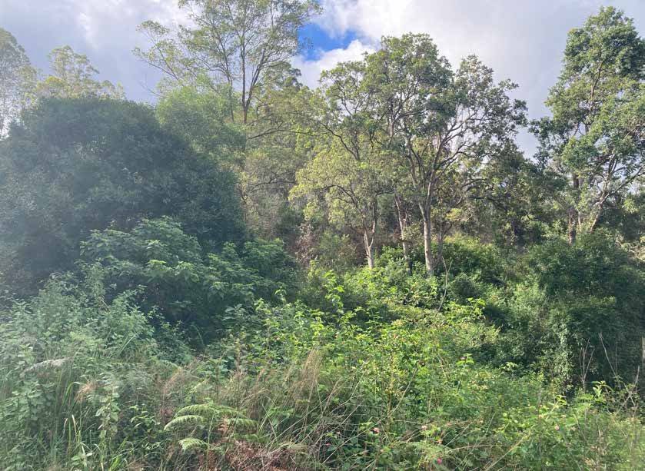

Weed infestation impacting the northern population © Copyright, Kelly Roche for NSW Department of

Planning and Environment

### Drought

While droughts are a natural phenomenon in Australia, climate change modelling suggests droughts are likely to be longer and more intense (BOM & CSIRO 2020). Drought episodes may have contributed to Eastern Bristlebird population declines due to resultant loss, modification and/or degradation of habitat (Clarke & Bramwell 1998; Stewart et al. 2004) and reduced food availability (e.g., reduction in invertebrates suitable for feeding nestlings; Hartley & Kikkawa 1994).

Northern Eastern Bristlebirds have been observed moving into gullies during long hot summers (Stone et al. 2019), highlighting the need for alternative habitat and refugia during temperature extremes. Northern bristlebirds are closely associated with the rainforest margin; all territories are found within 400 m of a dense rainforest edge.

These margins provide increased humidity for tall, thick tussock grasses and have better quality invertebrate resources for foraging (Stone et al. 2018). An increase in the frequency and duration of drought could have a negative impact on the condition of this ecotone, which will affect the reproductive potential of bristlebirds. Any suppression of reproductive capacity or compromised survivorship in the already small northern population could lead to rapid extinction.

*The Action Plan for Australian Birds 2020* (Charley et al. 2021; Bain et al. 2021) considered an increased frequency or length of droughts in an assessment of threats to the Eastern Bristlebird. Drought impacts may interact with other threats, including climate change, fire, and invasive weeds. For example, the 2019–2020 wildfires were exacerbated by drought (Ward et al. 2020).

Drought conditions may also impede the implementation of on-ground management actions. For example, chemical weed control is rendered ineffective during drought and over-dry conditions prevent prescribed burning due to associated risks (K Roche pers. comm. 2021)

### Predation by foxes

Because Eastern Bristlebird are ground-dwelling and nest close to the ground, the species is at risk of predation by foxes, particularly when wildfires reduce the amount of vegetation and increase Eastern Bristlebird exposure (Lindenmayer et al. 2009).

In addition, Eastern Bristlebird calling behaviour may make them susceptible to predation (OEH 2012).

The threat of predation by foxes varies across the distribution of the Eastern Bristlebird. Although not quantified, the threat of predation by foxes was assessed as higher for the central Eastern Bristlebird population, compared to northern and

southern populations (Appendix 2). The effects of predation are less significant for the northern population because the thick grassy habitat reduces foraging opportunities for invasive predators. Nonetheless, any natural predation (by native predators) or the occasional predation by invasive pest predators could have a significant impact

on northern populations of Eastern Bristlebird, due to the very small number of wild individuals remaining. Eastern Bristlebirds at Nadgee NR (southern population) recovered rapidly after fire in the absence of pest predator baiting programs, likely because the area has a healthy Dingo (*Canis familiaris*) population.

Predation by European red fox is listed as a Key Threatening Process under the EBPC Act, and a threat abatement plan has been prepared (DEWHA 2008a, 2008b).

### Predation by feral cats

In addition to foxes, feral cats predate on Eastern Bristlebirds (Meek 2003; Woinarski et al. 2017), although predation risk varies across the species spatial range. As with the threat of predation by foxes, the threat of predation by cats has not been quantified but was assessed as higher for the northern Eastern Bristlebird population, compared to central and southern populations that occur in dense heath vegetation that is relatively impenetrable to cats and foxes (Appendix 2). The threat of cats is also amplified by bushfires as they take advantage of recently burnt areas (McGregor et

al. 2016), as they prefer to hunt in open habitats and have higher hunting success in such habitats (McGregor et al. 2015). Studies are required to assess the overall impact of predation by cats and foxes, and the effectiveness of their control, on the Eastern Bristlebird.

Predation by feral cats is listed as a Key Threatening Process under the EBPC Act, and a threat abatement plan has been prepared (DE 2015a, 2015b).

### Disease in captive populations

Captive Eastern Bristlebirds may be at increased risk of infection with pathogens and parasites, due to low genetic diversity and the potential for stress during capture. Susceptibility to infection appears high in captive Eastern Bristlebirds and there is apparent fragility of birds during transfer to captivity (Selwood et al. 2021).

Eastern Bristlebirds in captive breeding programs have been subject to mortality from parasitic infections with *Atoxoplasma*, likely obtained in the wild prior to capture (D Bain pers. comm. 2021), and aspergillosis infections are a risk. Six of 15 birds rescued from Howe Flat, Victoria, during the 2019–2020 fires died due to aspergillosis (a non-contagious stress-induced respiratory illness) during their initial days in captivity (Selwood et al. 2021). An effective treatment regimen was established for surviving birds, and it is now recommended that Eastern Bristlebirds translocated

to captivity are treated prophylactically through food to prevent disease from aspergillosis (Selwood et al. 2021). It is also recommended that the species be housed on sandy soil substrates to reduce possibility of aspergillosis transfer *ex-situ* (M Lynch pers. comm. 2021).

### Disease in wild populations

Infection prevalence and parasite/pathogen burden and associated adverse effects in wild populations are unknown but may have the potential to impact on Eastern Bristlebird recovery. An improved understanding of disease in wild populations is needed to inform any translocation actions and reintroduction of Eastern Bristlebird into the wild. Captive birds have succumbed to parasite infections which were likely obtained in the wild prior to capture.

Disease threats may not be uniform across all wild Eastern Bristlebird populations. Small and/or fragmented populations like those of northern and southern Eastern Bristlebird populations may be at higher risk of adverse effects from disease, in part due to an increased susceptibility to disease that may be associated with lower genetic diversity.

Studies are needed to determine prevalence and impacts of both asymptomatic

infections and infections with clinical signs of disease in all wild populations.

### Clearing of habitat

Where habitat is not protected, contemporary clearing for agriculture, forestry, fuel breaks, utility easements, and residential development may continue to threaten the Eastern Bristlebird. Clearing results in the loss of Eastern Bristlebird habitat and may fragment populations, increasing their vulnerability to negative impacts of other threats. Increased fragmentation interacts with other threats and makes the Eastern Bristlebird more susceptible to local extinction. For example, fragmentation

may reduce the capacity of Eastern Bristlebirds to escape fire, improve feral predator access to Eastern Bristlebird habitat, increase the risk of vehicle strike, and facilitate human disturbance (TSSC 2001b).

While habitat on conservation reserves may be managed for Eastern Bristlebirds, recovery of habitat is difficult in some areas due to current land-zoning for urban development. Protection and management of habitat on private land, particularly for the northern population and at Jervis Bay, is extremely important. At Jervis Bay, the cumulative impact of residential developments remains a key threat to some local populations. Possible solutions include prioritising land supporting Eastern Bristlebird habitat for re-zoning to a category that conserves biodiversity values; and incorporating appropriate vegetation buffers, within the land zoned for urban development, at zoning boundaries adjacent to Eastern Bristlebird habitat.

### Feral pigs

Feral pigs (*Sus scrofa*) are potential predators of Eastern Bristlebird eggs and chicks and may disturb breeding birds, damage habitat, facilitate weed invasion, spread plant diseases (including *Phytophthora cinnamomi*), and create tracks that provide access by predators (Stewart 1998b). The threat of pigs is relevant to the northern population (QLD) only.

Predation, habitat degradation, competition and disease transmission by feral pigs has been listed as a Key Threatening Process under the EBPC Act, and a threat abatement plan has been prepared (DEE 2017).

### Overabundant non-native herbivores

Grazing by non-native herbivores may degrade Eastern Bristlebird habitat, reduce habitat connectivity, and destroy nests. For example, appropriate management of cattle grazing has been critical for survival of northern population on private land (L Gould pers. comm. 2021).

Deer are an emerging threat to the southern population (DAWE 2021), as they alter vegetation structural complexity, and create tracks that allow greater access into Eastern Bristlebird habitat by foxes and cats and may facilitate the spread of weeds and *P. cinnamomi* along tracks.

### Human disturbance

Human disturbance may result in habitat damage, disturbance of Eastern Bristlebird

breeding, abandonment of nests, and mortality from vehicle strike (DES 2019).

The use of call playback by birdwatchers may interfere with breeding behaviour during the breeding season.

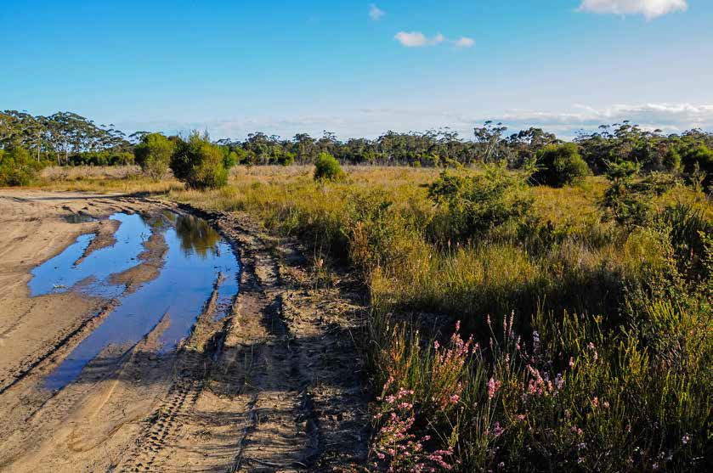

Human disturbance within the central population © Copyright, Chris Grounds

# Populations under particular pressure

All areas where the Eastern Bristlebird is known or is likely to occur require protective measures. The actions described in this Recovery Plan are intended

to provide ongoing protection for the Eastern Bristlebird throughout their range. Due to their small size and reduced genetic diversity, northern and southern

Eastern Bristlebird populations are likely to be under particular pressure from some current threats. Notably, the *Action Plan for Australian Birds 2020* (Charley et al. 2021) recognises the northern Eastern Bristlebird as Critically Endangered and the southern Eastern Bristlebird (NSW/ACT, VIC) as Near Threatened, based on IUCN Red List categories (IUCN 2001). Further, because some threats are higher in one population than another (Appendix 2) some Recovery Plan actions are population specific

(see section 6 for details).

# Vision, objectives and strategies

## Long-term vision

Eastern Bristlebird populations are ***genetically diverse*** and ***self-sustaining,*** and the species is resilient to impacts of climate change. Eastern Bristlebird recovery has been informed by comprehensive knowledge of Eastern Bristlebird ecology and best practice methods for conserving the species and its habitat. Eastern Bristlebird

habitat is protected, and Traditional Owners and the broader community are engaged

in habitat management.

## Recovery Plan objectives and strategies

|  |  |
| --- | --- |
| Objective 1 | By 2032, Eastern Bristlebird population *viability* is improved in the northern, central and southern populations, compared to baselines (see section 1.3).  **Strategy 1:** Population enhancement and augmentation. |
| Objective 2 | By 2032, levels of priority threats on the Eastern Bristlebird are reduced, compared to baselines.  **Strategy 2:** Threat management. |
| Objective 3 | By 2032, Eastern Bristlebird habitat extent and condition are maintained or improved, compared to baselines.  **Strategy 3:** Habitat protection, enhancement, and augmentation. |
| Objective 4 | By 2032, Eastern Bristlebird population assessments are enhanced by addressing data and knowledge gaps and viable Eastern Bristlebird population sizes and trends are determined.  **Strategy 4:** Biology and ecology knowledge enhancement. |

|  |  |
| --- | --- |
| Objective 5 | By 2032, targeted stakeholder engagement has:   * increased collaboration with private landholders to expand or strengthen involvement in Eastern Bristlebird conservation e.g., areas available for surveys, potential release sites, and active habitat management; * increased engagement of Traditional Owners in Eastern Bristlebird recovery decision-making processes; and * extended community/volunteer involvement in Eastern Bristlebird surveys.   **Strategy 5:** Stakeholder engagement and participation. |
| Objective 6 | By 2032, Eastern Bristlebird:   * recovery priorities are incorporated within relevant policies, management plans, regulations, codes of practice and planning tools; * recovery actions are implemented and reviewed across tenures and jurisdictions; * recovery planning and implementation is underpinned by an adaptive-management framework; and * data and meta data are available (within permissibility requirements) from a centralised repository.   **Strategy 6:** Coordinate, review and report on recovery progress. |

# Actions to achieve the specific objectives

Actions identified for the recovery of the Eastern Bristlebird are described below with a timeframe of 10-years.

Where an action is relevant to one or two, rather than all three populations, the relevant population(s) is indicated in text as follows: N northern population, C central population, and S southern population. Responsible Agencies are in bold text with potential supporting partners not in bold.

Priorities assigned to actions should be interpreted as follows:

|  |  |
| --- | --- |
| Priority 1: | Taking prompt action is necessary in order to mitigate the key threats to the Eastern Bristlebird and also provide valuable information to help identify long-term population trends |
| Priority 2: | Action would provide a more informed basis for the long-term management and recovery of the Eastern Bristlebird. |
| Priority 3: | Action is desirable, but not critical to the recovery of the Eastern Bristlebird or assessment of trends in that recovery. |

**STRATEGY 1:** Population enhancement and augmentation

|  |  |  |  |  |  |
| --- | --- | --- | --- | --- | --- |
| Action | Description | Priority | Performance Criteria | Responsible Agencies and potential partners | Indicative Cost |
| 1.1 | Maintain an Eastern Bristlebird captive breeding program. N | 1 | Population size/number of mature individuals in the captive breeding program has increased, including reproductive success, number of breeding pairs and fledging success:   * Captive breeding targets are identified and met. * Genetically robust founder stock have been sourced from wild populations. * Best-practice captive-breeding and animal husbandry information and knowledge are shared and continually   improved. | **Australian Government**  **State governments**  **Zoos and wildlife sanctuaries**  Academic/research institutions  NGOs  Wildlife health practitioners | $250,000 pa |
|  |  |  | * Best-practice translocation (including reintroduction) procedures (including pre-, during, and post- translocation   phases) are identified. |  |  |
|  |  |  | * A mortality and morbidity database for captive birds is developed and historic captive Eastern Bristlebird   mortality/morbidity risk is identified. |  |  |
| 1.2 | Develop and implement an Eastern Bristlebird  genetic rescue program to extant wild populations. | 1 | Genetic diversity has increased (e.g., allelic richness, heterozygosity); inbreeding within populations has been mitigated:   * A genetic rescue strategy is developed and implemented (see 1.3, 4.1 and 4.3). * Genetic diversity indicators are monitored e.g., genetic variance at least maintained in the central population, and increased in the   northern and southern populations. | **State government**  **Academic/ research institutions**  NGOs | $100,000 pa |
|  |  |  | * Wild populations are genetically   augmented where warranted. |  |  |

**STRATEGY 1:** Population enhancement and augmentation continued

|  |  |  |  |  |  |
| --- | --- | --- | --- | --- | --- |
| Action | Description | Priority | Performance Criteria | Responsible Agencies and potential partners | Indicative Cost |
| 1.3 | Implement an Eastern Bristlebird translocation plan(s) (including  monitoring). N, S | 1 | Area of occupancy, number of locations, number of subpopulations and population trends for northern and southern populations has increased:   * Potential release sites on private and public land are identified, utilising established criteria. * Translocation plans, incorporating new knowledge and monitoring strategies, and aligned to legislative requirements, are developed and, where relevant, implemented. * Genetic management guidelines are developed and incorporated into   translocation plans. | **State governments**  **Australian Government**  **Public land managers**  **Traditional Owners**  **Private landowners**  **Academic/ research institutions**  NGOs | $250,000 pa |
|  |  |  | * Reintroduction(s) have been carried out in the northern population and closely monitored to ensure adaptive management can occur if needed. | Wildlife health practitioners  Regional NRM organisation |  |
|  |  |  | * A second wild population is established in Victoria and closely monitored to ensure adaptive   management can occur if needed. |  |  |

N northern population, C central population S southern population.

**STRATEGY 2:** Threat management

|  |  |  |  |  |  |
| --- | --- | --- | --- | --- | --- |
| Action | Description | Priority | Performance Criteria | Responsible Agencies and potential partners | Indicative Cost |
| 2.1 | Develop and implement wildfire risk mitigation strategies relevant to each population. | 1 | Area of inappropriate fires and cumulative impact (departure from an appropriate regime) has decreased:   * Prescribed burning and other hazard reduction activities (e.g., mechanical vegetation removal and increased asset protection zones and buffer zones). Strategies are appropriate for   habitat protection and restoration. | **Australian Government**  **State governments**  **Public land managers**  **Traditional Owners**  **Private landowners**  **Emergency services**  **Fire and Biodiversity Consortia**  Local governments  Academic/research institutions  NGOs  Regional NRM organisation | $300,000 pa |
|  |  |  | * Site-specific fire management plans are developed, reviewed, and implemented. Within each site   management plan – |  |
|  |  |  | – Appropriate mitigation strategies (e.g., fire breaks) and location of strategic asset protection zones (or equivalent) on public or private  land are identified. |  |
|  |  |  | – Risk to important habitat on public and private land is mitigated by site prioritisation and cross-tenure  fire management. |  |
|  |  |  | – Eastern Bristlebird habitat is identified as an asset to be prioritised for protection during  wildfire suppression activities. |  |
|  |  |  | * Responsible agencies and partners, including regional and local community fire services (RFS, CFA) are aware of Eastern Bristlebird habitat and the importance of   protecting it. |  |
|  |  |  | * Traditional Owners are engaged in   wildfire mitigation strategies. |  |
|  |  |  | * A fire-management decision-support tool is developed to assist fire   planning by land managers. |  |
|  |  |  | * Land managers utilise a   fire-management decision-support tool, for fire planning. |  |

**STRATEGY 2:** Threat management continued

|  |  |  |  |  |  |
| --- | --- | --- | --- | --- | --- |
| Action | Description | Priority | Performance Criteria | Responsible Agencies and potential partners | Indicative Cost |
|  |  |  | * Fire management decisions incorporate monitoring data (derived from bird and habitat surveys) and interactions between weeds, fuel loads and fire risk management. * Land managers are aware of the importance of protecting   Eastern Bristlebird habitat when undertaking burning (and other land management) activities.   * Land managers understand how to reduce the impact of fire when implementing burns (e.g., staged burning of boundaries to ensure a   single fire front, timing and weather to reduce intensity).   * Fire management impacts are considered at the local population scale. * An emergency response to wildfire is developed (including rapid suppression and extraction for northern and southern populations). * All relevant fire planning and conservation management documents prioritise protection of Eastern Bristlebird habitat and include rapid wildfire response strategies in Eastern   Bristlebird habitat. |  |  |

**STRATEGY 2:** Threat management continued

|  |  |  |  |  |  |
| --- | --- | --- | --- | --- | --- |
| Action | Description | Priority | Performance Criteria | Responsible Agencies and potential partners | Indicative Cost |
| 2.2 | Manage feral cats and foxes | 1. C, S 2. N | Impacts of feral cat and fox predation has decreased:   * Knowledge of 1) feral predator impact and 2) feral predator control action effectiveness has increased, and effectiveness of feral predator management has improved. * A standardised (at the site level) monitoring program for feral predators is designed and implemented. * Reporting on feral predator monitoring across tenures and jurisdictions is nationally coordinated and results are accessible by responsible agencies and partners. * Targeted feral predator monitoring is applied before, during, and after translocation. * Actions to control feral cats and foxes are undertaken when relevant.   + Site-specific plans address site-level threats.   + Traditional Owners and public and private landowners are engaged in feral predator management.   + Predator exclusion mechanisms are established, where warranted, in translocation sites.   + Control methods for feral cats that are appropriate for different habitat types are developed and   implemented. | **Australian Government**  **State governments**  **Public land managers**  **Traditional Owners**  **Private landowners**  NGOs  Regional NRM organisation | $500,000 pa |

**STRATEGY 2:** Threat management continued

|  |  |  |  |  |  |
| --- | --- | --- | --- | --- | --- |
| Action | Description | Priority | Performance Criteria | Responsible Agencies and potential partners | Indicative Cost |
| 2.3 | Ongoing management strategy for dieback, invasive weed, invasive native plant species, and pathogens. | 2 | Proportion of Eastern Bristlebird habitat that is native vegetation has increased; spatial extent and density of invasive weed species and extent/proportion of eucalyptus forest dieback within Eastern Bristlebird distribution has decreased:   * Management strategies for dieback, invasive weed, invasive native   plant species, and pathogens are implemented.   * + Site-specific plans incorporate management actions and consider Eastern Bristlebird use of weeds as habitat (Bitou Bush in central populations and Crofton Weed   in northern populations). For example, staged removal of weeds is undertaken to reduce impact of habitat loss.   * + Educational and awareness-raising materials (e.g., signs alerting visitors to the importance of hygiene in reducing the threat from Phytophthora and other pathogens) are developed and disseminated.   + Management actions are incorporated into translocation or release site management plans.   + Strategies for vegetation management have been established for habitat of the northern population (to maintain balance between rainforest and open grassy forests).N   + Hygiene protocols to prevent the spread of weeds, Phytophthora and other pathogens (foot baths, equipment and vehicle cleaning)   are developed and implemented. | **State governments**  **Local government**  **Public land managers**  **Traditional Owners**  **Private landowners**  Academic/research institutions  NGOs  Regional NRM organisation | $175,000 pa |

**STRATEGY 2:** Threat management continued

|  |  |  |  |  |  |
| --- | --- | --- | --- | --- | --- |
| Action | Description | Priority | Performance Criteria | Responsible Agencies and potential partners | Indicative Cost |
|  |  |  | * The presence of Phytophthora across the Eastern Bristlebird’s distribution is assessed (where relevant). * Phytophthora monitoring protocols are developed to detect spread or new outbreaks. * Dieback, weed, invasive native plant species, and pathogen impact and management action effectiveness has been assessed.   + Knowledge of dieback, weed, invasive native plant species, and pathogen impact has improved and is collated.   + Knowledge of the effectiveness of dieback, weed, invasive native plant species, and pathogen management actions has improved.   + The impact of Myrtle Rust on habitat is assessed.   + Manipulative experiments are conducted to understand the threat posed by dieback and the effectiveness of dieback   management. |  |  |
| 2.4 | Continue feral pig control actions in habitat for Eastern Bristlebird populations (southern Queensland). N | 2 | Impacts of feral pigs has decreased:   * Feral pig presence/abundance is reduced. * Incursions are detected early via surveillance. * Feral pig damage to habitat is measured and reduced. * Feral pig management actions are incorporated into land and property management plans (where relevant). * The use of relevant tools (e.g., Feral Pig Scan in NSW) is incorporated into local management. | **State governments**  **Local governments**  **Public land managers**  **Traditional Owners**  **Private landowners**  NGOs  Regional NRM organisation | $75,000 pa |

**STRATEGY 2:** Threat management continued

|  |  |  |  |  |  |
| --- | --- | --- | --- | --- | --- |
| Action | Description | Priority | Performance Criteria | Responsible Agencies and potential partners | Indicative Cost |
| 2.5 | Extend the Safe Cat Safe Wildlife campaign across the distribution  of the Eastern Bristlebird. | 1. C, S 2. N | Impact of pet cats has decreased:   * The Safe Cat Safe Wildlife campaign is implemented in relevant areas across the distribution of the Eastern Bristlebird. | **Zoos Victoria RSPCA**  **Local governments**  **Wildlife health practitioners**  State governments NGOs  Academic/research  institutions | $75,000 pa |
| 2.6 | Undertake deer management actions in southern Eastern Bristlebird habitat. | 3 C, S | Impact of feral deer has decreased:   * Management actions reduce the presence/abundance of deer on Eastern Bristlebird habitat. | **State governments**  **Traditional Owners**  **Private landowners**  NGOs  Regional NRM organisation | $100,000 pa |

N northern population, C central population S southern population.

#### **STRATEGY 3:** Habitat protection, enhancement, and augmentation

|  |  |  |  |  |  |
| --- | --- | --- | --- | --- | --- |
| Action | Description | Priority | Performance Criteria | Responsible Agencies and potential partners | Indicative Cost |
| 3.1 | Undertake evidence-based ecological burns. | 1 | Area of suitable habitat within Eastern Bristlebird distribution has increased:   * Evidence-based ecological burns improve the extent and/or quality of suitable habitat. * Baseline mapping of fire history/ extent of suitable habitat is available. * Fire management strategies and site-specific plans are audited to   identify the extent to which ecological burns are evidence-based and effective (i.e., improve the extent and/ or quality of suitable habitat).   * Traditional Owners are engaged in ecological burning strategies where relevant. * Appropriate habitat management burns are conducted (where relevant to site condition and context) in   previously occupied territories. | **Australian Government**  **State governments**  **Public land managers**  **Traditional Owners**  **Private landowners**  Academic/research institutions  Emergency services NGOs | $200,000 pa |
| 3.2 | Refine Eastern Bristlebird habitat mapping. N, S | 1 | Knowledge of Eastern Bristlebird distribution has increased:   * Fine scale, accurate vegetation mapping is developed and accessible. | **State governments**  **Academic institutions**  Regional NRM organisation  NGOs | $100,000 |
| 3.3 | Monitor  post-fire habitat extent, quality, connectivity, and refugia. | 2 | Habitat extent, quality and connectivity within Eastern Bristlebird distribution has increased:   * Post-fire habitat assessments are undertaken and incorporated in Eastern Bristlebird recovery planning and on-ground management actions. | **Australian Government**  **State governments**  **Public land managers**  **Traditional Owners**  **Private landowners**  Academic/research institutions  NGOs | $150,000 pa |

**STRATEGY 3:** Habitat protection, enhancement, and augmentation continued

|  |  |  |  |  |  |
| --- | --- | --- | --- | --- | --- |
| Action | Description | Priority | Performance Criteria | Responsible Agencies and potential partners | Indicative Cost |
| 3.4 | Encourage private landholders with Eastern Bristlebird habitat to engage in formal or informal conservation agreements. | 3 | The proportion of private landholders with Eastern Bristlebird habitat engaged in formal or informal conservation agreements is increased. | **State governments**  **Local governments**  **Private landowners**  Regional NRM organisation  NGOs | $50,000 pa |
| 3.5 | Investigate the feasibility of adding Booderee NP  and Beecroft to the Register of  Critical Habitat | 1 | Consideration has been given to the potential conservation benefits of adding Booderee NP and Beecroft to the Register of Critical Habitat under section 207A of the EPBC Act. | **Australian Government** | Core business |

N northern population, C central population S southern population.

**STRATEGY 4:** Biology and ecology knowledge enhancement

|  |  |  |  |  |  |
| --- | --- | --- | --- | --- | --- |
| Action | Description | Priority | Performance Criteria | Responsible Agencies and potential partners | Indicative Cost |
| 4.1 | Collect and collate existing demographic and genetic data. | 1 | Existing demographic (e.g., sex ratios, juvenile abundance, breeding success) and genetic data have been collated and are used to identify research needs and address knowledge gaps and to inform data and viability analyses (e.g., Population Viability Analysis (PVA) and other relevant Recovery Plan actions. | **Australian Government**  **State governments**  **Public land managers**  **Private landowners** | $100,000 pa |
|  |  |  |  | **Academic/ research institutions** |  |
|  |  |  |  | NGOs |  |
|  |  |  |  | Regional NRM organisation |  |
| 4.2 | Determine viable population sizes using Population Viability Analysis (PVA) and incorporating information arising from other relevant Recovery Plan actions. | 1 | An Eastern Bristlebird PVA has been undertaken for each Eastern Bristlebird population, incorporating information arising from other relevant Recovery Plan actions.  Eastern Bristlebird viable population sizes have been determined.  Development of an Eastern Bristlebird metapopulation strategy, informed by a PVA, has been undertaken. | **Australian Government**  **State governments**  **Public land managers**  **Private landowners**  **Academic/ research institutions**  NGOs | $100,000 |

**STRATEGY 4:** Biology and ecology knowledge enhancement continued

|  |  |  |  |  |  |
| --- | --- | --- | --- | --- | --- |
| Action | Description | Priority | Performance Criteria | Responsible Agencies and potential partners | Indicative Cost |
| 4.3 | Analyse new wild and captive Eastern Bristlebird genetic data. | 1 | Genetic knowledge for Eastern Bristlebird has increased:   * A long-term, national, standardised genetic monitoring program has been initiated. * Genetic samples (preferably blood spots) have been sourced and analysed, using the latest genomic methods, for each population and major subpopulations. * Chromosomal differences between populations have been assessed to determine if cross population   breeding is viable. | **Australian Government**  **State governments**  **Public land managers**  **Traditional Owners**  **Private landowners**  **Academic/ research institutions** | $100,000 |
|  |  |  | * Genetic diversity and inbreeding have been assessed and this information is used to inform founder sizes. | NGOs |  |
|  |  |  | * Genetic implications of translocations based on a small number of founders   are understood. |  |  |
| 4.4 | Surveys of Eastern Bristlebird  populations are undertaken using methodology that facilitates monitoring  of population trends. | 1 | Monitoring of all Eastern Bristlebird populations has increased:   * Surveys (standardised at a site level) are undertaken annually or biannually in all Eastern Bristlebird populations (incorporating sites where the species may occur across its distribution. * Baseline data facilitate measurement of progress towards Recovery   Plan objectives.   * Direct listening monitoring is augmented by passive acoustic monitoring and acoustic recordings are analysed. | **Australian Government**  **State governments**  **Public land managers**  **Traditional Owners**  **Private landowners**  **Academic/ research institutions** | $175,000 pa |
|  |  |  | * Appropriate call recogniser(s) are developed for each population. * Additional monitoring sites have been established in post-wildfire unburnt   areas as appropriate. | NGOs  Regional NRM organisation |  |
|  |  |  | * Population trends are monitored and reported annually for locations   surveyed at least annually and, where possible, other locations as data  becomes available. |  |  |

**STRATEGY 4:** Biology and ecology knowledge enhancement continued

|  |  |  |  |  |  |
| --- | --- | --- | --- | --- | --- |
| Action | Description | Priority | Performance Criteria | Responsible Agencies and potential partners | Indicative Cost |
| 4.5 | Undertake targeted research to address Eastern Bristlebird knowledge gaps. | 2 | Key knowledge gaps addressed through targeted applied research into species ecology has increased.  Understanding of the following has improved:   * Wild population breeding success factors and trends. * The sources of nest predation and disturbance and the effects of this disturbance on breeding outcomes. N * The impacts of Bell Miner associated dieback, Lantana and overgrowing native canopy. N * The impacts of habitat disturbance   and modification by deer. S | **Australian Government**  **State governments**  **Private landowners**  **Academic/ research institutions**  **Wildlife health practitioners**  **NGOs**  Regional NRM organisation | $250,000 pa |
|  |  |  | * The characteristics of gut parasites (Atoxoplasma) that impact   captive-breeding success. |  |  |
|  |  |  | * The management of pathogens in wild and captive populations   (to inform husbandry practices and  translocation actions). |  |  |
|  |  |  | * Potential future invasive weeds and pathogens (species and their distribution) have been identified   by modelling. |  |  |
|  |  |  | * The impacts of climate change on   populations. |  |  |
|  |  |  | – Potential climatic refuges  are identified. |  |  |
|  |  |  | – Populations most at risk of  climate change impacts have been identified. |  |  |
|  |  |  | – Impacts of increased frequency and severity of drought and heat waves, changes in rainfall patterns and  sea-level rise on habitat is modelled and associated refuge sites are  identified and protected. |  |  |

**STRATEGY 4:** Biology and ecology knowledge enhancement continued

|  |  |  |  |  |  |
| --- | --- | --- | --- | --- | --- |
| Action | Description | Priority | Performance Criteria | Responsible Agencies and potential partners | Indicative Cost |
|  |  |  | – Threat mitigation planning incorporates synergistic impacts of climate change.   * Where available, historic climatic data are shared for known and potential Eastern Bristlebird sites. * Radio-transmitter attachment methods are developed that enable translocated Eastern Bristlebirds to be   monitored using radio telemetry. |  |  |
| 4.6 | Continue to map specific Eastern Bristlebird habitat and connectivity across all tenures (including private land) and update maps with records, territory boundaries and fire histories | 2 | Spatial data that maps Eastern Bristlebird habitat, presence, territory boundaries and fire histories has increased:   * Spatial data are made available to all relevant agencies to generate maps of connectivity between subpopulation habitats. * Spatial data and maps are stored and shared amongst relevant management agencies. | **Australian Government**  **State governments**  **Public land managers**  **Private landowners**  **Academic/ research institutions**  NGOs | $100,000 pa |
| 4.7 | Manage disease | 2 | Infection prevalence and infection incidence decreased:   * Prevalence of key infections of concern e.g., Atoxoplasmosis (with or without signs of disease) in wild populations is quantified. * Disease risk analysis and management protocols are developed and implemented for   all translocations. | State governments  Academic/research institutions  NGOs  Wildlife health practitioners | $75,000 |

N northern population, C central population S southern population.

**STRATEGY 5:** Stakeholder engagement and participation

|  |  |  |  |  |  |
| --- | --- | --- | --- | --- | --- |
| Action | Description | Priority | Performance Criteria | Responsible Agencies and potential partners | Indicative Cost |
| 5.1 | Build a private landowner network and gain access to sites for Eastern Bristlebird surveys and potential Eastern Bristlebird release sites. N | 2 | Proportion of total area of private land being managed for Eastern Bristlebird recovery has increased:   * A private landowner network is established. * The private landowner network facilitates improved Eastern Bristlebird habitat management.   Proportion of total area of private land accessible for Eastern Bristlebird surveys and release has increased:   * The private landowner network facilitates access to survey sites and potential release sites. * Key landholder changes are tracked   and assessed for threat impact. | **State government**  **Local governments**  **Regional NRM organisation**  **Private landowners**  NGOs | $30,000 pa |
| 5.2 | Include Traditional Owners and incorporate cultural values in Eastern Bristlebird conservation management. | 2 | Number and diversity of Traditional Owners involved in Eastern Bristlebird conservation and management  has increased:   * Traditional Owners are included in Eastern Bristlebird conservation management decision-making processes. * Eastern Bristlebird conservation management includes Traditional Owners and incorporates their cultural values. * The cultural significance of the Eastern Bristlebird is identified across the species’ distribution and relevant management information   incorporated into recovery planning. | **State government**  **Traditional Owners**  NGOs  Private landowners  Academic/research institutions | $30,000 pa |
| 5.3 | Convene an annual  national Eastern Bristlebird forum. | 2 | Number and diversity of stakeholders involved in Eastern Bristlebird conservation:   * A national forum is held annually and attended by key conservation   stakeholders. | **All** | $50,000 pa |

**STRATEGY 5:** Stakeholder engagement and participation continued

|  |  |  |  |  |  |
| --- | --- | --- | --- | --- | --- |
| Action | Description | Priority | Performance Criteria | Responsible Agencies and potential partners | Indicative Cost |
| 5.4 | Support and enhance the ongoing community/ volunteer  survey program in the northern population and establish or enhance similar programs in central and southern  populations. | 2 | The number of community/volunteer survey programs and participants has increased:   * The northern population community/ volunteer survey program is strengthened through coordinated efforts and adequate resourcing over several years. N * Community/volunteer survey programs are established in central and southern populations where opportunities exist. C, S | **State government**  **Eastern Bristlebird Recovery – Northern Working Group**  NGOs  Regional NRM organisation | $50,000 pa |

N northern population, C central population S southern population.

#### **STRATEGY 6:** Coordinate, review and report on recovery progress

|  |  |  |  |  |  |
| --- | --- | --- | --- | --- | --- |
| Action | Description | Priority | Performance Criteria | Responsible Agencies and potential partners | Indicative Cost |
| 6.1 | Establish an Eastern Bristlebird  Recovery Team. | 1 | An Eastern Bristlebird Recovery Team is established within the first 6-months and is aligned with best-practice governance guidelines.  Implementation of the Recovery Plan is supported by a national, collaborative approach.  Recovery effort is coordinated across tenures and jurisdictions as appropriate. | **Australian Government**  **State governments**  **NGOs**  **Traditional Owners**  **Academic/ research institutions**  **Zoos and wildlife sanctuaries** | $50,000 pa |
| 6.2 | Incorporate emergency measures should interventions not succeed, or if species population trends decline unabated. | 1 | Key emergency response trigger points or thresholds have been identified  and incorporated in relevant plans and procedures.  Emergency response governance and protocols have been established. | **Australian Government**  **State governments**  **Academic/ research institutions**  **Recovery Team**  NGOs  Regional NRM organisation | $10,000 pa |
| 6.3 | Incorporate Eastern Bristlebird conservation priorities into policies, management plans, regulations, codes of practice and  planning tools. | 2 | Number of site management plans containing measurable indicators has increased:   * Eastern Bristlebird conservation priorities are incorporated into policies, management plans, regulations, codes of practice and planning tools. | **Australian Government**  **State governments**  **Local governments** | Core government business |

**STRATEGY 6:** Coordinate, review and report on recovery progress continued

|  |  |  |  |  |  |
| --- | --- | --- | --- | --- | --- |
| Action | Description | Priority | Performance Criteria | Responsible Agencies and potential partners | Indicative Cost |
| 6.4 | Share knowledge and data relating to Eastern Bristlebird biology, ecology,  and threat management. | 2 | Knowledge and data (including recovery plan progress) of Eastern Bristlebird  has increased.   * The Australian Government’s SPRAT database is maintained and updated (including maps of specific Eastern Bristlebird habitat and connectivity). * Web-based species information is maintained and updated when new information is available. * These pages could also host links or copies of research reports,   best practice manuals and updates on outcomes.   * This would also aid in assessment of the new recovery plan and development of the next iteration. * Species specific publications and resources are produced. * A centralised, accessible repository for collated data and meta data   is developed.   * Recovery Plan actions are supported by a communications plan   where appropriate. | **Australian Government**  **State governments**  **Australian Defence Force**  **Traditional Owners**  **Academic/ research institutions**  **Wildlife health practitioners**  **Private landowners**  **NGOs**  **Regional NRM organisation** | Core government business |
| 6.5 | Continually monitor and evaluate the Recovery Plan and share review outcomes. | 2 | Proportion of performance criteria met within 5- and 10- years has been documented. Annual evaluation  of Recovery Plan actions has been completed.   * Responsible agencies have coordinated, reviewed, evaluated, and reported on recovery outcomes for the life of the Recovery Plan. * In consultation with relevant stakeholders, a five-year review of the Recovery Plan has been undertaken. * The conservation status of the Eastern Bristlebird is reviewed every five years in conjunction with the   Recovery Plan review. | **Recovery Team** | $20,000 pa |

**STRATEGY 6:** Coordinate, review and report on recovery progress continued

|  |  |  |  |  |  |
| --- | --- | --- | --- | --- | --- |
| Action | Description | Priority | Performance Criteria | Responsible Agencies and potential partners | Indicative Cost |
| 6.7 | Implement the Eastern Bristlebird Recovery  – Northern Working Group Business Plan and continually review the business plan and share  outcomes. N | 2 | Maintain the functionality and capacity of the Eastern Bristlebird Recovery – Northern Working Group  Responsible agencies have coordinated, reviewed, evaluated, and reported on recovery outcomes for the life of the Eastern Bristlebird Recovery – Northern Working Group Business Plan. | **Eastern Bristlebird Recovery – Northern Working Group** | $10,000 pa |
| 6.8 | Adopt an adaptive management approach that incorporates survey, monitoring, analyses, research, and modelling outcomes into management actions. | 2 | Adaptive management is incorporated within all recovery planning processes.  All Recovery Plan actions apply relevant and current best practice. | **Australian Government**  **State governments**  **Academic/ research institutions**  **Wildlife health practitioners**  NGOs  Regional NRM organisation  Zoos and wildlife sanctuaries | Core business |

N northern population, C central population S southern population.

# Duration and cost of the recovery process

It is anticipated that the recovery process will not be achieved prior to the scheduled five-year review of the Recovery Plan. The cost of implementing this plan should be incorporated into the core business expenditure of the affected organisations, and through additional funds obtained for the explicit purpose of implementing this Recovery Plan. It is expected that Commonwealth and state agencies will use this plan to prioritise actions to protect the species and enhance its recovery, and that projects will be undertaken according to agency priorities and available resources.

All actions are considered important steps towards ensuring the long-term survival of

the species.

#### **TABLE 3:** Summary of recovery actions and estimated costs in for the first five years of implementation (these estimated costs do not take into account inflation over time)

|  |  |  |  |  |  |  |
| --- | --- | --- | --- | --- | --- | --- |
| Action | Cost | | | | | |
| Year 1 | Year 2 | Year 3 | Year 4 | Year 5 | Total |
| Strategy 1 | $600,000 | $600,000 | $600,000 | $600,000 | $600,000 | $3,000,000 |
| Strategy 2 | $955,000 | $955,000 | $955,000 | $925,000 | $955,000 | $4,745,000 |
| Strategy 3 | $600,000 | $500,000 | $500,000 | $500,000 | $500,000 | $2,600,000 |
| Strategy 4 | $900,000 | $625,000 | $625,000 | $625,000 | $625,000 | $3,400,000 |
| Strategy 5 | $160,000 | $160,000 | $160,000 | $160,000 | $160,000 | $800,000 |
| Strategy 6 | $130,000 | $100,000 | $100,000 | $100,000 | $100,000 | $530,000 |
| TOTAL | $3,345,000 | $2,940,000 | $2,940,000 | $2,940,000 | $2,940,000 | $15,075,000 |

Note: Costing were determined during the consultation public period

# Effects on other native species and biodiversity benefits

Measures to mitigate threats to the Eastern Bristlebird and protect their habitat will benefit other threatened plant and animal species and ecological communities within the species’ range. Key Biodiversity Areas triggered by Eastern Bristlebirds

for instance list a total of 10 other species as Triggers. These include: Black-breasted Buttonquail (*Turnix melanogaster*), Green Catbird (*Ailuroedus crassirostris*), Regent Bowerbird (*Sericulus chrysocephalus*), Logrunner (*Orthonyx temminckii*), Albert’s Lyrebird (*Menura alberti*), Rufous Scrub-bird (*Atrichornis rufescens*), Paradise Riflebird (*Ptiloris paradiseuss*), Pale-yellow Robin (*Tregellasia capito*), Pilotbird (*Pycnoptilus floccosus*) and Rockwarbler (*Origma solitaria*). The habitat of the northern population is shared with Spotted-tailed Quoll (*Dasyurus maculatus*), Koala (*Phascolarctos cinereus*), Grey-headed Flying-fox (*Pteropus poliocephalus*), Glossy Black-Cockatoo (*Calyptorhynchus lathami*), Long-nosed Potoroo (*Potorous tridactylus*), Hastings River Mouse (*Pseudomys oralis*), Greater Glider (*Petauroides volans*),

Yellow-bellied Glider (*Petaurus australis*) and other threatened species.

Threatened Ecological Communities listed under the EPBC Act that overlap with Eastern Bristlebird distribution include Lowland Rainforests of Subtropical Australia, Littoral Rainforest and Coastal Vine Thickets of Eastern Australia and, to a limited extent in Queensland, White Box – Yellow Box – Blakely’s Red Gum Grassy Woodland and Derived Native Grassland. There are also a number of Ecological Communities listed at the state level that will benefit from increased efforts to protect and conserve Eastern Bristlebird habitat. Many mammals, invertebrates and plants will also receive benefits as a result of measures put in place to protect and rejuvenate Eastern Bristlebird habitat.

# Social and

economic considerations

The major social and economic impacts of this Recovery Plan will be on those who require approval to remove or modify Eastern Bristlebird habitat and are prevented from doing so or are required to modify their proposal by a consent authority. This may include increased costs due to the assessment processes, requirement to provide offset funding, to secure or rehabilitate habitat, or for other threat-mitigation work.

A network of community volunteers participates in Recovery Plan actions, for example surveys. Involvement can provide social benefits with community members and engaged groups having a sense of achievement, inclusion, community spirit

and pride whilst gaining enjoyment and appreciation of their surrounding natural environment. Additional social benefits include encouraging passive recreation, appreciation of natural aesthetic values and increased awareness and appreciation of the cultural values of Traditional Owners.

Cats are a threat to the Eastern Bristlebird. There may be social and economic costs associated with local government companion animal restrictions where they are implemented, particularly where there is a significant interface between urban centres and Eastern Bristlebird habitat.

Eastern Bristlebird Recovery Plan actions may conflict with other interests such as tourism and the use of recreational vehicles.

# Affected interests

Organisations and individuals likely to be affected by the actions proposed in this plan include: Government agencies (Commonwealth, state and territory, local); private landholders; Traditional Owners (including ranger programmes); researchers; zoos and wildlife sanctuaries; bird-watching groups; conservation groups; wildlife interest groups; 4WD groups; environmental consulting companies; tourism operators; industry and commercial bodies; and, proponents of development in the vicinity of Eastern Bristlebird habitat.

This list should not be considered exhaustive. Other interest groups may be included in the future or need to be considered when specialised tasks are required. Table 4 lists some of the interest groups, how they could contribute to the success of the Recovery Plan, and the potential impacts/benefits that may emerge from the Recovery Plan’s implementation.

**TABLE 4:** Eastern Bristlebird interest groups, their contribution to Eastern Bristlebird recovery, and potential impacts/benefits arising from the Recovery Plan.

|  |  |  |
| --- | --- | --- |
| Interest Group | Contribution | Impacts/Benefits |
| Australian Government | Responsible for development, coordination, and evaluation of the plan.  Responsible for implementation of the plan in Commonwealth areas.  Subject to available resources, providing financial support for implementation of the plan. | Informed decision making regarding the EPBC Act referral and assessment process.  Greater ability to deliver on domestic and international obligations regarding biodiversity conservation.  Increased knowledge of the Eastern Bristlebird and its habitats – increased exchange of information between decision makers and the community. |
| Australian Government Department of Defence – Australian  Defence Force | Contributing to the development and implementation of the plan | Manage on-site management plans that impact Eastern Bristlebird recovery. |

|  |  |  |
| --- | --- | --- |
| Interest Group | Contribution | Impacts/Benefits |
| State and territory government agencies | Contributing to the development of the plan.  Potential implementation of the plan within jurisdictional boundaries. | Greater ability to deliver on state obligations regarding biodiversity conservation.  Increased knowledge of the Eastern Bristlebird and its habitats – increased exchange of information. |
| WaterNSW | Contributing to the development and implementation of the plan | Manage on-site management plans that impact Eastern Bristlebird recovery. |
| Local Government | Contributing to the development of the plan and taking the plan into  consideration when reviewing planning schemes.  Potential implementation of on ground activities within jurisdictions. | Increased knowledge of the Eastern Bristlebird and its habitats – increased exchange of information.  Enhanced ability to deliver obligations regarding biodiversity conservation.  Supports local tourism industry. |
| Natural Resource Management (NRM) regional bodies | Integrating the plan into NRM regional plans.  Opportunity to deliver on-ground activities. | Increased awareness of regional importance of important habitat sites. Informing managers of biodiversity values.  Opportunity to seek funding for conservation and awareness projects under biodiversity conservation programs.  Develop research partnerships with scientists and the community. |
| Land councils (including those that have  co-management or sole management responsibilities for important habitats). | Contributing to the development of the plan and development and implementation of site  management plans – research and monitoring activities  – contributing traditional knowledge. | Increased knowledge of the Eastern Bristlebird and its habitats – increased exchange of information.  Opportunity to seek funding for conservation projects and achieve ownership of projects.  Develop research partnerships with scientists and the community.  Develop traditional burning practices that consider the ecological requirements of the Eastern Bristlebird. |

|  |  |  |
| --- | --- | --- |
| Interest Group | Contribution | Impacts/Benefits |
| Traditional Owners (including those who have  co-management or sole management responsibilities for important habitats). | Contributing to the development of the plan and development and implementation of site  management plans – research and monitoring activities  – contributing traditional knowledge. | Increased knowledge of the Eastern Bristlebird and its habitats – increased exchange of information.  Opportunity to seek funding for conservation projects and achieve ownership of projects.  Develop research partnerships with scientists and the community.  Develop traditional burning practices that consider the ecological requirements of the Eastern Bristlebird. |
| Conservation Groups | Contributing to the implementation and evaluation of the plan, particularly in conducting research and monitoring programs – implementing on ground activities. | Opportunity to seek funding for conservation and awareness projects under biodiversity conservation programs.  Greater coordination of targeted conservation projects.  Delivering on charitable/not-for-profit goals benefiting the public. |
| Community and Special Interest groups | Contributing to the plan and volunteering for conservation activities – implementing on ground activities.  Adding to the knowledge of the Eastern Bristlebird via contribution to datasets. | More Eastern Bristlebird to enjoy.  Opportunity to participate in conservation projects. |
| Researchers | Contributing to the implementation and evaluation of the plan. | Increased exchange of information – opportunity to seek funding for research.  Opportunity to establish collaborations within Australia and internationally. |
| Recreational users of sites | Contributing to the development of the plan. | Some leisure activities that affect important habitat sites may need to be managed.  Recipients for education and awareness activities that focus on how they may continue their activities and contribute to the conservation of threatened species at the same time. |
| Landholders | Contributing to the development and implementation of the plan. | These groups will be the target of education and awareness activities. Particularly on how site management plans may be implemented by landholders.  Opportunity to build voluntary incentives into the plan for landholders to comply with recommendations.  Enhance certainty regarding EPBC Act referrals. |

|  |  |  |
| --- | --- | --- |
| Interest Group | Contribution | Impacts/Benefits |
| Commercial users of sites or surrounding area | Contributing to the Plan and implementing measures that minimise the impact of their operations on threatened birds. | Recipients for education and awareness activities, with a focus on minimising the impacts of their operations on threatened species and the habitats on which they depend.  Enhance certainty regarding EPBC Act referrals |
| Zoos and Wildlife Sanctuaries | Contributing to the development of the plan  Housing the Captive breeding components of the plan  Lending biological and wildlife health support to the recovery process | Increased exchange of information – opportunity to seek funding for research.  Opportunity to establish collaborations within Australia and internationally.  Increased awareness of regional importance of important habitat sites. Informing managers of biodiversity values.  Opportunity to seek funding for conservation projects under biodiversity conservation programs. |
| Wildlife health practitioners | Contributing to the development of the plan  Lending biological and wildlife health support to the recovery process | Increased exchange of information – opportunity to seek funding for research.  Opportunity to establish collaborations within Australia and internationally.  Opportunity to seek funding for conservation projects under biodiversity conservation programs. |
| RSPCA | Promote responsible pet ownership. | Opportunity to establish collaborations within Australia. |

# Consultation

The National Recovery Plan for Eastern Bristlebird (*Dasyornis brachypterus*) has been developed through extensive consultation with a broad range of stakeholders. The consultation process brought together key species experts and conservation managers, from a range of organisations, to categorize ongoing threats to the Eastern Bristlebird, and identify knowledge gaps and potential management options.

Consultation included representatives from government agencies, non-government organisations, researchers, Traditional Owners and local community groups. The first phase of consultation, and the development of a first draft, was managed by BirdLife Australia. During the second phase of the drafting process, the Department of Climate Change, Energy, the Environment and Water (Commonwealth) continued to work closely with key stakeholders to finalise the recovery plan.

Notice of the draft plan was made available for public comment for three months between 3 September 2021 and 17 December 2021. Any comments received that were relevant to the survival of the species were considered by the Threatened Species Scientific Committee as part of its assessment process.

# Organisations and persons involved in evaluating the performance of the plan

This plan should be reviewed no later than five years from when it was endorsed and made publicly available. The review will determine the performance of the plan and assess:

* whether the plan continues unchanged, is varied to remove completed actions, or

varied to include new conservation priorities; or

* whether a recovery plan is no longer necessary for the species as either conservation advice will suffice, or the species are removed from the threatened species list.

As part of this review, the listing status of the species will be assessed against the

EPBC Act species listing criteria.

The review will be coordinated by the Department of Climate Change, Energy, the Environment and Water (Commonwealth) in association with relevant Australian and state government agencies and key stakeholder groups such as non-governmental organisations, local community groups and scientific research organisations.

Key stakeholders who may be involved in the review of the performance of the Recovery Plan, include organisations likely to be affected by the actions proposed in this plan and are expected to include:

##### Australian Government

* Department of Climate Change, Energy, the Environment and Water.
* Parks Australia.
* Department of Defence – Australian Defence Force.

##### State/territory governments

* New South Wales – Department of Planning and Environment, National Parks and Wildlife Service.
* Queensland – Department of Environment and Science.
* Victoria – Department of Environment, Land, Water and Planning; Parks Victoria.
* Regional natural resource management organisations (NSW and Vic).
* Local governments

##### Other

* + BirdLife Australia.
  + Emergency services (e.g., CFA).
  + Traditional owners.
  + Industry.
  + Local communities.
  + Local conservation groups.
  + Northern Eastern Bristlebird Working Group.
  + Private landholders.
  + Regional natural resource management organisations (Qld).
  + RSPCA.
  + Sydney Water.
  + Universities and other research organisations.
  + Wildlife health practitioners.
  + Zoos and Aquarium Association.

# References

Bain D (2007) Two potential sexing techniques for the Eastern Bristlebird *Dasyornis brachypterus*. *Australian Zoologist* 34, 1, 92–96.

Bain DW, Baker JR, French KO & Whelan RJ (2008) Post-fire recovery of eastern bristlebirds (*Dasyornis brachypterus*) is context-dependent. *Wildlife Research 35* 1, 44–49.

Bain D, Clarke RH, Oliver D, Bramwell MD, MacGregor C, Lindenmayer DB, Maple D, Dexter N, Ehmke G, Burbidge AH, Menkhorst PW & Garnett ST (2021) Southern Eastern Bristlebird *Dasyornis brachypterus brachypterus*. In *The Action Plan for*

*Australian Birds 2020*. (Eds ST Garnett and GB Baker) pp. 584–587. CSIRO Publishing, Melbourne.

Bain D & McPhee N (2005) Resurveys of the Eastern Bristlebird Dasyornis brachypterus in central-eastern New South Wales 1999–2001: their relationship with fire and observer competence. *Corella* 29, 1–6.

Baker J (1997) The decline, response to fire, status, and management of the Eastern Bristlebird. *Pacific Conservation Biology* 3, 3, 235–243.

Baker J (1998) Ecotones and fire and the conservation of the endangered Eastern Bristlebird. Ph.D. Thesis. University of Wollongong.

Baker J (2000) The Eastern Bristlebird: cover-dependent and fire-sensitive.

*Emu-Austral Ornithology* 100, 4 286–298.

Baker J (2001) Population density and home range estimates for the eastern bristlebird at Jervis Bay, south-eastern Australia. *Corella* 25, 3, 62–67.

Baker J (2003) Fire-sensitive birds and adaptive management. In ‘Bushfires: Managing the Risks. Proceedings of the 2002 NCC Bushfire Conference’. pp. 59–65. Nature Conservation Council of NSW: Sydney.

Baker J (2009) Assessment of Eastern Bristlebird habitat: Refining understanding of appropriate habitats for reintroductions. *Ecological Management & Restoration* 10, S136 – S139.

Baker J, Bain D, Clarke J & French K (2012) Translocation of the Eastern Bristlebird 2: applying principles to two case studies. *Ecological Management and Restoration* 13, 159–65.

Baker J & Clarke J (1999) Radio-tagging the Eastern Bristlebird: methodology and effects. *Corella* 23, 25–32.

Baker GB, Dettman EB & Wilson SJ (1997) Fire and its impact on avian population dynamics. *Pacific Conservation Biology* 3, 206–212.

Barker RD & Vestjens WJM (1990) The Food of Australian Birds, II. Passerines. CSIRO, Melbourne.

Bird JP, Martin R, Akçakaya HR, Gilroy J, Burfield IJ, Garnett ST, Symes A, Taylor J, Şekercioğlu ÇH, Butchart SHM (2020) Generation lengths of the world’s birds and their implications for extinction risk. *Conservation Biology* 34, 1252–1261.

BirdLife International (2021) Eastern Bristlebird *Dasyornis brachypterus*. [http://](http://datazone.birdlife.org/species/factsheet/eastern-bristlebird-dasyornis-brachypterus/text) [datazone.birdlife.org/species/factsheet/eastern-bristlebird-dasyornis-brachypterus/](http://datazone.birdlife.org/species/factsheet/eastern-bristlebird-dasyornis-brachypterus/text) [tex](http://datazone.birdlife.org/species/factsheet/eastern-bristlebird-dasyornis-brachypterus/text)t Date accessed: 11 May 2021.

Blakers M, Davies SJJF & Reilly PW (1984) The Atlas of Australian Birds. Oxford University Press, Melbourne.

Booth R (2009) The captive component of the recovery plan for the northern ultrataxa

of the eastern bristlebird *Dasyornis brachypterus monoides*. Unpublished report.

Bradstock RA, Bedward M, Gill AM & Cohn, JS (2005) Which mosaic? A landscape ecological approach for evaluating interactions between fire regimes, habitats and animals. *Wildlife Research* 32, 409–423.

Bramwell M (1990) ‘Observatory Bird-banding Project’ in Barren Grounds Bird Observatory and Field Study Centre Report 1988–1990, RAOU Report No 76, Melbourne, pp 19–23.

Bramwell MD (2008) The Eastern Bristlebird Dasyornis brachypterus in East Gippsland, Victoria, 1997–2002. *Australian Field Ornithology* 25, 2–11.

Bramwell MD, Pyke G, Adams C & Coontz P (1992) Habitat use by Eastern Bristlebirds in Barren Grounds Nature Reserve. *Emu* 92, 117–21.

BOM (Bureau of Meteorology) (2020) Annual climate statement 2019. Bureau of Meteorology, Australian Government. [http://www.bom.gov.au/climate/current/](http://www.bom.gov.au/climate/current/annual/aus/2019/) [annual/aus/2019/](http://www.bom.gov.au/climate/current/annual/aus/2019/) Date accessed: 15 June 2021.

BOM (Bureau of Meteorology) & CSIRO (Commonwealth Scientific and Industrial Research Organisation) (2020) State of the Climate 2020. CSIRO, Acton.

Campbell AJ (1900) Nests and Eggs of Australian Birds. Private, Sheffield.

Cesar (2020) Genetic analysis of eastern bristlebird samples from the Southern population, Cesar Pty Ltd.

Chaffer N (1954) The Eastern Bristle-bird. *Emu* 54, 153–62. Chapman G (1999) Bristlebirds: see how they run. *Wingspan* 9, 1.

Charley D, Stewart D, Stone ZL, Roche K, Tasker L, Molyneux A, Gillman S, Baker L, Watson P, Maron M, Thomas J & Garnett ST (2021) Northern Eastern Bristlebird

*Dasyornis brachypterus monoides*. In The Action Plan for Australian Birds 2020. (Eds ST Garnett and GB Baker) pp. 588–591. CSIRO Publishing, Melbourne.

Clarke R & Bramwell M (1998) The eastern bristlebird ‘*Dasyornis brachypterus’* in East

Gippsland, Victoria. *Australian Bird Watcher* 17, 5, 245–253.

Clarke R, Selwood K & Mott R (2020) Our helicopter rescue may seem a lot of effort for a plain little bird, but it was worth it. The Conversation. [https://theconversation.com/](https://theconversation.com/our-helicopter-rescue-may-seem-a-lot-of-effort-for-a-plain-little-bird-but-it-was-worth-it-138818) [our-helicopter-rescue-may-seem-a-lot-of-effort-for-a-plain-little-bird-but-it-was-wor](https://theconversation.com/our-helicopter-rescue-may-seem-a-lot-of-effort-for-a-plain-little-bird-but-it-was-worth-it-138818) [th-it-138818](https://theconversation.com/our-helicopter-rescue-may-seem-a-lot-of-effort-for-a-plain-little-bird-but-it-was-worth-it-138818). Date accessed: 13 May 2021.

CMP (Conservation Measures Partnership) (2020) Open standards for the practice of conservation V4.0. Conservation Measures Partnership.

Collins L, Bradstock RA, Clarke H, Clarke MF, Nolan RH, Penman TD (2021) The 2019/2020 mega-fires exposed Australian ecosystems to an unprecedented extent of high-severity fire. Environmental Research Letters 16, 044029.

Cooper RM (1991) 1987 New South Wales Bird Report. *Australian Birds* 24, 49–69. Cornell Lab of Ornithology (2013) All About Feathers. All About Bird Biology

<birdbiology.org>. Cornell Lab of Ornithology, Ithaca, New York. Date accessed: 5 May 2021

DAWE (Department of Agriculture, Water and the Environment) (2021) 2012 Eastern Bristlebird Recovery Plan review draft. Australian Government Department of Agriculture, Water and the Environment. Canberra, Australia.

DAWE (Department of Agriculture, Water and the Environment) (2021b) Booderee National Park Aboriginal culture and history. Australian Government

Department of Agriculture, Water and the Environment https://www.environment. gov.au/topics/national-parks/booderee-national-park/culture-and-history/ aboriginal-culture-and-history#:~:text=Booderee%20is%20a%20Koori%20 owned,of%20the%20Wreck%20Bay%20people.&text=Booderee%20is%20 owned%20and%20jointly,of%20the%20Wreck%20Bay%20community. Date accessed: 5 June 2021.

DE (Department of Environment) (2014) *Phytophthora cinnamomi* disease. Department of the Environment . [http://www.environment.gov.au/biodiversity/](http://www.environment.gov.au/biodiversity/invasive-species/diseases-fungi-and-parasites/phytophthora-cinnamomi-disease) [invasive-species/diseases-fungi-and-parasites/phytophthora-cinnamomi-disease](http://www.environment.gov.au/biodiversity/invasive-species/diseases-fungi-and-parasites/phytophthora-cinnamomi-disease). Date accessed: 18 May 2021.

DE (Department of Environment) (2015a) Threat abatement plan for predation by feral cats. Department of Environment. [http://www.environment.gov.](http://www.environment.gov.au/system/files/resources/78f3dea5-c278-4273-8923-fa0de27aacfb/files/tap-predation-feral-cats-2015.pdf) [au/system/files/resources/78f3dea5-c278–4273-8923-fa0de27aacfb/files/](http://www.environment.gov.au/system/files/resources/78f3dea5-c278-4273-8923-fa0de27aacfb/files/tap-predation-feral-cats-2015.pdf)

[tap-predation-feral-cats-2015.pdf](http://www.environment.gov.au/system/files/resources/78f3dea5-c278-4273-8923-fa0de27aacfb/files/tap-predation-feral-cats-2015.pdf). Date accessed: 18 May 2021.

DE (Department of Environment) (2015b) Background document for the Threat abatement plan for predation by feral cats. Department of

Environment. [https://www.environment.gov.au/system/files/resources/78f3d](https://www.environment.gov.au/system/files/resources/78f3dea5-c278-4273-8923-fa0de27aacfb/files/tap-predation-feral-cats-2015-background.pdf)

[ea5-c278–4273-8923-fa0de27aacfb/files/tap-predation-feral-cats-2015-background.](https://www.environment.gov.au/system/files/resources/78f3dea5-c278-4273-8923-fa0de27aacfb/files/tap-predation-feral-cats-2015-background.pdf) [pdf](https://www.environment.gov.au/system/files/resources/78f3dea5-c278-4273-8923-fa0de27aacfb/files/tap-predation-feral-cats-2015-background.pdf). Date accessed: 23 May 2021.

DEE (Department of Energy and Environment) (2013) Novel biota and their impact on biodiversity: listing advice and information sheet. Department of the Environment and Energy. [http://www.environment.gov.au/system/files/pages/008e4e04–642a-](http://www.environment.gov.au/system/files/pages/008e4e04-642a-45b5-8313-53514b0e1b52/files/novel-biota-threat-abatement-guidelines.pdf) [45b5–8313-53514b0e1b52/files/novel-biota-threat-abatement-guidelines.pdf](http://www.environment.gov.au/system/files/pages/008e4e04-642a-45b5-8313-53514b0e1b52/files/novel-biota-threat-abatement-guidelines.pdf). Date accessed: 22 March 2021.

DEE (Department of Energy and Environment) (2017) Predation, habitat Degradation, competition, and disease transmission by feral pigs. Department of Energy and Environment. [http://www.environment.gov.au/system/files/resources/b022b](http://www.environment.gov.au/system/files/resources/b022ba00-ceb9-4d0b-9b9a-54f9700e7ec9/files/tap-feral-pigs-2017.pdf)

[a00-ceb9–4d0b-9b9a-54f9700e7ec9/files/tap-feral-pigs-2017.pdf](http://www.environment.gov.au/system/files/resources/b022ba00-ceb9-4d0b-9b9a-54f9700e7ec9/files/tap-feral-pigs-2017.pdf). Date accessed: 22 March 2021

DEE (Department of the Environment and Energy) (2018). Threat abatement plan for disease in natural ecosystems caused by *Phytophthora cinnamomic.* Department of the Environment and Energy. [http://www.environment.gov.au/system/files/resources/](http://www.environment.gov.au/system/files/resources/ee1f3b9f-6e2e-4a01-86f3-6abb167fb443/files/tap-phytophthora-cinnamomi-2018.pdf) [ee1f3b9f-6e2e-4a01–86f3–6abb167fb443/files/tap-phytophthora-cinnamomi-2018.pdf](http://www.environment.gov.au/system/files/resources/ee1f3b9f-6e2e-4a01-86f3-6abb167fb443/files/tap-phytophthora-cinnamomi-2018.pdf). Date accessed: 18 May 2021.

DES (Department of Environment and Science) (2018) A summary of recovery effort and future direction for the Eastern Bristlebird (*Dasyornis brachypterus monoides*). Department of Environment and Science, Queensland Government, Brisbane. [http://203.8.128.186/wildlife/threatened-species/documents/species-recovery-sum](http://203.8.128.186/wildlife/threatened-species/documents/species-recovery-summary-future-direction-report.pdf) [mary-future-direction-report.pdf](http://203.8.128.186/wildlife/threatened-species/documents/species-recovery-summary-future-direction-report.pdf).

DES (Department of Environment and Science) (2019) Species profile—*Dasyornis brachypterus* (Eastern Bristlebird). Department of Environment and Science, Queensland. <https://apps.des.qld.gov.au/species-search/details/?id=1405>. Date accessed: 8 March 2021.

DEWHA (Department of the Environment, Water, Heritage, and the Arts) (2008) Background document for the threat abatement plan for predation by the European red fox, Department of the Environment, Water, Heritage, and the Arts. [http://www.environment.gov.au/system/files/resources/1846b741–4f68–4](http://www.environment.gov.au/system/files/resources/1846b741-4f68-4bda-a663-94418438d4e6/files/tap-fox-background.pdf)

[bda-a663–94418438d4e6/files/tap-fox-background.pdf](http://www.environment.gov.au/system/files/resources/1846b741-4f68-4bda-a663-94418438d4e6/files/tap-fox-background.pdf). Date accessed: 22 March 2021.

DEWHA (Department of the Environment, Water, Heritage, and the Arts) (2013) Matters of National Environmental Significance – Significant impact guidelines 1.1, Environment Protection and Biodiversity Conservation Act 1999. Department of the Environment, Water, Heritage, and the Arts. Australian Government. [https://www.environment.gov.au/system/files/resources/42f84df4–720b-4](https://www.environment.gov.au/system/files/resources/42f84df4-720b-4dcf-b262-48679a3aba58/files/nes-guidelines_1.pdf)

[dcf-b262–48679a3aba58/files/nes-guidelines_1.pdf](https://www.environment.gov.au/system/files/resources/42f84df4-720b-4dcf-b262-48679a3aba58/files/nes-guidelines_1.pdf). Date accessed: 18 May 2021

DPIE (Department of Planning Industry and Environment) (2018) Eastern Bristlebird profile. Department of Planning Industry and Environment, NSW. [https://www.](https://www.environment.nsw.gov.au/threatenedspeciesapp/profile.aspx?id=10206) [environment.nsw.gov.au/threatenedspeciesapp/profile.aspx?id=10206](https://www.environment.nsw.gov.au/threatenedspeciesapp/profile.aspx?id=10206). Date accessed: 8 March 2021.

DPIE (Department of Planning Industry and Environment) (2019) Saving Our Species Eastern Bristlebird 2018–2019 annual report card. Department of Planning Industry and Environment, NSW. [https://www.environment.nsw.gov.au/-/media/OEH/](https://www.environment.nsw.gov.au/-/media/OEH/Corporate-Site/Documents/Animals-and-plants/Threatened-species/Report-cards/2018-2019/02-site-managed-fauna/eastern-bristlebird-dasyornis-brachypterus-2018-19.PDF) [Corporate-Site/Documents/Animals-and-plants/Threatened-species/Report-ca](https://www.environment.nsw.gov.au/-/media/OEH/Corporate-Site/Documents/Animals-and-plants/Threatened-species/Report-cards/2018-2019/02-site-managed-fauna/eastern-bristlebird-dasyornis-brachypterus-2018-19.PDF) [rds/2018–2019/02-site-managed-fauna/eastern-bristlebird-dasyornis-brachypte](https://www.environment.nsw.gov.au/-/media/OEH/Corporate-Site/Documents/Animals-and-plants/Threatened-species/Report-cards/2018-2019/02-site-managed-fauna/eastern-bristlebird-dasyornis-brachypterus-2018-19.PDF)

[rus-2018–19.PDF](https://www.environment.nsw.gov.au/-/media/OEH/Corporate-Site/Documents/Animals-and-plants/Threatened-species/Report-cards/2018-2019/02-site-managed-fauna/eastern-bristlebird-dasyornis-brachypterus-2018-19.PDF). Date accessed: 18 May 2021.

DPIE (Department of Planning, Industry and Environment) (2020) Eastern Bristlebird National Forum. Department of Planning, Industry and Environment, NSW. [https://](https://vimeo.com/411208189) [vimeo.com/411208189](https://vimeo.com/411208189). Date accessed: 21 May 2021.

DSE (Department of Sustainability and Environment) (1999) Flora and Fauna Guarantee Act 1988 Action Statement No. 89. Eastern bristlebird *Dasyornis brachypterus*. Department of Sustainability and Environment, East Melbourne, Victoria. [https://www.environment.vic.gov.au/ data/assets/pdf_file/0021/32862/](https://www.environment.vic.gov.au/__data/assets/pdf_file/0021/32862/Eastern_Bristlebird_Dasyornis_brachypterus.pdf) [Eastern_Bristlebird_Dasyornis_brachypterus.pdf.](https://www.environment.vic.gov.au/__data/assets/pdf_file/0021/32862/Eastern_Bristlebird_Dasyornis_brachypterus.pdf) Date accessed: 8 March 2021.

DSEWPC (Department of Sustainability, Environment, Water, Population and Communities) (2011) European Red Fox (*Vulpes vulpes*). Department of Sustainability, Environment, Water, Population and Communities. [http://www.environment.](http://www.environment.gov.au/system/files/resources/1910ab1d-a019-4ece-aa98-1085e6848271/files/european-red-fox.pdf) [gov.au/system/files/resources/1910ab1d-a019–4ece-aa98–1085e6848271/files/](http://www.environment.gov.au/system/files/resources/1910ab1d-a019-4ece-aa98-1085e6848271/files/european-red-fox.pdf) [european-red-fox.pdf](http://www.environment.gov.au/system/files/resources/1910ab1d-a019-4ece-aa98-1085e6848271/files/european-red-fox.pdf). Date accessed: 22 March 2021.

Donald P, Buchanan G, Balmford A, Bingham H, Couturier A, La G, Gacheru P, Herzog S, Jathar G, Kingston N, Marnewick D, Maurer G, Reaney L, Shmygaleva T, Sklyarenko S, Stevens C, Butchart S, Nature Kenya (2019) The prevalence, characteristics and effectiveness of Aichi Target 11 “other effective area-based conservation measures” (OECMs) in Key Biodiversity Areas between unprotected KBAs with or without

OECMs in forest loss or in a number of state-pressure-response metrics. Conservation Letters. Conservation Letters. 2019;e12659.

Dowdy AJ, Ye H, Pepler A, Thatcher M, Osbrough SL, Evans JP, Di Virgilio G & McCarthy N (2019) Future changes in extreme weather and pyroconvection risk factors for Australian wildfires. Scientific Reports 9, 10073.

Emison WB, Beardsell CM, Norman FI, Loyn RH & Bennett SC (1987) Atlas of Victorian Birds. Dept. of Conservation, Forests and Lands and Royal Australasian Ornithologists Union, Melbourne.

Evans JP, Argueso D, Olson R, Di Luca A (2017) Bias-corrected regional climate projections of extreme rainfall in south-east Australia. Theoretical and Applied Climatology 130, 1085–1098.

Garnett ST, Baker GB (2021) *The Action Plan for Australian Birds 2020*. CSIRO Publishing, Melbourne.

Garnett ST, Franklin DC, Ehmke G, VanDerWal JJ, Hodgson L, Pavey C, Reside AE, Welbergen JA, Butchart SHM, Perkins GC & Williams SE (2013) Climate change adaptation strategies for Australian birds. National Climate Change Adaptation Research Facility, Gold Coast.

Garnett ST, Szabo JK, Dutson G (2011) *The Action Plan for Australian Birds 2010*. CSIRO Publishing, Melbourne.

Gibson L (1999) Diet of Eastern Bristlebirds. MSc Thesis, University of Wollongong, NSW.

Gibson L & Baker J (2004) Diet of the Eastern Bristlebird Dasyornis brachypterus in New South Wales. *Corella* 28, 79–81.

Gosper CR & Baker J (1997) Notes on the birds of Nadgee, particularly the Striated Fieldwren *Calamanthus fuliginosus*. Australian Bird Watcher 17, 111–25.

Gould J (1865) Handbook to the Birds of Australia. Vol 1, pp 342–3. London.

Hartley SL & Kikkawa J (1994) The population management of the Eastern Bristlebird (*Dasyornis brachypterus*). Department of Environment and Heritage, Queensland Parks and Wildlife Service, Brisbane.

Herold N, Ekström M, Kala J, Goldie J & Evans JP (2018) Australian climate extremes in the 21st century according to a regional climate model ensemble: Implications for health and agriculture. *Weather and Climate Extremes* 20, 54–68.

Higgins PJ & Peter JM (eds.) (2002) Handbook of Australian, New Zealand and Antarctic Birds Volume 6: Pardalotes to Shrike-thrushes. Oxford University Press, Melbourne, pp 95–107.

Holmes G (1989) Eastern Bristlebird: species management plan for northern populations. Brisbane and Sydney: Draft unpublished report to the Queensland Parks and Wildlife Service and NSW National Parks and Wildlife Service.

Holmes G (1998) Eastern Bristlebird Recovery Plan 1998–2003. Draft report prepared for the Eastern Bristlebird Recovery Team. Queensland Department of Environment, Brisbane.

IUCN (International Union for Conservation of Nature) (2001) IUCN Red List Categories and Criteria: Version 3.1. IUCN Species Survival Commission, Gland and Cambridge.

IUCN (International Union for Conservation of Nature) (2016) A Global Standard for the Identification of Key Biodiversity Areas, Version 1.0. First edition. Gland, Switzerland: IUCN.

Jordan R (1984) The Eastern Bristlebird: effects of fire on a population, in R Jordan and P Jordan (eds), Barren Grounds Bird Observatory and Field Studies Centre Report 1982–1984. Royal Australasian Ornithologists Union, Melbourne, pp. 30.

KBA Standards and Appeals Committee (2019) Guidelines for using a Global Standard for the Identification of Key Biodiversity Areas. Version 1.0. Prepared by the KBA Standards and Appeals Committee of the IUCN Species Survival Commission and IUCN World Commission on Protected Areas. Gland, Switzerland: IUCN. viii + 148pp.

Lamb D, Turnbull MH & Meyers N (1993) Eastern Bristlebird habitat assessment in southern Queensland and northern New South Wales. Report to Australian National Parks and Wildlife Service. University of Queensland, Brisbane.

Lea AH & Gray JT (1935) The food of Australian birds. *Emu* 35, 145–78.

Lederer RL (1972) The Role of Avian Rictal Bristles. *The Wilson Bulletin* 84, 2, 193–197.

Lindenmayer DB, Likens GE & Franklin JF (2010) Rapid responses to facilitate ecological discoveries from major disturbances. *Frontiers in Ecology and the Environment* doi: 10.1890/090184.

Lindenmayer DB, MacGregor C, Wood JT, Cunningham RB, Crane M, Michael D, Montague-Drake R, Brown D, Fortescue M, Dexter N & Hudson M (2009) What factors influence rapid post-fire site re-occupancy? A case study of the endangered Eastern Bristlebird in eastern Australia. *International Journal of Wildland Fire* 18, 1, 84–95.

Lindenmayer DB, MacGregor C, Wood J, Westgate MJ, Ikin K, Foster C, Ford F & Zentelis R (2016) Bombs, fire and biodiversity: Vertebrate fauna occurrence in areas subject to military training. *Biological Conservation* 204, 276–283.

Lindenmayer DB, Wood J, MacGregor C, Hobbs RJ & Catford JA (2017) Non-target impacts of weed control on birds, mammals, and reptiles. *Ecosphere*, 8(5), p.e01804.

Love Stowell S, Pinzone C & Martin A (2017) Overcoming barriers to active interventions for genetic diversity. *Biodiversity and Conservation* 26. 10.1007/ s10531–017-1330-z.

Loyn RH (1985) ‘Ecology, distribution and density of birds in Victorian forests’ in A Keast, HF Recher, H Ford, and D Saunders (eds), Birds of Eucalypt Forests and

Woodlands: Ecology, Conservation, Management. Surrey Beatty and Sons, Chipping Norton, New South Wales, pp 33–46.

McGregor HW, Legge S, Jones ME & Johnson CN (2015) Feral Cats Are Better Killers in Open Habitats, Revealed by Animal-Borne Video. *PLoS ONE* 10, 8, e0133915.

McGregor HW, Legge S, Jones ME & Johnson CN (2016) Extraterritorial hunting expeditions to intense fire scars by feral cats. *Scientific Reports* 6, 22559.

McKechnie A, Hockey P, Wolf B (2012) Feeling the heat: Australian landbirds and climate change. *Emu* 112, i–vii.

McNamara E (1946) Field notes on the Eastern Bristle-bird. *Emu* 45, 260–5.

Meek PD (2003) Home range of house cats *Felis catus* living within a National Park.

*Australian Mammalogy* 25, 1, 51–60.

Miles J (2004) Permanent Vegetation Plots in Nadgee Coastal Heaths. Unpublished report to Department of Environment and Conservation, Merimbula, New

South Wales.

Miradi, 2020. Miradi Adaptive Management Software for Conservation Projects. [www.](http://www.miradi.org/) [miradi.org](http://www.miradi.org/). Date accessed: 23 May 2021.

Morris AK, McGill AR & Holmes G (1981) Handlist of Birds in New South Wales. NSW Field Ornithologists Club, Sydney.

NESP (National Environmental Science Program) (2018) Northern bristlebird genetics report: Information for genetic management. National Environmental Science Program Threatened Species Research Hub. Australian Government, Canberra. [https://www.nespthreatenedspecies.edu.au/media/tw2nc23y/4–1-12-northern-bristl](https://www.nespthreatenedspecies.edu.au/media/tw2nc23y/4-1-12-northern-bristlebird-genetics-report_v5.pdf) [ebird-genetics-report_v5.pdf](https://www.nespthreatenedspecies.edu.au/media/tw2nc23y/4-1-12-northern-bristlebird-genetics-report_v5.pdf) Date accessed: 18 May 2021

NESP (National Environmental Science Program) (2019) Threatened Species Strategy Year 3 Scorecard – Eastern Bristlebird. National Environmental Science Program Threatened Species Research Hub. Australian Government, Canberra. [http://www.](http://www.environment.gov.au/system/files/pages/ac4ea84f-6020-4fe7-974c-e49e4e248520/files/eastern-bristlebird-year-3-scorecard.pdf) [environment.gov.au/system/files/pages/ac4ea84f-6020–4fe7–974c-e49e4e248520/](http://www.environment.gov.au/system/files/pages/ac4ea84f-6020-4fe7-974c-e49e4e248520/files/eastern-bristlebird-year-3-scorecard.pdf) [files/eastern-bristlebird-year-3-scorecard.pdf.](http://www.environment.gov.au/system/files/pages/ac4ea84f-6020-4fe7-974c-e49e4e248520/files/eastern-bristlebird-year-3-scorecard.pdf) Date accessed: 18 May 2021

OEH (Office of Environment and Heritage) (2012) National Recovery Plan for Eastern Bristlebird *Dasyornis brachypterus*. NSW Office of Environment and Heritage, Department of Premier and Cabinet (NSW), Sydney.

OEH (Office of Environment and Heritage) (2018) ‘Saving our Species project 2017–2018 annual report card Eastern Bristlebird’. NSW Office of Environment and Heritage, Parramatta.

OEH (Office of Environment and Heritage) (2019) ‘Saving our Species project 2018–2019 annual report card Eastern Bristlebird’. NSW Office of Environment and Heritage, Parramatta.

Oliver D, Bain D, McCreery D & Martens J (2021) Post-fire eastern bristlebird and mainland ground parrot monitoring at Nadgee Nature Reserve 8–11 March 2021. Report to Department of Planning, Industry and Environment, Sydney.

Oliver D & Malolakis G (2020) Rapid post-fire assessment of upland and coastal heaths and surrounding forest vegetation at Nadgee NR and implications for threatened heathland avifauna. Report to Department of Planning, Industry and Environment, Sydney.

Olsen P & Weston M (2005) Fire and Birds. Fire management for biodiversity.

Supplement to *Wingspan* 15, 3. [https://www.birdlife.org.au/documents/](https://www.birdlife.org.au/documents/OTHPUB-FireandBirds.pdf)

[OTHPUB-FireandBirds.pdf](https://www.birdlife.org.au/documents/OTHPUB-FireandBirds.pdf) Date accessed: 23 March 2021.

Parrott ML, Wicker LV, Lamont A, Banks C, Lang M, Lynch M, McMeekin B, Miller KA, Ryan F, Selwood KE & Sherwen SL (2021) Emergency Response to Australia’s Black Summer 2019–2020: The Role of a Zoo-Based Conservation Organisation in Wildlife Triage, Rescue, and Resilience for the Future. *Animals* 11, 6, 1515.

Perkins-Kirkpatrick SE, White CJ, Alexander LV, Argüeso D, Boschat G, Cowan T, Evans JP, Ekström M, Oliver ECJ, Phatak A & Purich A (2016) Natural Hazards: Heatwaves.

*Climatic Change* 131, 1, 101–114.

Pyke GH, Saillard R & Smith J (1995) Abundance of Eastern Bristlebirds in relation to habitat and fire history. *Emu* 95, 106–10.

Roberts DG, Baker J & Perrin C (2011) Population genetic structure of the endangered

Eastern Bristlebird, *Dasyornis brachypterus*; implications for conservation.

*Conservation Genetics*, 12, 4, 1075–1085.

Sandpiper Ecological Surveys (2000) Assessment of Eastern Bristlebird (*Dasyornis brachypterus)* Habitat, Northern New South Wales: Vegetation Structure and Floristics. Unpublished report prepared for the NSW National Parks and

Wildlife Service.

Sandpiper Ecological Surveys (2007) Eastern bristlebird habitat monitoring program: habitat monitoring report 1999–2006. Report prepared for the NSW Department of Environment and Conservation.

Schodde R & Mason IJ (1999) The directory of Australian birds, Passerines. CSIRO Publishing, Melbourne.

Selwood KE, Antos MA, Bramwell M, Lee A, Lynch M, Magrath MJL, Maute K,

Melvin F, Mott R, Perri M, Whiteford C & Clarke RH (2021) Emergency conservation interventions during times of crisis: a case study for a threatened bird species in the Australian Black Summer bushfires. *Conservation Science and Practice.* In press.

Smith GT (1977) The effect of environmental change on six rare birds. *Emu* 77, 173–9.

Smith GT (1987) Observations on the biology of the Western Bristle-bird *Dasyornis longirostris*. *Emu* 87, 111–8.

Stewart D, Gillman S & Rounsevell D (2004) The recovery process for the eastern Bristlebird ‘*Dasyornis brachypterus*’ in Queensland. The Sunbird: Journal of the Queensland Ornithological Society 34, 2, 66.

Stone Z (2018a) Habitat requirements for the reintroduction and persistence of the Northern Eastern Bristlebird (*Dasyornis brachypterus*). University of Queensland. PhD Thesis. [https://core.ac.uk/download/pdf/189928119.pdf.](https://core.ac.uk/download/pdf/189928119.pdf) Date accessed: 23 May 2021.

Stone Z (2018b) Northern bristlebird genetics report: Information for genetic management. Report prepared for New South Wales Office of Environment & Heritage – Saving our Species. [https://www.nespthreatenedspecies.edu.au/media/tw2nc23](https://www.nespthreatenedspecies.edu.au/media/tw2nc23y/4-1-12-northern-bristlebird-genetics-report_v5.pdf) [y/4–1-12-northern-bristlebird-genetics-report_v5.pdf](https://www.nespthreatenedspecies.edu.au/media/tw2nc23y/4-1-12-northern-bristlebird-genetics-report_v5.pdf). Date accessed: 17 January 2022.

Stone ZL, Tasker E & Maron M (2018) Grassy patch size and structure are important for northern Eastern Bristlebird persistence in a dynamic ecosystem. *Emu-Austral Ornithology* 118, 3, 269–280.

Stone ZL, Tasker E & Maron M (2019) Patterns of invertebrate food availability and the persistence of an avian insectivore on the brink. *Austral Ecology* 44, 680–690.

Sunnucks P (2013) Genetic subdivision of Eastern Bristlebirds, response to Roberts *et al*. (2011): Population genetic structure of the endangered Eastern Bristlebird, *Dasyornis brachypterus*; implications for conservation. Unpublished manuscript.

TSSC (Threatened Species Scientific Committee) (2001a) Loss of terrestrial climatic habitat caused by anthropogenic emissions of greenhouse gases. Threatened Species Scientific Committee. Australian Government. [http://www.environment.gov.au/](http://www.environment.gov.au/biodiversity/threatened/key-threatening-processes/loss-of-habitat-caused-by-greenhouse-gases) [biodiversity/threatened/key-threatening-processes/loss-of-habitat-caused-by-green](http://www.environment.gov.au/biodiversity/threatened/key-threatening-processes/loss-of-habitat-caused-by-greenhouse-gases) [house-gases](http://www.environment.gov.au/biodiversity/threatened/key-threatening-processes/loss-of-habitat-caused-by-greenhouse-gases). Date accessed: 18 May 2021

TSSC (Threatened Species Scientific Committee) (2001b) Land clearance. Threatened Species Scientific Committee. Australian Government. [http://www.environment.](http://www.environment.gov.au/biodiversity/threatened/key-threatening-processes/land-clearance) [gov.au/biodiversity/threatened/key-threatening-processes/land-clearance](http://www.environment.gov.au/biodiversity/threatened/key-threatening-processes/land-clearance). Date accessed: 23 March 2021

UNESCO (United Nations Educational, Scientific and Cultural Organisation) (2016) United Nations Educational, Scientific and Cultural Organisation Man the Biosphere Programme. [http://www.unesco.org/new/en/natural-sciences/](http://www.unesco.org/new/en/natural-sciences/environment/ecological-sciences/biosphere-reserves/asia-and-the-pacific/australia/croajingolong/)

[environment/ecological-sciences/biosphere-reserves/asia-and-the-pacific/australia/](http://www.unesco.org/new/en/natural-sciences/environment/ecological-sciences/biosphere-reserves/asia-and-the-pacific/australia/croajingolong/) [croajingolong/](http://www.unesco.org/new/en/natural-sciences/environment/ecological-sciences/biosphere-reserves/asia-and-the-pacific/australia/croajingolong/). Date accessed: 5 May 2021.

Ward M, Tulloch AI, Radford JQ, Williams BA, Reside AE, Macdonald SL, Mayfield HJ, Maron M, Possingham HP, Vine SJ & O’Connor JL (2020) Impact of

2019–2020 mega-fires on Australian fauna habitat. *Nature Ecology & Evolution* 4, 10, 1321–1326.

Weeks AR, Stoklosa J, Hoffmann AA (2016) Conservation of genetic uniqueness of populations may increase extinction likelihood of endangered species: the case of Australian mammals. *Frontiers in Zoology* 13, 31.

# Appendix 1: Threat assessment criteria

The approach to assessing current threats was taken from the Conservation Standards, an internationally adopted set of principles and practices for conservation project design, management, and monitoring developed by the Conservation Measures Partnership.

The following assessment criteria were used to assess current threats, where the

‘target’ is the Eastern Bristlebird.

**Scope** – Defined spatially as the proportion of the target that can reasonably be expected to be affected by the threat within ten years given the continuation of current circumstances and trends. For species, measured as the proportion of the target’s population.

* Very High: The threat is likely to be pervasive in its scope, affecting the target across all or most (71–100%) of its occurrence/population.
* High: The threat is likely to be widespread in its scope, affecting the target across much (31–70%) of its occurrence/population.
* Medium: The threat is likely to be restricted in its scope, affecting the target across some (11–30%) of its occurrence/population.
* Low: The threat is likely to be very narrow in its scope, affecting the target across a small proportion (1–10%) of its occurrence/population.

**Severity** – Within the scope, the level of damage to the target from the threat that can reasonably be expected if current circumstances and trends persist. For species,

usually measured as the degree of reduction of the target population within the scope.

* Very High: The threat is likely to destroy or eliminate the target or reduce its population by 71–100% within 3 years or 3 generations.
* High: The threat is likely to seriously degrade/reduce the target or reduce its population by 31–70% within 10 years or 3 generations.
* Medium: The threat is likely to moderately degrade/reduce the target or reduce its population by 11–30% within ten years or three generations.
* Low: The threat is likely to only slightly degrade/reduce the target or reduce its population by 1–10% within ten years or three generations.

**Irreversibility** – The degree to which the effects of a threat can be reversed, and the target affected by the threat restored.

* Very High: The effects of the threat cannot be reversed, and it is very unlikely the target can be restored, and/or it would take more than 100 years to achieve this.
* High: The effects of the threat technically can be reversed, and the target restored

but it is not affordable and/or it would take 21–100 years to achieve this.

* Medium: The effects of the threat can be reversed, and the target restored with a

reasonable commitment of resources and/or within 6–20 years.

* Low: The effects of the threat are easily reversible, and the target can be easily restored at a relatively low cost and/or within 0–5 years.

# Appendix 2: Spatial distribution of current threats

Current threats (as of 2020/21) to the Eastern Bristlebird, ranked according to an overall threat rating derived from an assessment of scope, severity, and irreversibility (see Appendix 1 for detailed criteria).

|  |  |  |  |  |
| --- | --- | --- | --- | --- |
| Threat | Scope | Severity | Irreversibility | Overall rating |
| Inappropriate fire regimes arising from wildfire | Very High | Very High | High | Very High |
| Inappropriate fire regimes arising from management | Very High | High | Medium | High |
| Climate change | Very High | Medium | High | Medium |
| Lack of genetic diversity | High | Medium | Medium | Medium |
| Dieback and invasive weeds | High | Medium | Medium | Medium |
| *Northern population* | High | Medium | Medium | Medium |
| *Central population* | Low | Low | Low | Low |
| *Southern population* | Low | Low | Low | Low |
| Drought | High | Medium | Medium | Medium |
| Predation by foxes | High | High | Low | Medium |
| *Northern population* | Low | Low | Low | Low |
| *Central population* | High | High | Low | Medium |
| *Southern population* | Low | Low | Low | Low |
| Predation by feral cats | Medium | Medium | High | Medium |
| *Northern population* | Medium | Medium | High | Medium |
| *Central population* | Medium | Low | Low | Low |
| *Southern population* | Medium | Low | Medium | Low |
| Disease (wild populations) | Medium | High | Medium | Medium |
| Disease (captive populations) | Low | High | Medium | Low |
| Clearing of habitat | Low | Very High | High | Low |
| Feral pigs *Northern population* | Low | Medium | Medium | Low |
| Overabundant herbivores | Low | Low | Medium | Low |
| Human disturbance | Low | Low | Low | Low |

BIO937.0622