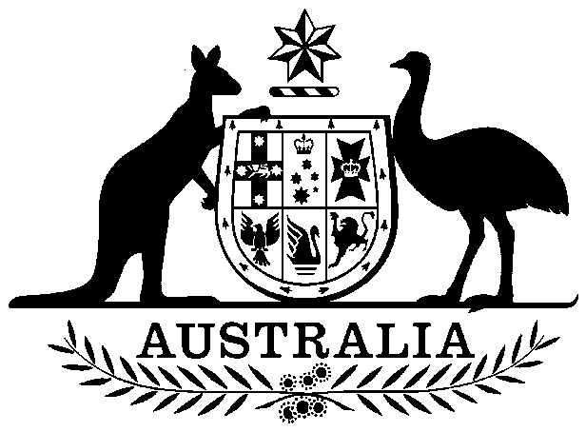

**COMMONWEALTH OF AUSTRALIA**

##### *Environment Protection and Biodiversity Conservation Act 1999*

**Amendment of List of Exempt Native Specimens – New South Wales Marine Vegetation Fishery, April 2024**

I, BELINDA JAGO, Branch Head, Ocean and Wildlife Branch, as Delegate of the Minister for the Environment and Water, pursuant to subsection303DC(1)(a) of the *Environment Protection and Biodiversity Conservation Act 1999* (EPBC Act), hereby amend the list of exempt native specimens established under section 303DB of the EPBC Act by **deleting** from the list specimens and any associated notations specified in **Schedule 1**, and by **including** in the list specimens and associated notations as set out in **Schedule 2**.

This instrument is a legislative instrument for the purposes of the *Legislation Act 2003*.

This instrument commences the day after it is registered.

# Dated this 3rd day of April 2024

………….…Belinda Jago………………

Delegate of the Minister for the Environment and Water

**SCHEDULE 1**

Under the heading Freshwater and Marine Animals delete from the list the following items and any associated notations:

|  |  |  |
| --- | --- | --- |
| **Taxon/Item** | **Common Name** | **Notation** |
| Specimens that are or are derived from marine vegetation taken under permits issued by the NSW Department of Primary Industries in accordance with the *Fisheries Management Act 1994* (NSW), *Marine Estate Management Act*2014 (NSW), Fisheries Management (General) Regulation 2019(NSW)*,* theFisheries Management (Aquaculture) Regulation 2017(NSW) and the Marine Estate Management Regulation 2017 (NSW), but not including:  (a)  specimens that belong to taxa listed under section 209 of the EPBC Act (Australia’s List of Migratory Species), or  (b)  specimens that belong to taxa listed under section 248 of the EPBC Act (Australia’s List of Marine Species), or  (c)  specimens that belong to eligible listed threatened species, as defined under section 303BC of the EPBC Act, or  (d)  specimens that belong to taxa listed under section 303CA of the EPBC Act (Australia’s CITES List). | New South Wales Southern Cross Botanicals Beach-cast Sea Kelp Fishery | * The specimen, or the marine vegetation from which it is derived, was taken lawfully; and * The specimens are included in the list until 7 April 2024. |

**SCHEDULE 2**

Under the heading Freshwater and Marine Animals include in the list the following items and associated notations:

|  |  |  |
| --- | --- | --- |
| **Taxon/Item** | **Common Name** | **Notation** |
| Specimens that are or are derived from marine vegetation taken under permits issued by the NSW Department of Primary Industries in accordance with the *Fisheries Management Act 1994* (NSW), *Marine Estate Management Act*2014 (NSW), Fisheries Management (General) Regulation 2019(NSW)*,* theFisheries Management (Aquaculture) Regulation 2017(NSW) and the Marine Estate Management Regulation 2017 (NSW), but not including:  (a)  specimens that belong to taxa listed under section 209 of the EPBC Act (Australia’s List of Migratory Species), or  (b)  specimens that belong to taxa listed under section 248 of the EPBC Act (Australia’s List of Marine Species), or  (c)  specimens that belong to eligible listed threatened species, as defined under section 303BC of the EPBC Act, or   1. (d)  specimens that belong to taxa listed under section 303CA of the EPBC Act (Australia’s CITES List). | New South Wales Marine Vegetation Fishery | * The specimen, or the marine vegetation from which it is derived, was taken lawfully; and * The specimens are included in the list until 7 April 2027. |