PHILIPPA JILLIAN SPENCE, Director of Aviation Safety, on behalf of CASA, make this instrument under regulations 101.028 and 201.025 of the *Civil Aviation Safety Regulations 1998*.

**[Signed P. Spence]**

Pip Spence  
Director of Aviation Safety

4 April 2024

Part 101 Manual of Standards (Chief Remote Pilot Licence Instructor and Other Matters) Amendment Instrument 2024

1 Name of instrument

This instrument is the *Part 101 Manual of Standards (Chief Remote Pilot Licence Instructor and Other Matters) Amendment Instrument 2024*.

2 Commencement

(1) This instrument commences on the day after it is registered.

(2) However, the amendments in Schedule 2 do not take effect until 10 July 2024.

3 Amendment of the Part 101 Manual of Standards

Schedules 1 and 2 amend the *Part 101 (Unmanned Aircraft and Rockets) Manual of Standards 2019*.

Schedule 1 Amendments — Miscellaneous

[1A] Section 1.03, the Table, column 2, item 1A

omit

10 April 2024

insert

10 July 2024

[1] Subsection 1.04 (2), Definitions

insert

***aerodrome boundary*** means the perimeter of an aerodrome within which is included:

(a) any passenger terminal building and vehicle parking facilities; and

(b) all movement areas; and

(c) all other airside buildings, structures or places to which the public does not have access.

[2] Subsection 1.04 (2), definition of *indoors operation*

omit

RPA *(wherever occurring)*

insert

RPA or model aircraft

[3] Subsection 1.04 (2), definition of *movement area* including the Note

repeal and substitute

***movement area*** has the meaning given in subsection 3.01(2) of the *Part 139 (Aerodromes) Manual of Standards 2019*.

[4] Subsection 1.04 (2), definition of *RPA*

repeal and substitute

***RPA*** has the meaning given in regulation 101.021 of CASR.

[5] Subsection 2.29 (1), the chapeau

omit

An RPA training organisation

insert

A RePL training organisation

[6] Paragraph 2.29 (1) (a)

omit

RPA training organisation

insert

RePL training organisation

[7] Subsection 2.29 (2), the chapeau

omit

An RPA training organisation

insert

A RePL training organisation

[8] Subsection 2.29 (3)

omit

RPA training organisation

insert

RePL training organisation

[9] Paragraph 2.30 (2) (a)

omit

RPA training organisation

insert

RePL training organisation

[10] Paragraph 2.30 (2) (d)

omit

RPA training organisation’s

insert

RePL training organisation’s

[11] Subsection 2.31 (1)

omit

an RPA training organisation

insert

a RePL training organisation

[12] Subsection 4.03 (4)

repeal and substitute

(4) A person may fly a micro RPA in the no-fly zone of a controlled aerodrome PROVIDED the aircraft does not enter:

(a) an approach and departure path described in paragraph (b) of the definition of ***no-fly zone of a controlled aerodrome***; or

(b) any area within the aerodrome boundary.

[13] Subsection 4.03 (7)

repeal and substitute

(6) A person may fly a model aircraft that has a gross weight of no more than 250 g in the no-fly zone of a controlled aerodrome PROVIDED the aircraft does not enter:

(a) an approach and departure path described in paragraph (b) of the definition of ***no-fly zone of a controlled aerodrome***; or

(b) any area within the aerodrome boundary.

[14] Section 4.04, the heading

omit

**and indoors**

[15] Subsections 4.04 (1) and (2)

repeal

[16] Section 4.05, Figure 4.05 (1)-1

repeal and substitute

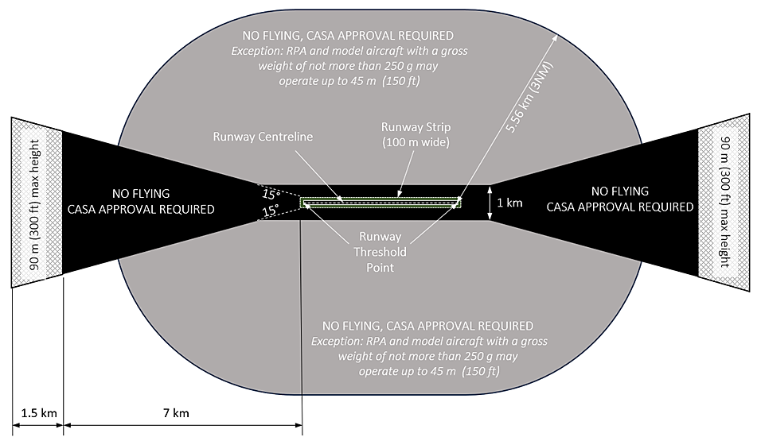

Figure 4.05 (1)-1: Controlled aerodromes — approach and departure paths (shows matters, but shape only illustrates matters)

[17] Subsection 9.01 (1)

omit

an RPA

insert

an RPA or a model aircraft

[18] Section 9.02, paragraph (a) of the definition of *defined unmanned aircraft*

repeal

[19] Section 9.02, definition of RPA

repeal

[20] Subsection 9.03 (1)

omit

an RPA,

insert

an RPA or a model aircraft,

[21] Paragraph 9.03 (2) (c)

repeal and substitute

(c) an operation using a defined unmanned aircraft; or

(d) an operation using a micro RPA.

*Note*   A person must not operate an unmanned aircraft in such a manner as to create an obstruction to an aircraft taking off from, or approaching for landing at, a landing area or a runway of an aerodrome – see subregulation 101.075 (4) of CASR.

[22] Subsection 9.03 (3), including both Notes

repeal and substitute

(3) Despite subsection (1), a person may fly an RPA or model aircraft in relevant airspace during a relevant event, but only if the flight is:

(a) an indoors operation; or

(b) both:

(i) the operation of a micro RPA, or a model aircraft that has a gross weight of not more than 250 g; and

(ii) outside the movement area, and the approach and departure paths referred to in section 9.06; or

(c) an operation using a defined unmanned aircraft.

*Note*   See also regulation 101.075 of CASR for offences in relation to operations near aerodromes.

[23] Section 9.04

omit

If the person

insert

(1) If the person

[24] Section 9.04

omit

RPA *(wherever occurring)*

insert

RPA or model aircraft

[25] After subsection 9.04 (1)

insert

(2) To avoid doubt, this section does not apply to an operation mentioned in subsection 9.03 (2) or (3).

[26] Section 9.05, the heading

omit

**and indoors**

[27] Subsections 9.05 (1) and (2)

repeal

Schedule 2 Amendments — Chief RePL Instructor

[1] Section 1.03

repeal

[2] Subsection 1.04 (2), Definitions

insert

***CRI*** means chief RePL instructor.

***chief RePL instructor*** has the meaning given in section 2.29A.

[3] Subsection 1.04 (2), definition of *examiner* (first occurring)

omit

chief remote pilot (wherever occurring)

*insert*

CRI

[4] Subsection 1.04 (2), definition of *examiner* (second occurring)

omit

chief remote pilot (wherever occurring)

insert

CRI

[5] Subsection 1.04 (2), paragraph (b) of the definition of *nominated personnel*

repeal and substitute

(b) the chief remote pilot (the ***CRP***);

(ba) if the operator is a RePL training organisation — the chief RePL instructor (***CRI***);

[6] Division 2.7, the heading

repeal and substitute

Division 2.7 The CRI and the RePL training instructors

2.29A Chief RePL instructor

(1) For the purpose of conducting a RePL training course for a type of RPA, a RePL training organisation must at all times have a CRI.

(2) A CRI must be a person who:

(a) meets the eligibility requirements of this section; and

(b) is nominated to CASA by the RePL training organisation on the approved form; and

(c) is approved by CASA:

(i) as a fit and proper person to assume the aviation safety duties and responsibilities of a CRI; and

(ii) as having the capacity to undertake the role in all the circumstances; and

(iii) as having met the eligibility requirements under subsection (3).

*Note*   A refusal to approve a nominated person would be subject to review by the Administrative Appeals Tribunal (the ***AAT***) under regulation 201.004 of CASR.

(3) To be eligible to be a CRI, a person must:

(a) hold a RePL for each type of RPA for which the RePL training organisation conducts training that also covers each make and model of the type; and

(b) meet all of the requirements under subsection 2.30 (2) to be a RePL training instructor; and

(c) have 1 or more of the following:

(i) a pilot instructor rating issued under Part 61 of CASR;

(ii) a Certificate IV in Training and Assessment issued by an approved educational institution;

(iii) a tertiary level qualification in teaching that is recognised as such by a State or Territory government;

(iv) other approved qualifications or experience equivalent to the rating, certificate or qualification mentioned in subparagraph (i), (ii) or (iii).

(4) The CRP of a RePL training organisation may be nominated to also be its CRI, but only if the CRP is:

(a) eligible to be the CRI in accordance with subsection (3); and

(b) given the nature and activities of the RePL training organisation — capable of safely combining the duties and responsibilities of a CRP and a CRI; and

(c) approved in writing by CASA to be the CRI.

(5) CASA may suspend or revoke an approval mentioned in paragraph (2) (c) or (4)(c) if CASA is satisfied that the CRI:

(a) has failed to discharge their duties and responsibilities in a manner that preserves, or is likely to preserve, aviation safety; or

(b) has adversely affected, or appears likely to adversely affect, aviation safety because, in all the circumstances, they lack the capacity or the time to safely undertake the role.

*Note*   A refusal to approve a nominated person, or a suspension or revocation of an approval, would be subject to review by the AAT under regulation 201.004 of CASR.

2.29B Duties and responsibilities of a CRI

General obligations

(1) For the purpose of conducting a RePL training course for a type of RPA, a RePL training organisation must ensure that its CRI performs and discharges the duties and responsibilities of a CRI that are mentioned in this MOS, including those mentioned in this section.

(2) The CRI must safely manage the conduct of each RePL training course of the organisation.

RePL training courses

(3) The CRI must ensure that each RePL training course is conducted in a professional and systematic manner, in accordance with principles of competency-based training that are set out in detail in the organisation’s documented practices and procedures.

(4) The CRI must ensure that the organisation complies with all aspects of the civil aviation legislation that relate to the conduct of each RePL training course, in particular Part 101 of CASR and the Part 101 MOS.

*Note*   See also the wide definition of ***civil aviation legislation*** in subsection 1.04 (2) and section 3 of the *Civil Aviation Act 1988*.

(5) The CRI must regularly report to the CEO and the CRP on the discharge of the duty under subsection (4).

(6) The CRI must ensure that the organisation’s documented practices and procedures for each RePL training course are so designed that the course will result in competent and effective training of each applicant doing the course.

(7) The CRI must ensure that sufficient numbers of RePL training instructors, and RPA that are appropriate for the training course, are deployed and allocated to allow for competent and effective training of each applicant in each RePL training course.

*Note*   An RPA is not appropriate for a particular training course if, for example, it is not capable of performing and enduring the manoeuvres required by the relevant practical competencies under this MOS.

(8) The CRI must set, monitor and maintain the organisation’s standards for its RePL training courses, in accordance with the organisation’s documented practices and procedures.

(9) The CRI must establish, implement and manage the organisation’s procedures to identify and rectify deficiencies in RePL training course training outcomes.

RePL training instructors

(10) The CRI must ensure that each RePL training instructor is provided with the training, information and documentation required to deliver competent and effective training in each RePL training course.

(11) The CRI must ensure that each RePL training instructor is initially assessed, and subsequently regularly assessed, in accordance with the organisation’s documented practices and procedures, to determine that they are competent to commence, and continue, to conduct the training or examining assigned to them.

(12) The CRI must ensure that RePL training instructors remain competent to perform their duties, and that any competency refresher training that may be required is appropriate for its purpose.

2.29C Transitional provisions for chief remote pilots only

(1) Despite subsections 2.29A (2) and (3), a person is deemed to be the CRI of a RePL training organisation if, on 10 July 2024, the person is the chief remote pilot of the organisation.

*Note*   The person must be the organisation’s actual chief remote pilot approved by CASA.

(2) On and from 10 January 2025, a person deemed under subsection (1) to be the CRI of a RePL training organisation must have the applicable qualifications mentioned in subsection 2.29A (3).

(3) On 10 January 2025, a deemed CRI who does not satisfy the requirements of subsection 2.29A (3) is no longer deemed to be the CRI.

*Note*   The CRI must not act as a RePL training instructor unless they satisfy the requirements of section 2.30.

[7] Paragraph 2.30 (2) (c)

repeal

[8] Subsection 2.30A (2)

omit

chief remote pilot (wherever occurring)

insert

CRI

[9] After subsection 10.03 (2)

insert

(2A) A certified RPA operator must ensure that the CRI keeps records to show that the CRI is regularly and professionally performing their duties, and discharging their responsibilities, under section 2.29B.

[10] Subsection 10.03A (1)

omit

chief remote pilot

insert

CRI

[11] After section 10.17 (5)

insert

(6) This section does not apply if the change in the information given to CASA is only:

(a) the deeming, under section 2.29C, of the operator’s chief remote pilot to be the operator’s CRI; or

(b) an editorial change to the documented practices and procedures that is solely and directly consequential on such deeming.

(7) Subsection (6) ceases to have effect on 10 January 2025.

*Note*   On and from 10 January 2025, section 10.17 resumes full effect, and the operator must have updated documented practices and procedures.

[12] Paragraph 10.17 (3) (d)

repeal and substitute

(d) the identity of the chief remote pilot;

(da) if the certified RPA operator is a RePL training organisation — the identity of the CRI;

[13] After section 10A.03

insert

10A.04 Deemed CRI is not a significant change

(1) Despite section 10A.01, the operation of section 2.29C to deem the chief remote pilot of a RePL training organisation to be the organisation’s CRI (the ***deemed CRI***) does not constitute a significant change for the purposes of the following provisions in the definition of ***significant change***:

(a) subparagraphs (a) (i) to (iv) and (vi);

(b) paragraph (b).

*Note*   ***Significant change*** is defined in subsection 1.04 (2).

(2) Subsection (1) does not apply if the deemed CRI ceases to be eligible to be deemed under section 2.29C.