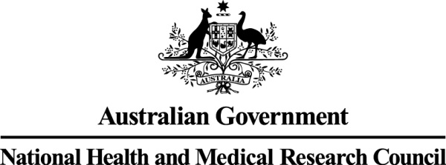

**COMMONWEALTH OF AUSTRALIA**

**Guidelines issued under Section 95(1) of the *Privacy Act 1988* (Cth)**

I, PRUE ALISON TORRANCE, Chief Executive Officer (A/g) of the National Health and Medical Research Council, with responsibility for issuing guidelines under the *Privacy Act 1988* (Cth)for the protection of privacy by agencies in the conduct of medical research, under section 95(1) of that Act, HEREBY;

* revoke the *Guidelines under Section 95(1) of the Privacy Act 1988* (Cth)*, 2014*

and

* issue the *Guidelines under Section 95(1) of the Privacy Act 1988* (Cth)*, 2014 (updated 2024)*

These guidelines take effect on the date of this instrument.

Dated this 21st day of March 2024.

[signed]

Prue Torrance  
Chief Executive Officer (A/g)