Federal Circuit and Family Court of Australia (Family Law) Amendment (2024 Measures No. 1) Rules 2024
We, Judges of the Federal Circuit and Family Court of Australia (Division 1), make the following Rules of Court.
Dated 2 May 2024
Alstergren CJ
McClelland DCJ
Aldridge J
Austin J
Bennett J
Berman J
Gill J
Baumann J
Henderson J
Williams J
Wilson J
Harper J
Hartnett J
Altobelli J
Howard J
McGuire J
Campton J
Jarrett J
Christie J
Schonell J
Strum J
McNab J
Smith J
Brasch J
Carter J

Judges of the Federal Circuit and Family Court of Australia (Division 1)

Contents
1 Name 1
2 Commencement 1
3 Authority 1
4 Schedules 1
Schedule 1—Amendments 2
Federal Circuit and Family Court of Australia (Family Law) Rules 2021 2

1 Name
These Rules are the Federal Circuit and Family Court of Australia (Family Law) Amendment (2024 Measures No. 1) Rules 2024.

2 Commencement
(1) Each provision of these Rules specified in column 1 of the table commences, or is taken to have commenced, in accordance with column 2 of the table. Any other statement in column 2 has effect according to its terms.

Commencement information
Column 1 | Column 2 | Column 3
Provisions | Commencement | Date/Details
1. The whole of these Rules | 6 May 2024. | 6 May 2024
Note: This table relates only to the provisions of these Rules as originally made. It will not be amended to deal with any later amendments of these Rules.
(2) Any information in column 3 of the table is not part of these Rules. Information may be inserted in this column, or information in it may be edited, in any published version of these Rules.

3 Authority
These Rules are made under Chapter 3 of the Federal Circuit and Family Court of Australia Act 2021.

4 Schedules
Each instrument that is specified in a Schedule to these Rules is amended or repealed as set out in the applicable items in the Schedule concerned, and any other item in a Schedule to these Rules has effect according to its terms.

Schedule 1—Amendments

Federal Circuit and Family Court of Australia (Family Law) Rules 2021
1 Subrule 1.05(1) (definition of child welfare record)
Omit “Schedule 9 to”, substitute “regulation 12CBA of”.
2 Subrule 1.05(1) (definition of conciliation)
Repeal the definition.
3 Subrule 1.05(1)
Insert:
conciliation conference means a dispute resolution process in which a judicial officer or an impartial third person assists the parties to the dispute to reach an agreement in the dispute.
4 Subrule 1.05(1) (definition of dispute resolution)
Omit “, includes”, substitute “includes”.
5 Subrule 1.05(1)
Insert:
harmful proceedings order has the meaning given by subsection 102QAC(1) of the Family Law Act.
6 Rule 1.06 (Table 1.1, table item 1, column headed “Power”, subparagraph (a)(ii))
Before “conference”, insert “conciliation”.
7 Rule 1.33
Repeal the rule, substitute:

1.33 Failure to comply with specified time limit
If a step is taken after the time specified for taking the step by these Rules, the Family Law Regulations or a procedural order, the step is of no effect.
8 Rule 1.34 (heading)
Repeal the heading, substitute:

1.34 Application to allow step after specified time limit
9 Subrule 1.34(1)
Repeal the subrule, substitute:
(1) A party may apply for relief from the effect of rule 1.33.
10 Paragraph 1.34(2)(h)
Omit “if the application is for relief from the effect of subrule 1.33(1)—”.
11 At the end of subrule 2.01(3)
Add:
; or (c) the application is permitted by rule 5.02.
12 Subrule 2.01(6) (Table 2.1, after table item 2)
Insert:
2A | Application to vary or set aside a final order under paragraph 10.13(1)(b) | Initiating Application (Family Law)

13 Subrule 2.01(6) (Table 2.1, table item 4, column headed “Kind of application”)
Omit “or parenting order”.
14 At the end of rule 2.16
Add:
(3) When written notice of the change of name is filed, the title of the proceeding is taken to have been amended accordingly.
15 Subrule 2.18(2) (note 3)
Omit “1.33(2)(d)”, substitute “10.27(1)(d)”.
16 Subrules 2.23(3) and (4)
Repeal the subrules, substitute:
(3) A document is filed when:
(a) the document is accepted for filing by the Registry Manager by affixing the seal of the court or a court stamp, as required by Part 15.1; or
(b) a judicial officer orders, or directs, that the document be taken to have been filed.
(4) A document that is accepted for filing by the Registry Manager under paragraph (3)(a) is taken to have been filed:
(a) if the document is received by 4.30 pm by legal time in the location of the filing registry on a business day—on that day; or
(b) in any other case—on the next business day for the filing registry.
17 Subrule 2.23(6) (note)
Omit “Family Law (Fees) Regulation 2012”, substitute “Family Law (Fees) Regulations 2022”.
18 Paragraph 3.10(1)(b)
Omit “court’s permission”, substitute “leave of the court”.
19 After subrule 3.10(1)
Insert:
(1A) A lawyer must not file a Notice under subrule (1) within 14 days before the day fixed for a final hearing except with the leave of the court, which must be sought in writing.
20 Rule 3.11 (at the end of note 1)
Add “and section 68LA of that Act sets out the role of an independent children’s lawyer”.
21 Rule 4.05
Repeal the rule, substitute:

4.05 Dispute resolution events
Court may require attendance at dispute resolution events
(1) In the exercise of its general powers of case management to achieve the overarching purpose of these Rules, the court may order a party to attend:
(a) a family consultant; or
(b) family counselling or family dispute resolution; or
(c) another dispute resolution event as permitted by the Family Law Act.
Judicial officers may conduct dispute resolution events
(2) A dispute resolution event may be conducted by a judicial officer.
22 Subrule 4.11(3) (note 2)
Omit “1.33”, substitute “10.27”.
23 Paragraph 5.02(2)(c)
Repeal the paragraph, substitute:
(c) to vary or set aside an order under rule 10.13 (other than a final order under paragraph 10.13(1)(b)); or
(d) an order for costs.
24 Rule 5.27 (note)
Repeal the note, substitute:
Note: All published judgments in family law proceedings are anonymised in accordance with the requirements of section 114Q of the Family Law Act.
25 At the end of paragraph 8.11(5)(a)
Add:
(vi) a member of the police force of a State or Territory;
26 Rule 8.12
Repeal the rule, substitute:

8.12 Report after dispute resolution
(1) At the end of court-ordered dispute resolution, the dispute resolution practitioner who conducted the dispute resolution must prepare a report, in the approved form, as to:
(a) whether an agreement was reached on an interim or final basis; and
(b) the conduct of the parties, in terms of whether the parties attended the dispute resolution and whether they made a genuine effort to resolve the issues in dispute.
(2) If the dispute resolution practitioner is a judicial officer, the judicial officer must place the report on the court file.
(3) If the dispute resolution practitioner is not a judicial officer:
(a) the practitioner must give the report to the applicant; and
(b) the applicant must file and serve the report.
(4) This rule does not apply to a dispute resolution event conducted by a Judge.
27 At the end of rule 10.13
Add:
(3) An application to vary or set aside a final order under paragraph (1)(b) must be made by filing an Initiating Application (Family Law).
28 Rule 10.24 (at the end of the heading)
Add “—vexatious proceedings orders and harmful proceedings orders”.
29 Before subrule 10.24(1)
Insert:
Vexatious proceedings orders
30 Paragraph 10.24(2)(b)
Repeal the paragraph, substitute:
(b) do the following:
(i) order the person to serve the application and affidavit;
(ii) order the person to file and serve any further affidavits in support of the application;
(iii) list the application for hearing.
31 At the end of rule 10.24
Add:
Harmful proceedings orders
(3) An application under subsection 102QAE(2) of the Family Law Act for leave to institute a proceeding that is subject to a harmful proceedings order:
(a) must be made in accordance with the approved form supported by an affidavit; and
(b) must not be served on a person unless the application for leave is granted, and an order is made, under section 102QAG of the Family Law Act.
Note 1: See subsection 102QAC(7) of the Family Law Act for the requirement for the court to make an order as to whether the other party is to be notified by the court:
(a) if a party who is the subject of a harmful proceedings order makes an application for leave under section 102QAE of the Family Law Act; or
(b) if the application is dismissed—that the application has been dismissed.
Note 2: See subsection 102QAE(2) of the Family Law Act for the power for a person who is subject to a harmful proceedings order to apply to the court to institute a proceeding.
Note 3: See subsection 102QAE(3) of the Family Law Act for the contents of the affidavit that must be filed with the application.
(4) On the first court date for the application, the court may:
(a) dismiss the application; or
(b) do the following:
(i) order the person to file and serve any further affidavits in support of the application;
(ii) list the application for hearing; or
(c) hear the application and, if leave is granted, order the person to file and serve the application and affidavit on the other party.
Note: An order made under subsection 102QAC(7) of the Family Law Act may require the court to notify the other party that the application has been dismissed.
(5) The court may dismiss the application in chambers without an oral hearing with or without the consent of the applicant.
Note: See subsections 102QAF(3) and (4) of the Family Law Act for the power of the court to dismiss the application in chambers without an oral hearing (either with or without the consent of the applicant).
32 Paragraphs 10.26(1)(d) and (2)(f)
Omit “Rules;”, substitute “Rules or the Family Law Regulations;”.
33 Subrules 10.27(1) and (2)
Repeal the subrules, substitute:
(1) If a party is in default, the court may do any of the following:
(a) order that the proceeding be stayed or dismissed as to the whole or any part of the relief claimed by the party;
(b) set aside a step taken or an order made;
(c) order that a step in the proceeding be taken within the time limited in the order;
(d) order costs;
(e) prohibit the party from taking a further step in the proceeding until the occurrence of a specified event;
(f) make any order that is to take effect if the party does not take a step ordered by the court in the proceeding in the time limited in the order;
(g) proceed on the non-defaulting party’s evidence together with:
(i) if considered appropriate by the court—such evidence as the defaulting party has filed; and
(ii) such evidence as tendered during cross-examination by the defaulting party; and
(iii) submissions by either party limited to the matters that are the subject of evidence;
(h) in exceptional circumstances—proceed on the non-defaulting party’s evidence without hearing from the defaulting party.
34 Subrule 10.27(3)
Omit “(3)”, substitute “(2)”.
35 Subrule 10.27(3)
Omit “or (2)”.
36 Chapter 11
Omit:
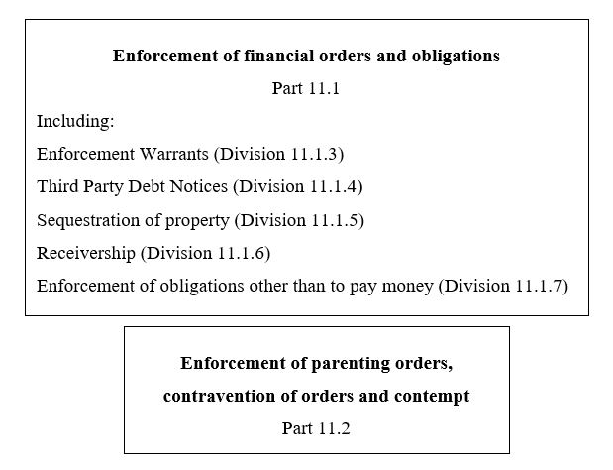
substitute:
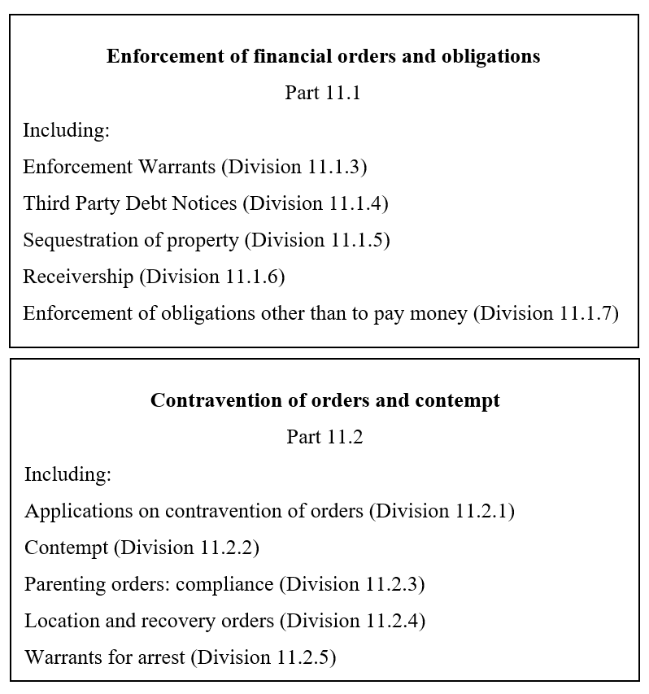
37 Part 11.2 (heading)
Omit “Enforcement of parenting orders, contravention”, substitute “Contravention”.
38 Division 11.2.1 (heading)
Omit “for enforcement of orders and”.
39 Rule 11.63 (not including the notes)
Repeal the rule, substitute:

11.63 Application of Division 11.2.1
This Division applies to an application for an order under the following:
(a) section 67X of the Family Law Act;
(b) Division 13A of Part VII of that Act;
(c) Part XIIIA of that Act.
40 Rule 11.63 (subparagraph (a)(i) of note 2)
Omit “70NFB(4)”, substitute “70NCE(1)”.
41 Rule 11.63 (subparagraph (a)(ii) of note 2)
Omit “70NFG(2)”, substitute “70NBF(4)”.
42 Subrule 11.64(1) (Table 11.1, table heading)
Omit “for enforcement of orders and”.
43 Subrule 11.64(1) (Table 11.1, table item 1)
Repeal the item.
44 Subrule 11.64(1) (Table 11.1, table item 3, column headed “Kind of application”)
Omit “Contravention of an order under this Act affecting children (as defined by section 4”, substitute “Contravention of a child-related order (within the meaning of subsection 70NBA(2)”.
45 Subrule 11.64(1) (example)
Repeal the example.
46 Paragraph 11.64(2)(b)
Omit “for an application referred to in item 1 of Table 11.1—”.
47 Paragraph 11.64(2)(b)
Omit “that the court is asked to enforce or”.
48 Subrule 11.64(2) (example)
Omit “70NFA(2)(b)”, substitute “70NBF(3)(b)”.
49 Rule 11.67
Omit “item 2, 3, 4 or 5 of”.
50 Paragraph 11.68(b)
Omit “for a respondent to an application referred to in item 2, 3, 4 or 5 of Table 11.1—”.
51 Rule 11.69
Omit “item 2, 3, 4 or 5 in”.
52 Rule 11.69 (note)
Omit “70NCB, 70NDB, 70NDC, 70NEB, 70NFB, 70NFF, 112AD,”, substitute “70NBB, 70NBC, 70NBD, 70NBF, 70NCA, 70NCB, 112AD, 112AE, 112AF, 112AG,”.
53 Subrule 11.71(4)
Omit “make”, substitute “consider making”.
54 Subrule 11.72(1)
Omit “under section 70NED”, substitute “under subsection 70NBD(3)”.
55 Subrule 11.72(1) (note)
Omit “Section 70NED”, substitute “Subsection 70NBD(3)”.
56 Subrule 11.72(1) (paragraphs (a) and (b) of the note)
Omit “paragraph 70NEB(1)(a)”, substitute “subsection 70NBD(1)”.
57 Rule 11.73
Omit “section 70NEG”, substitute “subsection 70NBD(4)”.
58 Subparagraph 11.79(1)(a)(iii)
Omit “item 2, 3, 4 or 5 of”.
59 Rule 11.81
Omit “subsection 65Q(2)”, substitute “section 70NDA”.
60 Paragraph 11.82(5)(a)
Omit “subsection 65Q(2)”, substitute “section 70NDA”.
61 Subrule 11.82(6) (definition of holding period)
Omit “65S(4)”, substitute “70PB(4)”.
62 Subrule 13.02(1) (note 2)
Omit “(see rule 2.23(3)(a))”.
63 Rule 15.13 (note 1)
Repeal the note, substitute:
Note 1: Sections 114Q and 114R of the Family Law Act restrict the publication of court proceedings. Section 114S of the Family Law Act sets out when a communication is not a communication to the public.
64 Subrule 15.19(2)
Omit “or (2)”.
65 Subrule 15.23(1) (note)
Repeal the note, substitute:
Note: Sections 114Q and 114R of the Family Law Act restrict the publication of information relating to proceedings. Section 114S of the Family Law Act sets out when a communication is not a communication to the public.
66 Subrule 15.24(1) (note)
Repeal the note, substitute:
Note: A person commits an indictable offence if the person communicates to the public a list of proceedings that refers to the names of parties (see section 114R of the Family Law Act).
67 Paragraph 1(5)(b) of Part 1 of Schedule 1
Repeal the paragraph, substitute:
(b) the developmental, psychological, emotional and cultural needs of the child, the capacity of each person who is proposed to have parental responsibility for the child to provide for those needs, and the benefit to the child of being able to have a relationship with people who are significant to them, where it is safe to do so;
68 Subclause 2(3) of Part 1 of Schedule 1
Omit “subrule 1.33(2)”, substitute “rule 10.27”.
69 Paragraph 1(5)(b) of Part 2 of Schedule 1
Repeal the paragraph, substitute:
(b) the developmental, psychological, emotional and cultural needs of the child, the capacity of each person who is proposed to have parental responsibility for the child to provide for those needs, and the benefit to the child of being able to have a relationship with people who are significant to them, where it is safe to do so;
70 Subclause 2(3) of Part 2 of Schedule 1
Omit “subrule 1.33(2)”, substitute “rule 10.27”.
71 Clause 2 of Schedule 4 (after table item 3.8)
Insert:

3.9 | Section 65DAAA FLA | To reconsider a final parenting order | but only if:  (a) a Senior Judicial Registrar is approved by the Chief Justice or CEO (subject to any directions of the Chief Justice) to exercise the power; or  (b) the order is made with the agreement or consent of all of the parties to the final parenting order

72 Clause 2 of Schedule 4 (table item 10.1, column 1)
Omit “paragraph 70NFB(2)(e)”, substitute “subparagraph 70NBF(1)(d)(ii) and section 70NCD”.
73 Clause 2 of Schedule 4 (table item 10.2)
Repeal the item, substitute:
10.2 | Section 70NBC FLA  but only if:  (a) the order to be varied or suspended was made by a Senior Judicial Registrar or Judicial Registrar; or  (b) the order to be varied or suspended is an order until further order; or  (c) the order to suspend or vary is made in undefended proceedings; or  (d) the power is exercised with the consent of all the parties to the proceedings | To vary or suspend a child-related order that is a parenting order

74 Clause 2 of Schedule 4 (table item 14.7)
Repeal the item, substitute:
14.7 | Rule 10.27 FCFCOA Rules | To make orders to stay or dismiss as to the whole or any part of the relief claimed, to order costs and to make other necessary orders if a party is in default

75 Clause 2 of Schedule 4 (table item 14.8, column 2)
Omit “subrule 1.33(1)”, substitute “rule 1.33”.
76 Clause 2 of Schedule 4 (after table item 19.3)
Insert:
19.4 | Subsection 68LA(5D) FLA | To determine whether exceptional circumstances exist that justify an independent children’s lawyer not performing a duty and to make an order requiring the independent children’s lawyer to perform a duty |  | but only if the final order is to be made by a Judicial Registrar

77 Clause 2 of Schedule 4 (table item 24.1)
Repeal the item, substitute:
24.1 | Subdivision DA of Division 8 of Part VII FLA | To make orders for information etc. in child-related proceedings

78 Clause 2 of Schedule 4 (table item 31.1, column 1)
Omit “45A”, substitute “102QAB”.
79 Clause 2 of Schedule 4 (table item 32.1)
Repeal the item, substitute:
32.1 | Paragraphs 10.13(1)(a), (b), (c), (d) and (f) FCFCOA Rules | Powers to make orders varying or setting aside an order if:  (a) the order was made in the absence of a party; or  (b) the order was obtained by fraud; or  (c) the order is interlocutory; or  (d) the order is an injunction or for the appointment of a receiver; or  (e) the party in whose favour the order was made consents

80 Clause 2 of Schedule 4 (table item 33.1, column 2)
Omit “1 year”, substitute “6 months”.
81 Clause 2 of Schedule 4 (at the end of the table)
Add:
Part 41—Communication of details of family law proceedings
41.1 | Subsection 114Q(2) and subparagraph 114R(2)(b)(i) FLA | To give a direction about, or approve, a communication to the public of an account of proceedings or a list of proceedings

