Torres Strait Prawn Fishery (Bycatch Reduction Devices) Instrument 2024
The Protected Zone Joint Authority make the following determination.

Dated 29/05/2024

Senator the Hon Murray Watt
Minister for Agriculture, Fisheries and Forestry
Minister for Emergency Management
Chair of the Protected Zone Joint Authority
For and on behalf of the Protected Zone Joint Authority

Contents
1 Name 1
2 Commencement 1
3 Authority 1
4 Definitions 1
5 Prohibition on fishing 1
6 Exemption to Prohibition on fishing 1
7 Schedules 2
Schedule 1— Bycatch reduction devices 3
Schedule 2—Repeals 7
Torres Strait Fisheries Management Notice No. 82 7

1 Name
This instrument is the Torres Strait Prawn Fishery (Bycatch Reduction Devices) Instrument 2024.

2 Commencement
This instrument commences on the day after it is registered on the Federal Register of Legislation.

3 Authority
This instrument is made under paragraph 16(1)(c) of the Act.

4 Definitions

Note: A number of expressions used in this instrument are defined in section 3 of the Act and section 1.3 of the Plan including the following:
- prawns;
- bycatch reduction device or BRD;
- try net;
- turtle excluder device or TED.

In this instrument:
Act means the Torres Strait Fisheries Act 1984;
Plan means the Torres Strait Prawn Fishery Management Plan 2009.
Net rigged for fishing means where part or all of a net is in the water, or if it is shackled, tied or otherwise connected to any trawl door or trawl board, or to any tow rope or cable, either on board the boat or attached in any manner to the boat.

5 Prohibition on fishing

Pursuant to paragraph 16(1)(c) of the Act, engaging in taking, processing or carrying of fish by a method, or with the use of equipment or a boat, is prohibited in the area of the Torres Strait Prawn Fishery unless a Bycatch Reduction Device specified in Schedule 1 is installed in each of the concession holder’s net rigged for fishing.

6 Exemption to Prohibition on fishing

A try net is exempt from the prohibition in section 5 of this instrument.

7 Schedules
Each instrument that is specified in Schedule 2 to this instrument is amended or repealed as set out in the applicable items in the Schedule concerned, and any other item in a Schedule to this instrument has effect according to its terms.

Schedule 1— Bycatch reduction devices
Each of the following are bycatch reduction devices:

Fisheye
  - An opening, commonly known as a fisheye, in a net is a recognised Bycatch Reduction Device if the opening complies with this section.
  - The opening must be—
  - held open by a rigid frame that consists of—
    - a semicircular-shaped frame; and
    - an isosceles triangle-shaped frame; and
  - no more than 66 meshes from the codend drawstrings of the net.
  - The rigid frame must be installed so that the apex of the equal sides of the isosceles triangle-shaped frame point towards the opening of the net.
  - The semicircular-shaped frame must be—
- at least—
    - 350mm wide; and
    - 150mm high; and
- divided in half by a rigid bar; and
- attached, by a rigid bar—
- from the midpoint of the semicircular-shaped part of the frame; and
- to the apex of the equal sides of the isosceles triangle-shaped frame.
  - The shortest side of the isosceles triangle-shaped frame must be—
- equal to the width of the semicircular-shaped frame; and
- attached, perpendicularly, to the widest part of the semicircular-shaped frame.
  - During trawling, nothing must cover any part of the opening.

Bigeye
- An opening, commonly known as a bigeye, in a net is a recognised BRD if the opening complies with this section.
- The opening must be—
- in the top of the net; and
- at least 350mm across the width of the net; and
- no more than 66 meshes from the codend drawstrings of the net.
- The edges of the opening must not overlap by more than 200mm.
- During trawling—
- the part of the opening closest to the mouth of the net must be weighted by an approved chain or 300g of other weights; and
- the part of the opening closest to the codend drawstrings of the net must be buoyed by at least 2 floats, each of which is at least—
- 90mm wide; and
- 50mm in diameter; and
- nothing must cover any part of the opening.
- In this section—
approved chain means a chain that—
- weighs at least 300g; and
- contains at least the following number of links—
- for a chain with links 4mm in diameter—42;
- for a chain with links 6mm in diameter—12;
- for a chain with links 8mm in diameter—6;
- for a chain with links 10mm in diameter—3.

Tom’s Fisheye

Tom’s Fisheye, an escape opening device installed in a net rigged for fishing to the following
specification:
- one device with the aft edge of the device located at 60 meshes from the codend drawstrings; and
- a vertical escape opening held open by a rigid frame that supports a rigid enclosed cone; and
- an escape opening measuring no less than 360 mm wide by 200 mm high and must face the codend; and
- a rigid cone measuring no less than 340 mm wide by 185 mm high by 290 mm in length fixed to the rigid frame; and
- with an escape gap between the rigid frame and rigid cone of 94 mm; and
- with an escape gap clear of any obstructions (including mesh ties).

Kon’s Covered Fisheyes

Kon’s Covered Fisheyes, two escape opening devices installed in a net rigged for fishing to the following specification:
- one escape opening device with the aft edge of the device located at 78 meshes from the codend drawstrings; and
- one escape opening device with the aft edge of the device located at 55 meshes from the codend drawstrings; and
- for which each escape opening device has the following characteristics prior to being installed in a net rigged for fishing:
- vertical escape opening held open by a rigid frame that encloses a rigid cone; and
- an escape opening measuring no less than 430 mm wide by 205 mm high and must face the codend; and
- a rigid cone measuring no less than 295 mm wide by 145 mm high by 275 mm in length fixed to the rigid frame; and
- with an escape gap between the rigid frame and the rigid cone of 55 mm.

FishEX 70

FishEX 70, an escape opening device installed in a net rigged for fishing to the following
specification:
- one device with the aft edge of the device located at 65 meshes from the codend drawstrings; and
- with an escape gap clear of any obstructions (including mesh ties); and
- for which the escape opening device has the characteristics detailed in Figure 1 prior to being installed in a net rigged for fishing.

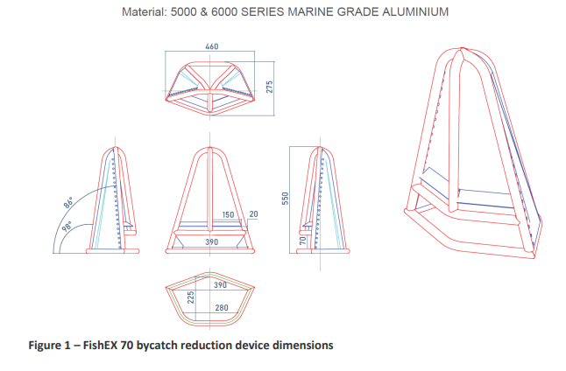

Popeye Fishbox

The Popeye Fishbox is an escape opening device installed in a net rigged for fishing to
the following specification:
- one device with the aft edge of the device located no further forward than 70 meshes, from the codend drawstrings; and
- a vertical escape opening held open by a rigid frame; and
- an escape opening measuring no less than 375 mm wide x 375 mm high; and
- a rigid foil positioned at the forward edge of the Bycatch Reduction Device no less than 200 mm in depth; and
- no pieces of netting or other material covering any escape openings, nor any opening closed by any other means, during fishing operations

Schedule 2—Repeals

Torres Strait Fisheries Management Notice No. 82
1 The whole of the instrument
Repeal the instrument

