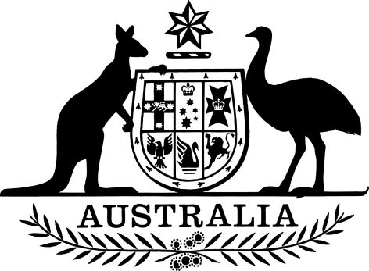

PB 48 of 2024

National Health (Application Fees for Pharmacist Approvals) Amendment Determination 2024
I, Mark Butler, Minister for Health and Aged Care, make the following determination.
Dated 24 May 2024
Mark Butler
Minister for Health and Aged Care

Contents
1 Name 1
2 Commencement 1
3 Authority 1
4 Schedules 1
Schedule 1—Amendments 2
National Health (Application Fees for Pharmacist Approvals) Determination 2020 2

1 Name
- This instrument is the National Health (Application Fees for Pharmacist Approvals) Amendment Determination 2024.
- This instrument may also be cited as PB 48 of 2024.

2 Commencement
- Each provision of this instrument specified in column 1 of the table commences, or is taken to have commenced, in accordance with column 2 of the table. Any other statement in column 2 has effect according to its terms.

Commencement information
Column 1 | Column 2 | Column 3
Provisions | Commencement | Date/Details
1. The whole of this instrument | 1 July 2024. | 1 July 2024
Note: This table relates only to the provisions of this instrument as originally made. It will not be amended to deal with any later amendments of this instrument.
(2) Any information in column 3 of the table is not part of this instrument. Information may be inserted in this column, or information in it may be edited, in any published version of this instrument.

3 Authority
This instrument is made under subsection 90(10) of the National Health Act 1953.

4 Schedules
Each instrument that is specified in a Schedule to this instrument is amended or repealed as set out in the applicable items in the Schedule concerned, and any other item in a Schedule to this instrument has effect according to its terms.

Schedule 1—Amendments

National Health (Application Fees for Pharmacist Approvals) Determination 2020
1 Paragraph 4(b)
Omit “$600”, substitute “$555”.

