

Native Title (Recognition as Representative Body – Central Land Council) Instrument 2024

I, Linda Burney MP, Minister for Indigenous Australians, make the following instrument.

Dated 12 June 2024

LINDA BURNEY MP

Minister for Indigenous Australians

Contents

1 Name 1

2 Commencement 1

3 Authority 1

4 Definitions 1

5 Schedules 1

6 Recognised Representative Aboriginal/Torres Strait Islander Body 2

7 Period of recognition 2

Schedule 1—Description of area (Southern Northern Territory) 3

Description of area 3

Map of area 4

Schedule 2— Repeals 5

Native Title (Recognition as Representative Body – Central Land Council) Instrument 2018 5

1 Name

This instrument is the *Native Title (Recognition as Representative Body – Central Land Council) Instrument 2024.*

2 Commencement

      (1)  Each provision of this instrument specified in column 1 of the table commences, or is taken to have commenced, in accordance with column 2 of the table. Any other statement in column 2 has effect according to its terms.

| **Commencement information** | | |
| --- | --- | --- |
| **Column 1** | **Column 2** | **Column 3** |
| **Provisions** | **Commencement** | **Date/Details** |
| 1.  The whole of this instrument | 1 July 2024 |  |

Note:          This table relates only to the provisions of this instrument as originally made. It will not be amended to deal with any later amendments of this instrument.

             (2)  Any information in column 3 of the table is not part of this instrument. Information may be inserted in this column, or information in it may be edited, in any published version of this instrument.

3 Authority

This instrument is made under subsection 203AD(1) of the *Native Title Act 1993*.

4 Definitions

 In this instrument:

***Act*** means the *Native Title Act 1993.*

***Representative Body***means a representative Aboriginal/Torres Strait Islander body recognised under section 203AD of the Act.

***Central Land Council***means the *Central Land Council* as established under section 21 of the *Aboriginal Land Rights (Northern Territory) Act 1976*.

5 Schedules

Each instrument that is specified in a Schedule to this instrument is amended or repealed as set out in the applicable items in the Schedule concerned, and any other item in a Schedule to this instrument has effect according to its terms.

**6  Recognised Representative Aboriginal/Torres Strait Islander Body**

                   For subsection 203AD(1) of the Act, the Central Land Council is recognised as the Representative Body for the area described in Schedule 1.

**7  Period of recognition**

                   For subsection 203AD(2) of the Act, this recognition as a Representative Body takes effect on 1 July 2024 and ceases to have effect at the end of 30 June 2030.

Schedule 1—Description of area (Southern Northern Territory)

**1**The Southern Northern Territory area is the area of land bounded by a line commencing at the intersection of the Northern Territory border and the South Australia and Western Australia State borders, and then proceeding north along the western boundary of the Northern Territory border to its intersection with the Central Land Council boundary line, vide *Aboriginal Land Rights (Northern Territory) Act 1976*, published in the Australian Government Gazette No.  S6, 26 January 1977, as amended by notice published in the Australian Government Gazette No.  G34, 30 August 1977, then generally south-easterly along the aforesaid boundary to its intersection with the eastern boundary of the Northern Territory border, then south along the eastern border of the Northern Territory to the intersection of the Northern Territory border and the South Australia and Queensland State borders, and then generally west along the southern boundary of the Northern Territory to the point where the line began.

Southern Northern Territory

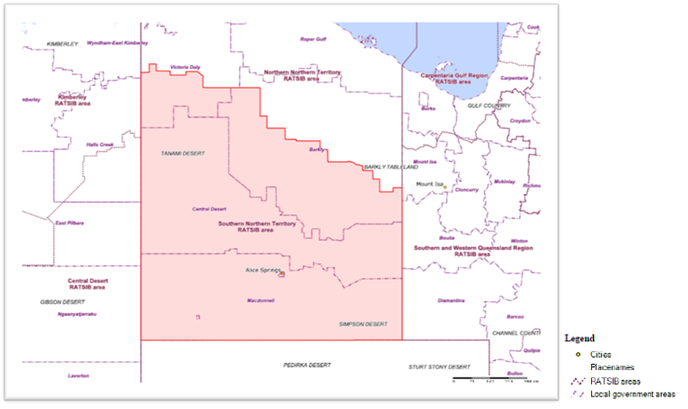

Alt text: Map and Legend showing description of Southern Northern Territory area

Schedule 2—Repeals

Native Title (Recognition as Representative Body – Central Land Council) Instrument 2018

1 The whole of the instrument

Repeal the instrument.