EXPLANATORY STATEMENT

Issued by authority of the Assistant Minister for Defence

Defence Regulation 2016

The instrument is made under subsection 58(1) of the *Defence Regulation 2016* (the Regulation). The instrument commences on the day after its registration on the Federal Register of Legislation and is a legislative instrument for the purposes of the *Legislation Act 2003* (the Legislation Act).

Purpose

Cultana is an area in South Australia, west of Adelaide and south of Port Augusta. The Commonwealth uses the area for the Australian Defence Force to conduct training exercises and weapons testing, safely in the area.

The purpose of the instrument is to update the defence area declared to be the Cultana Training Area. Parts of the Cultana Training Area have been divested to the South Australian Government, through the agency Renewal SA. As such, it is no longer appropriate for the land to be part of a declared defence area.

A defence area is an area of land, sea or airspace, in or adjacent to Australia, declared for use for a defence purpose. Subsection 58(1) of the Regulation empowers the Minister to declare such areas of land, sea or airspace.

Background

The instrument declares the Cultana Training Area, which was previously declared a ***Defence practice area*** under subsection 49(1) of the *Defence Force Regulations 1952* (Defence Force Regulations). Part 1 of Schedule 2 to the Gazette notice, *Defence Practice Areas (Revocation, amendment and declaration) Declaration 2011 (No. 1)*[1] declared the Cultana Training Area and the air above the Cultana Training Area to be a Defence practice area for carrying out military manoeuvre and live firing (including with air weapons and explosive ordnance). The Defence Force Regulations were repealed and replaced by the Regulation. Subsection 87(3) of the Regulation provides that Part XI of the Defence Force Regulations continues to apply in relation to a defence practice area that was, immediately before the repeal of those Regulations, declared under subregulation 49(1) of those Regulations. Practice areas declared under subsection 49(1) of the Defence Force Regulations continue to be governed by those Regulations, unless and until they are re-declared under the Regulation. As such, following the commencement of the instrument, the Cultana Training Area is no longer governed by Part XI of the Defence Force Regulations and is governed by the Regulation. Further detail on the change from defence practice areas to defence areas is available in the Explanatory Statement to the *Defence Regulation 2016*, as made.

Details of the instrument

Details of the instrument are set out in **Attachment A**.

Consultation

The Office of Impact Analysis was consulted in relation to this instrument and confirmed that a regulation impact analysis was not required for this instrument (OIA24-07280).

Consultation was also undertaken with the Office of the South Australian Premier and Cabinet and Renewal South Australia. That consultation supported the changes implemented by the instrument.

Parliamentary scrutiny

The instrument is subject to disallowance under section 42 of the Legislation Act.

A Statement of Compatibility with Human Rights has been prepared in accordance with subsection 9(1) of the *Human Rights (Parliamentary Scrutiny) Act 2011*. The Statement provides that the instrument is compatible with human rights because to the extent that it may limit human rights, those limitations are necessary, reasonable and proportionate. The Statement is included at **Attachment B**.

The instrument is made by the Honourable Matt Thistlethwaite MP, Assistant Minister for Defence,

Parliamentary Secretary to the Minister for Defence, in accordance with the requirements of section 58 of the Regulation. In accordance with subsection 58(3) of the Regulation, the area is Commonwealth land and Commonwealth leased land from the Crown SA, satisfying the necessary pre-condition before the Minister could declare the Cultana Training Area as a defence area.

Attachment A

Details of the *Defence (Cultana—Defence Area) Declaration 2024*

Section 1 Name

This section provides the name of the instrument is the *Defence (Cultana—Defence Area) Declaration 2024*.

Section 2 Commencement

This section provides the instrument commences on the day after it is registered on the Federal Register of Legislation.

Section 3 Declaration of Defence Area—Cultana Training Area

Paragraph 3(1)(a) provides the Cultana Training Area is the area of land and the airspace above that land which is depicted by the map in the Schedule to the instrument. The purpose of this paragraph is to define the Cultana Training Area to assist in making the declaration of the area as a ‘defence area’ for the purposes of section 58 of the Regulation. Paragraph 3(1)(b) declares the Cultana Training Area as a defence area.

Subsection 3(2) specifies, for the purpose of paragraph 58(2)(a) of the Regulation, the Cultana Training Area declaration is required to be used for the defence purpose of carrying out military manoeuvre and live firing, including with air weapons and explosive ordnance.

Subsection 3(3) specifies, for the purpose of paragraph 58(2)(b) of the Regulation, entry to the Cultana Training Area is prohibited at all times. Prohibition at all times provides certainty to Defence and to members of the public. In particular, members of the public will not have to question whether access is permitted at any given time, as it is always prohibited. This certainty is important as under subsection 59(3) of the Regulation, a person commits an offence if the person is in a defence area and at the time they are in the area, entry to the area is prohibited. However, if a person has permission, from a relevant person, to be in a defence area at the time, the offence provision in subsection 59(3) of the Regulation does not apply to the person (see subsection 59(4) of the Regulation). This would apply in limited circumstances and would not apply, broadly, to members of the public.

Schedule—Map

The schedule includes the map, depicting the area of land that is the declared defence area, the Cultana Training Area. The declared defence area includes the airspace above the land depicted in the map. The declared defence area is the area identified by the legend to the map as ‘defence land retained’. The map also indicates land that has been sold to South Australia. A copy of the map is on the following page.

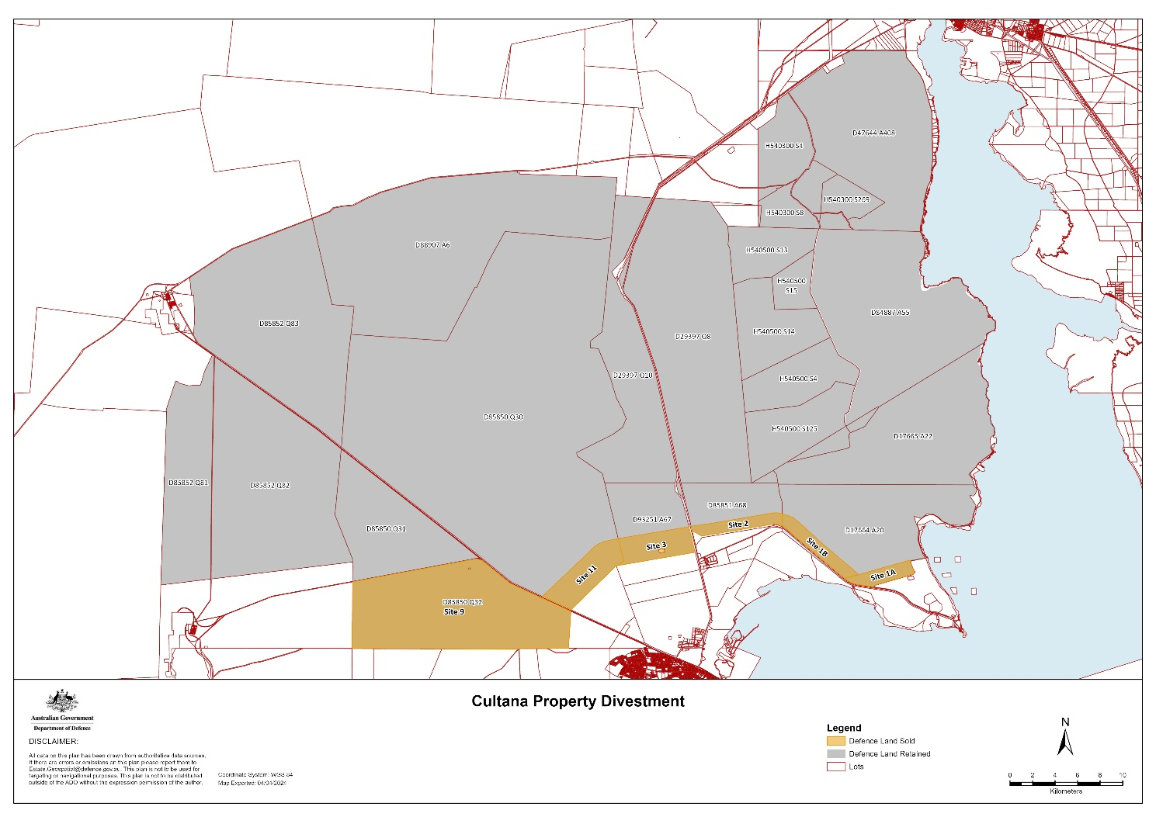

Attachment B

**Statement of Compatibility with Human Rights**

*Prepared in accordance with Part 3 of the Human Rights (Parliamentary Scrutiny) Act 2011*

**Defence (Cultana—Defence Area) Declaration 2024.**

This instrument is compatible with the human rights and freedoms recognised or declared in the international instruments listed in section 3 of the *Human Rights (Parliamentary Scrutiny) Act 2011*.

**Overview of the Instrument**

Cultana is an area in South Australia, west of Adelaide and south of Port Augusta. The Commonwealth has utilises the area for the Australian Defence Force to conduct training exercises and weapons testing, safely in the area.

The purpose of the instrument is to declare the Cultana Training Area for the defence purpose of carrying out military manoeuvre and live firing, including with air weapons and explosive ordnance. The instrument also operates to decrease the size of the Cultana Training Area, in response to a divestment of part of the land to the South Australian Government. The area was previously declared a defence practice area under Part XI of the *Defence Force Regulations 1952*. The majority of the land continues to be part of the newly-declared Cultana Training Area.

A defence area is an area of land, sea or airspace, in or adjacent to Australia, declared by the Minister under subsection 58(1) of the *Defence Regulation 2016* (the Regulation) for a defence purpose.

**Human rights implications**

The instrument engages the right to freedom of movement under Article 12 of the *International Covenant on Civil and Political Rights* (ICCPR).

The right to freedom of movement includes the right to move freely within a country for those who are lawfully in that country. The instrument restricts who may enter the Cultana Training Area and limits the right to move freely within Australia.

Article 12(3) of the ICCPR provides that the right to freedom of movement shall not be subject to any restrictions except those which are provided by law, are necessary to protect national security, public order, public health or morals or the rights and freedoms of others, and are consistent with the other rights recognised in the ICCPR.

The Cultana Training Area is the area of land depicted in the map in Schedule 1 to the instrument. Subsection 3(3) of the instrument provides that entry into the area is prohibited at all times. In order to ensure the security of military exercises and weapons testing carried out in the Cultana Training Area, and to ensure the safety of the public during these exercises, it is appropriate to prohibit access to the area at all times. Accordingly, there is a rational connection between the measure implemented by the instrument and the legitimate objective intended to be achieved.

**Conclusion**

The Disallowable Legislative Instrument is compatible with human rights because to the extent that it may limit human rights, those limitations are reasonable, necessary and proportionate.

1. Published in Commonwealth of Australia Gazette No. GN 28, 20 July 2011.