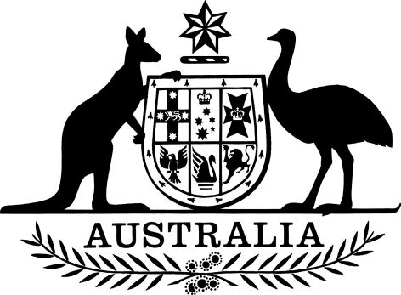

National Health (Pharmaceutical Benefits) Amendment (Eighth Community Pharmacy Agreement) Regulations 2024
I, General the Honourable David Hurley AC DSC (Retd), Governor-General of the Commonwealth of Australia, acting with the advice of the Federal Executive Council, make the following regulations.
Dated 20 June 2024
David Hurley
Governor-General
By His Excellency’s Command
Mark Butler
Minister for Health and Aged Care

Contents
1 Name 1
2 Commencement 1
3 Authority 1
4 Schedules 1
Schedule 1—Amendments 2
National Health (Pharmaceutical Benefits) Regulations 2017 2

1 Name
This instrument is the National Health (Pharmaceutical Benefits) Amendment (Eighth Community Pharmacy Agreement) Regulations 2024.

2 Commencement
(1) Each provision of this instrument specified in column 1 of the table commences, or is taken to have commenced, in accordance with column 2 of the table. Any other statement in column 2 has effect according to its terms.

Commencement information
Column 1 | Column 2 | Column 3
Provisions | Commencement | Date/Details
1. The whole of this instrument | 1 July 2024. | 1 July 2024
Note: This table relates only to the provisions of this instrument as originally made. It will not be amended to deal with any later amendments of this instrument.
(2) Any information in column 3 of the table is not part of this instrument. Information may be inserted in this column, or information in it may be edited, in any published version of this instrument.

3 Authority
This instrument is made under the National Health Act 1953.

4 Schedules
Each instrument that is specified in a Schedule to this instrument is amended or repealed as set out in the applicable items in the Schedule concerned, and any other item in a Schedule to this instrument has effect according to its terms.

Schedule 1—Amendments

National Health (Pharmaceutical Benefits) Regulations 2017
1 Subsection 5(1) (definition of additional patient charge)
Omit “clause 4.2.1(c) or 4.2.2(c) of the Seventh Community Pharmacy Agreement, as in force on 1 July 2020”, substitute “clause 6.2.1(c) of the Eighth Community Pharmacy Agreement, as in force on 1 July 2024”.

