

National Capital Plan Amendment (No.99 – Molonglo Valley Town Centre) Amending Instrument 2024

I, Kristy McBain, Minister for Regional Development, Territories and Local Government, make the following instrument.

Dated 9September 2024

Kristy McBain

Minister for Regional Development, Territories and Local Government

Contents

1 Name 1

2 Commencement 1

3 Authority 1

4 Schedules 1

Schedule 1—Amendments 2

National Capital Plan 2

1 Name

This instrument is the *National Capital Plan Amendment (No.99 – Molonglo Valley Town Centre) Amending Instrument*.

2 Commencement

(1) Each provision of this instrument specified in column 1 of the table commences, or is taken to have commenced, in accordance with column 2 of the table. Any other statement in column 2 has effect according to its terms.

| Commencement information | | |
| --- | --- | --- |
| Column 1 | Column 2 | Column 3 |
| Provisions | Commencement | Date/Details |
| 1. The whole of this instrument | The day after this instrument is registered. |  |

Note: This table relates only to the provisions of this instrument as originally made. It will not be amended to deal with any later amendments of this instrument.

(2) Any information in column 3 of the table is not part of this instrument. Information may be inserted in this column, or information in it may be edited, in any published version of this instrument.

3 Authority

This instrument is made under paragraph 19(1)(a) of the *Australian Capital Territory (Planning and Land Management) Act 1988*.

4 Schedules

Each instrument that is specified in a Schedule to this instrument is amended or repealed as set out in the applicable items in the Schedule concerned, and any other item in a Schedule to this instrument has effect according to its terms.

Schedule 1—Amendments

National Capital Plan

1. Part 3 Land use and general land use controls

Section 3.1 – General Policy Plans

Repeal Figure 2: General Policy Plan – Metropolitan Canberra and substitute with the following:

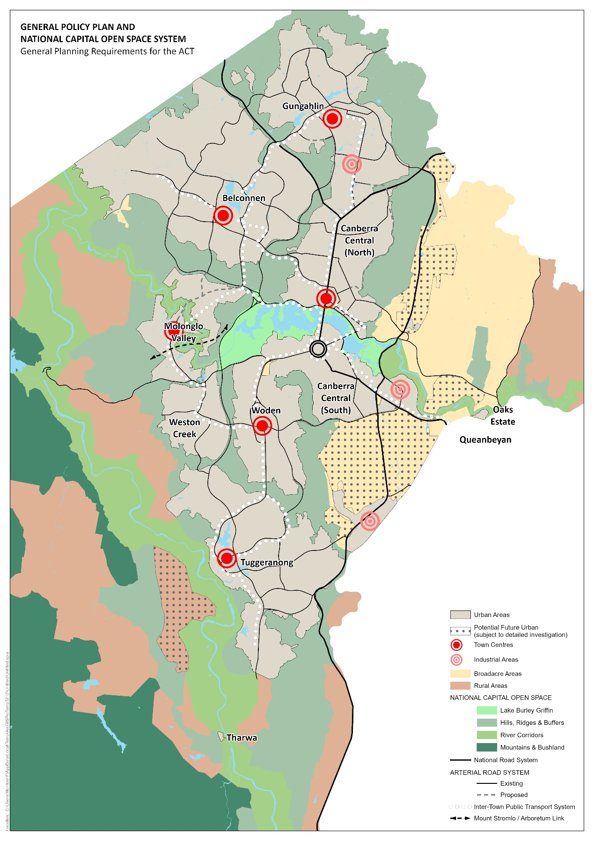

2. Section 3.3.1 Background

Omit paragraph 2 and substitute with the following:

For the foreseeable future, urban land in Metropolitan Canberra will comprise:

* the towns of Canberra Central, Woden/Weston Creek, Belconnen, Tuggeranong, Gungahlin and Molonglo Valley
* the villages of Hall, Oaks Estate and Tharwa
* land at Hume, Mitchell and Fyshwick.

3. Section 3.3.3 Policies for Urban Areas

Omit point a. and replace with the following:

1. The urban area of Canberra will comprise:

* the towns of Canberra Central, Woden/Weston Creek, Belconnen, Tuggeranong, Gungahlin and Molonglo Valley
* the villages of Hall, Oaks Estate and Tharwa
* land at Hume, Mitchell and Fyshwick.

4. Section 3.5.3 Policies for employment locations

Under point a., add a further dot point in alphabetical order:

* Molonglo Valley Town Centre

5. Section 3.5 – Employment Locations

Repeal Figure 10: Defined Activity Centres and substitute with the following:

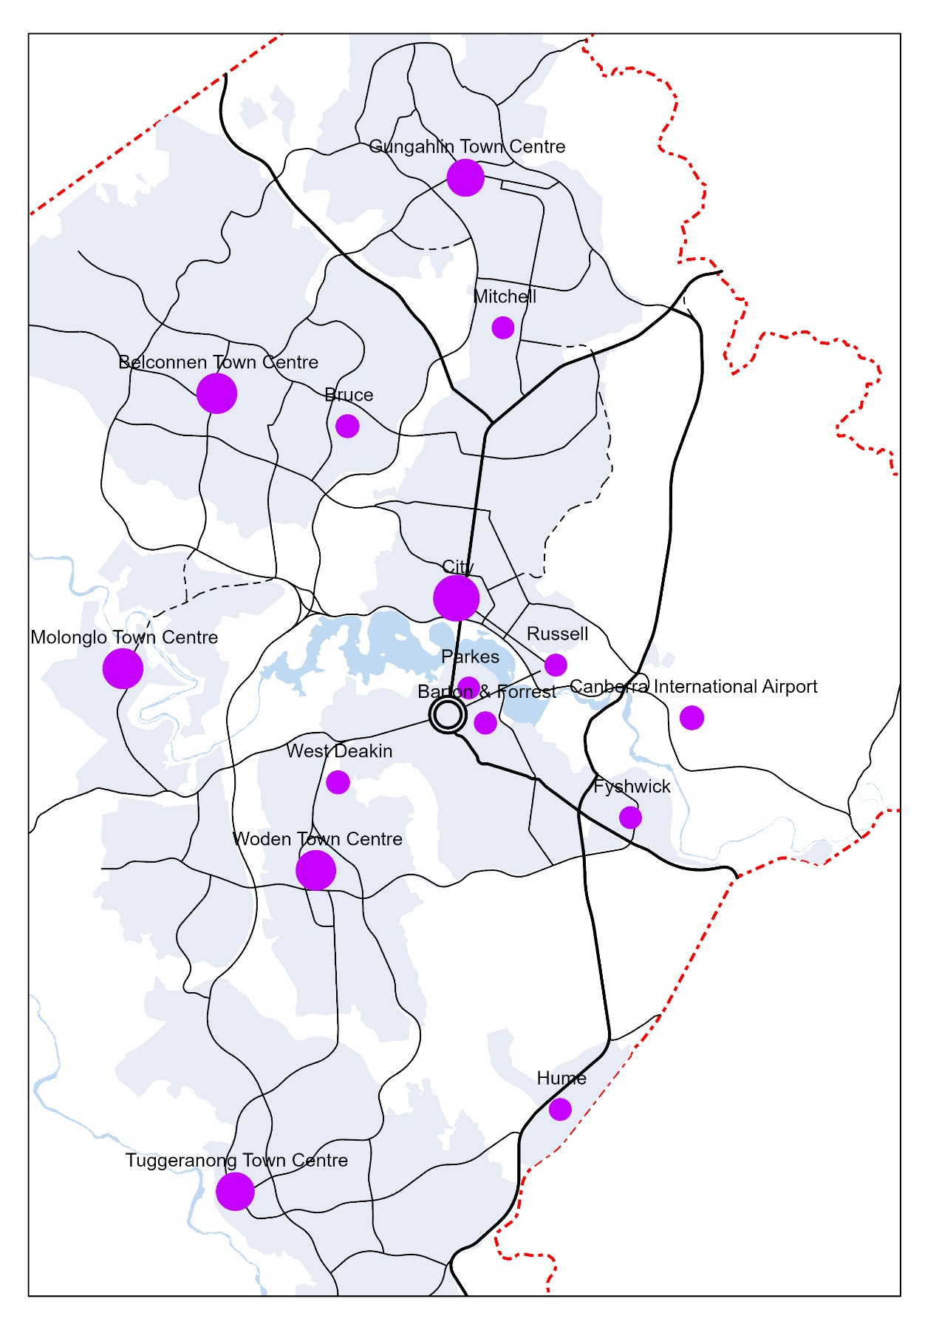

**Consequential changes**

The Draft Amendment will recognise consequential changes to page numbers, figure numbers and text references, and contents page.