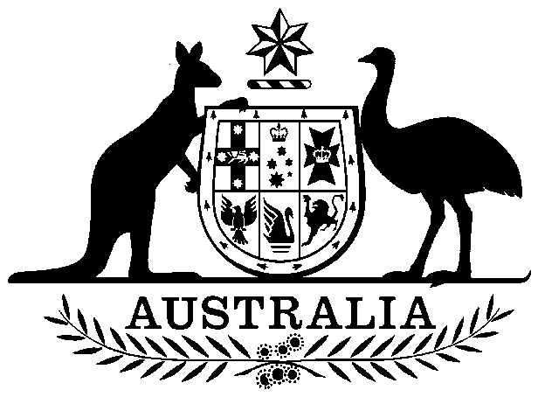

**COMMONWEALTH OF AUSTRALIA**

##### *Environment Protection and Biodiversity Conservation Act 1999*

**Amendment of List of Exempt Native Specimens – South Australian Beach-cast Marine Algae Fishery, September 2024**

I, JESSICA HOEY, Director, Ocean and Wildlife Branch, as Delegate of the Minister for the Environment and Water, pursuant to subsection303DC(1)(a) of the *Environment Protection and Biodiversity Conservation Act 1999* (EPBC Act), hereby amend the list of exempt native specimens established under section 303DB of the EPBC Act by **deleting** from the list specimens and any associated notations specified in **Schedule 1**, and by **including** in the list specimens and associated notations as set out in **Schedule 2**.

This instrument is a legislative instrument for the purposes of the *Legislation Act 2003*.

The instrument commences 17 September 2024.

Dated this 9th day of September 2024

JESSICA HOEY

….…………………………………………….

Delegate of the Minister for the Environment and Water

**SCHEDULE 1**

Under the heading Freshwater and Marine Animals delete from the list the following items and any associated notations:

|  |  |  |
| --- | --- | --- |
| **Taxon/Item** | **Common Name** | **Notation** |
| Specimens taken in the South Australian Beach-cast Marine Algae Fishery, as defined in the *Fisheries Management Act 2007* (SA), Fisheries Management (Miscellaneous Developmental Fishery) Regulations 2013 (SA), Fisheries Management (Miscellaneous Fishery) Regulations 2015 (SA), and Fisheries Management (General) Regulations 2017 (SA), but not including:  (a)   specimens that belong to taxa listed under section 209 of the EPBC Act (Australia’s List of Migratory Species), or  (b)   specimens that belong to taxa listed under section 248 of the EPBC Act (Australia’s List of Marine Species), or  (c)   specimens that belong to eligible listed threatened species, as defined under section 303BC of the EPBC Act, or  (d)   specimens that belong to taxa listed under section 303CA of the EPBC Act (Australia’s CITES List). | South Australian Beach-cast Marine Algae Fishery | * The specimens were taken lawfully; * the specimens are covered by the declaration of an approved wildlife trade operation under section 303FN of the EPBC Act in relation to the fishery. |

**SCHEDULE 2**

Under the heading Freshwater and Marine Animals include in the list the following items and associated notations:

|  |  |  |
| --- | --- | --- |
| **Taxon/Item** | **Common Name** | **Notation** |
| Specimens that are or are derived from marine vegetation taken under licences or permits issued by the Department of Primary Industries and Regions South Australia in accordance with the *Fisheries Management Act 2007* (SA);Fisheries Management (General) Regulations 2017 (SA), Fisheries Management (Miscellaneous Fishery) Regulations 2015 (SA), Fisheries Management (Miscellaneous Research Fishery) Regulations 2013 (SA), Fisheries Management (Miscellaneous and Developmental Fishery) Regulations 2013 (SA), and the Policy for the Management of the Beach-cast Marine Algae Fishery (2023) but not including:   1. specimens that belong to taxa listed under section 209 of the EPBC Act (Australia’s List of Migratory Species), or 2. specimens that belong to taxa listed under section 248 of the EPBC Act (Australia’s List of Marine Species), or 3. specimens that belong to eligible listed threatened species, as defined under section 303BC of the EPBC Act, or 4. specimens that belong to taxa listed under section 303CA of the EPBC Act (Australia’s CITES List). | South Australian Beach-cast Marine Algae Fishery | * the specimen, or the marine vegetation from which it is derived, was taken lawfully; * the Department of Primary Industries and Regions South Australia must inform the Department of Climate Change, Energy, the Environment and Water of any intended material changes to the South Australian Beach-cast Marine Algae Fishery management arrangements that may affect this approval; * the Department of Primary Industries and Regions South Australia must inform the Department of Climate Change, Energy, the Environment and Water of any intended changes to fisheries legislation that may affect the legislative instruments relevant to this approval; * the Department of Primary Industries and Regions South Australia must produce and present reports on the South Australian Beach-cast Marine Algae Fishery to the Department of Climate Change, Energy, the Environment and Water by 17 September each year; and * the specimens are included in the list until 17 September 2034. |