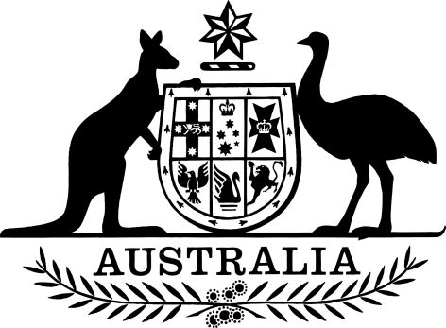

Health Insurance (Section 3C Pathology Services – Point-of-Care Testing Services) Determination 2024
I, Mary Warner, delegate of the Minister for Health and Aged Care, make the following determination.
Dated 24 September 2024
Mary Warner
Assistant Secretary
Diagnostic Imaging and Pathology Branch
Medicare Benefits and Digital Health Division
Health Resourcing Group
Department of Health and Aged Care

Contents
1 Name 1
2 Commencement 1
3 Authority 1
4 Definitions 1
5 Treatment of relevant services 2
6 Application of items 2
Schedule 1—Relevant services 4

1 Name
This instrument is the Health Insurance (Section 3C Pathology Services – Point-of-Care Testing Services) Determination 2024.

2 Commencement
- Each provision of this instrument specified in column 1 of the table commences, or is taken to have commenced, in accordance with column 2 of the table. Any other statement in column 2 has effect according to its terms.

Commencement information
Column 1 | Column 2 | Column 3
Provisions | Commencement | Date/Details
1. The whole of this instrument | 1 November 2024.
Note: This table relates only to the provisions of this instrument as originally made. It will not be amended to deal with any later amendments of this instrument.
- Any information in column 3 of the table is not part of this instrument. Information may be inserted in this column, or information in it may be edited, in any published version of this instrument.

3 Authority
This instrument is made under subsection 3C(1) of the Health Insurance Act 1973.

4 Definitions
Note: A number of expressions used in this instrument are defined in definitions section of the Act, including the following:
- item;
(b) professional service;
(c) schedule fee.
In this instrument:
Act means the Health Insurance Act 1973.
eligible Aboriginal and Torres Strait Islander health practitioner has the same meaning as in the Health Insurance (Section 3C General Medical Services – Allied Health Services) Determination 2024.
eligible Aboriginal health worker has the same meaning as in the Health Insurance (Section 3C General Medical Services – Allied Health Services) Determination 2024.
general medical services table means the table prescribed under subsection 4(1) of the Act.
health professional means a practice nurse, eligible Aboriginal and Torres Strait Islander health practitioner or eligible Aboriginal health worker.
medical practitioner has the same meaning as subsection 3(1) of the Act.
Modified Monash 6 area has the same meaning as in the general medical services table.
Modified Monash 7 area has the same meaning as in the general medical services table.
pathology service has the same meaning as subsection 3(1) of the Act.
pathology services table means the table prescribed under subsection 4A(1) of the Act.
practice nurse has the same meaning as in the general medical services table.
relevant provisions means all provisions, of the Act and regulations made under the Act, and the National Health Act 1953 and regulations made under the National Health Act 1953, relating to pathology services, professional services or items.
relevant service means a health service, as defined in subsection 3C(8) of the Act, that is specified in a Schedule.
Schedule means a Schedule to this instrument.
- Unless the contrary intention appears, a reference in this instrument to a provision of the Act or the National Health Act 1953 or regulations made under the Act or under the National Health Act 1953 as applied, adopted or incorporated in relation to specifying a matter is a reference to those provisions as in force from time to time and any other reference to provisions of an Act or regulations is a reference to those provisions as in force from time to time.

5 Treatment of relevant services
(1) For subsection 3C(1) of the Act, a relevant service provided in accordance with this instrument is to be treated, for the relevant provisions, as if:
(a) it were both a professional service and a pathology service; and
(b) there were an item in Group P9 of the pathology services table that:
(i) related to the service; and
(ii) specified for the service a fee in relation to each State, being the fee specified in Schedule 1 in relation to the service.
Note: For this Determination, an internal Territory is deemed to form part of the State of New South Wales – see subsection 3C(7) of the Act.

6 Application of items
(1) Item 73813 applies to a service only if:
(a) the service is rendered at, or from, a practice location in:
(i) a Modified Monash 6 area; or
(ii) a Modified Monash 7 area;
(b) the medical practitioner providing the service, or the health professional providing the service on behalf of a medical practitioner, is employed by an organisation that:
(i) delivers health services; and
(ii) is participating in the First Nations Molecular Point-of-Care (PoC) Testing Program;
(c) the service is provided in accordance with the Program referred to in subparagraph (b)(ii);
(d) the service is conducted by a medical practitioner, or on behalf of a medical practitioner by a health professional, who has achieved competency as a PoC operator by the First Nations Molecular PoC Testing Program for the test(s) performed;
(e) the PoC test(s) gives valid patient result(s).

Schedule 1—Relevant services
Group P9—Simple Basic Pathology Tests
Column 1  Item | Column 2  Description | Column 3  Fee ($)
73813 | Detection performed by, or on behalf of, a medical practitioner of:  - chlamydia trachomatis (CT) and neisseria gonorrhoeae (NG) via molecular point-of-care testing for the diagnosis of CT or NG infection; and  - trichomonas vaginalis (TV) via molecular point-of-care testing for the diagnosis of TV infection | 117.65

