***Australian Film, Television and Radio School Act 1973***

# **DETERMINATION OF DEGREES, DIPLOMAS AND CERTIFICATES** **No. 2024/1**

I, **Rachel Perkins**, on behalf of the Australian Film, Television and Radio School, make a determination under section 6A of the Australian *Film, Television and Radio School Act 1973* (the Act) specifying the following degrees, diplomas and certificates for the purposes of paragraph 5(1)(g) of the Act.

**Graduate Certificate in Radio and Podcasting  
Graduate Certificate in Arts Screen**

This Determination comes into effect on the day after it is registered with the Federal Register of Legislative Instruments.

Dated: 13 September 2024

Signed:

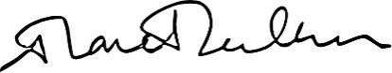

Rachel Perkins

Chair of Council

Australian Film, Television and Radio School