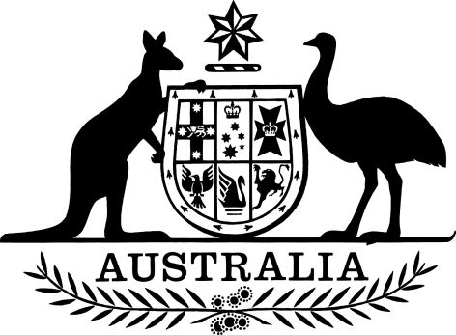

PB 110 of 2024

National Health (Take Home Naloxone) Amendment (2024 Measures No. 1) Special Arrangement 2024
I, Maryka Gaudio, as delegate for the Minister for Health and Aged Care, make the following special arrangement.
Dated 21 October 2024
Maryka Gaudio
Assistant Secretary A/g
Pharmacy Branch
Technology Assessment and Access Division
Department of Health and Aged Care

Contents
1 Name 1
2 Commencement 1
3 Authority 1
4 Schedules 1
Schedule 1—Amendments 2
National Health (Take Home Naloxone) Special Arrangement 2019 2

1 Name
- This instrument is the National Health (Take Home Naloxone) Amendment (2024 Measures No. 1) Special Arrangement 2024.
- This instrument may also be cited as PB 110 of 2024.

2 Commencement
(1) Each provision of this instrument specified in column 1 of the table commences, or is taken to have commenced, in accordance with column 2 of the table. Any other statement in column 2 has effect according to its terms.

Commencement information
Column 1 | Column 2 | Column 3
Provisions | Commencement | Date/Details
1. The whole of this instrument | 1 November 2024. | 1 November 2024.
Note: This table relates only to the provisions of this instrument as originally made. It will not be amended to deal with any later amendments of this instrument.
(2) Any information in column 3 of the table is not part of this instrument. Information may be inserted in this column, or information in it may be edited, in any published version of this instrument.

3 Authority
This instrument is made under subsection 100(2) of the National Health Act 1953.

4 Schedules
Each instrument that is specified in a Schedule to this instrument is amended or repealed as set out in the applicable items in the Schedule concerned, and any other item in a Schedule to this instrument has effect according to its terms.

Schedule 1—Amendments

National Health (Take Home Naloxone) Special Arrangement 2019
1 Clause 1 of Schedule 1 (table item 5)
Repeal the item.

