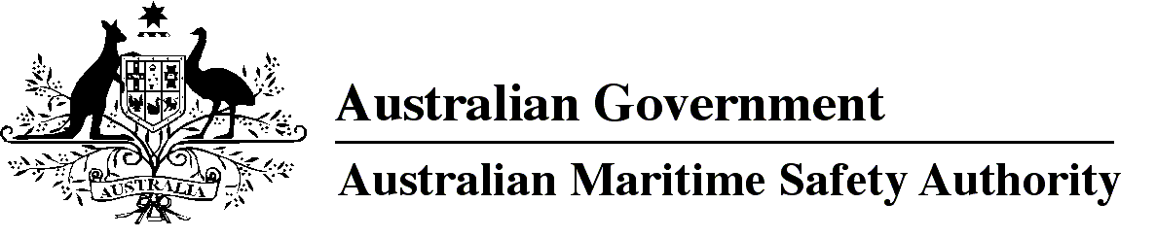

AMSA MO 2024/4

Marine Orders Amendment (Marine Order 11 — consequential changes) Order 2024

I, Kaylene Dale, Chief Executive Officer of the Australian Maritime Safety Authority, make this Order under subsection 342(1) of the *Navigation Act 2012*.

Dated   12 November 2024

Kaylene Dale  
Chief Executive Officer

1 Name of Marine Order

This Marine Order is *Marine Orders Amendment (Marine Order 11 — consequential changes) Order 2024*.

2 Commencement

This Marine Order commences immediately after the commencement of *Marine Order 11 (Living and working conditions on vessels) 2024*.

3 Amendment of Marine Orders

Each Marine Order mentioned in the name of a Division in Schedule 1 to this Marine Order is amended in accordance with that Division.

Schedule 1 Amendment

Division 1 *Marine Order 2 (Australian International Shipping Register) 2016*

[1] Section 2

omit

*Marine Order 11 (Living and working conditions on vessels) 2015*

insert

*Marine Order 11 (Living and working conditions on vessels) 2024*

Division 2 *Marine Order 71 (Masters and deck officers) 2023*

[2] Schedule 2

omit each mention of

*Marine Order 11 (Living and working conditions on vessels) 2015*

insert

*Marine Order 11 (Living and working conditions on vessels) 2024*

**Note**

1. All legislative instruments and compilations of legislative instruments are registered on the Federal Register of Legislation under the *Legislation Act 2003.* See www.legislation.gov.au.