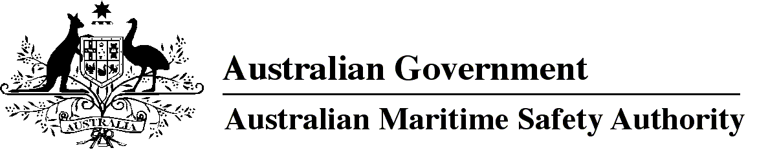

AMSA MO 2024/6

Marine Order Amendment (Marine Order 504 — consequential changes) Order 2024

I, Kaylene Dale, Chief Executive Officer of the Australian Maritime Safety Authority, (the National Marine Safety Regulator under section 9 of the *Marine Safety (Domestic Commercial Vessel) National* Law), make this Marine Order under subsection 163(1) of the *Marine Safety (Domestic Commercial Vessel) National Law*.

Dated   14 November 2024

Kaylene Dale  
Chief Executive Officer

1 Name of Marine Order

This Marine Order is *Marine Order Amendment (Marine Order 504 — consequential changes) Order 2024*.

2 Commencement

This Marine Order commences immediately after the commencement of *Marine Order 504 (Certificates of operation — national law) 2024*.

3 Amendment

Schedule 1 to this Marine Order amends *Marine Order 505 (Certificates of competency — national law) 2022*.

Schedule 1 Amendment

[1] Section 4

omit

*and operation requirements — national law) 2018*

insert

*— national law) 2024*

[2] Subsection 7(4)

omit first mention of

Schedule 1

insert

section 16

**Note**

1. All legislative instruments and compilations of legislative instruments are registered on the Federal Register of Legislation under the *Legislation Act 2003.* See www.legislation.gov.au.