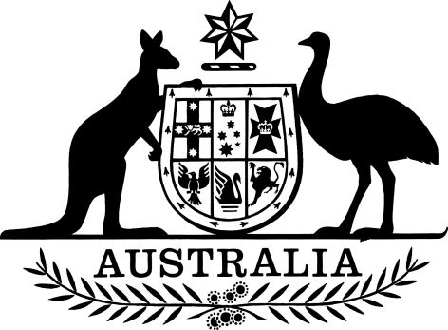

National Health (Immunisation Program – Designated Vaccines) Amendment Determination (No. 2) 2024
I, Kelly Fisher, delegate of the Minister for Health and Aged Care, make the following determination.
Dated 27 November 2024
Kelly Fisher
Assistant Secretary, Immunisation Reform Branch, National Immunisation Division

Contents
1 Name 1
2 Commencement 1
3 Authority 1
4 Schedules 1
Schedule 1—Amendments 2
National Health (Immunisation Program – Designated Vaccines) Determination 2014 (No.1) 2

1 Name
This instrument is the National Health (Immunisation Program – Designated Vaccines) Amendment Determination (No. 2) 2024.

2 Commencement
- Each provision of this instrument specified in column 1 of the table commences, or is taken to have commenced, in accordance with column 2 of the table. Any other statement in column 2 has effect according to its terms.

Commencement information
Column 1 | Column 2 | Column 3
Provisions | Commencement | Date/Details
1. The whole of this instrument | The day after this instrument is registered.
Note: This table relates only to the provisions of this instrument as originally made. It will not be amended to deal with any later amendments of this instrument.
(2) Any information in column 3 of the table is not part of this instrument. Information may be inserted in this column, or information in it may be edited, in any published version of this instrument.

3 Authority
This instrument is made under subsections 9B(2) and (5) of the National Health Act 1953.

4 Schedules
Each instrument that is specified in a Schedule to this instrument is amended or repealed as set out in the applicable items in the Schedule concerned, and any other item in a Schedule to this instrument has effect according to its terms.

Schedule 1—Amendments

National Health (Immunisation Program – Designated Vaccines) Determination 2014 (No.1)
1 Before paragraph 7(9A)(a)
Insert:
(aa) a child who is at least 6 months of age but less than 5 years of age; or.
2 Paragraph 7(9A)(a)
Omit “5 years of age”, substitute “6 months of age”.
3 Paragraph 7(9A)(b)
Omit “5 years of age”, substitute “6 months of age”.
4 Paragraph 7(9A)(c)
Omit “5 years of age”, substitute “6 months of age”.
5 Part 2 of Schedule 1 (table item 210A, column headed “number and timing of doses”)
Omit “5 years of age”, substitute “6 months of age”.
6 In the appropriate position in Part 2 of Schedule 1 (table)
Insert:

Item | Vaccine and the circumstances in which vaccine may be provided | Brand | Formulation | Active ingredient and strength | Number and timing of doses
222 | Vaccine  respiratory syncytial virus (RSV) stabilised prefusion F subunit  Circumstances  Vaccine may be provided to a person who is pregnant | Abrysvo | Injection (0.5mL) | Each 0.5mL dose contains 120 µg of stabilised prefusion F proteins (60 µg RSV-A and 60 µg RSV-B antigens) | 1 dose:  - at 28 to 36 weeks gestation; or  - after 36 weeks gestation, if vaccination is two weeks prior to birth.

