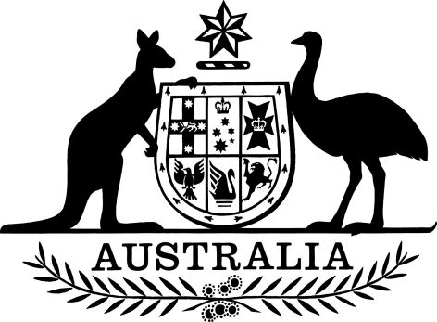

PB 132 of 2024

National Health (Concession Card or Entitlement Card Fee) Amendment Determination 2024
I, Sarah Norris, delegate of the Minister for Health and Aged Care, make the following Determination.
Dated 27 November 2024

Sarah Norris
Assistant Secretary
Pharmacy Branch
Technology Assessment and Access Division
Health Resourcing Group
Department of Health and Aged Care

Contents
1 Name 1
2 Commencement 1
3 Authority 1
4 Schedules 1
Schedule 1—Amendments 2
National Health (Concession Card or Entitlement Card Fee) Determination 2021 (PB 133 of 2021) 2

1 Name
- This instrument is the National Health (Concession Card or Entitlement Card Fee) Amendment Determination 2024.
- This instrument may also be cited as PB 132 of 2024.

2 Commencement
(1) Each provision of this instrument specified in column 1 of the table commences, or is taken to have commenced, in accordance with column 2 of the table. Any other statement in column 2 has effect according to its terms.

Commencement information
Column 1 | Column 2 | Column 3
Provisions | Commencement | Date/Details
1. The whole of this instrument | 1 January 2025 | 1 January 2025
Note: This table relates only to the provisions of this instrument as originally made. It will not be amended to deal with any later amendments of this instrument.
(2) Any information in column 3 of the table is not part of this instrument. Information may be inserted in this column, or information in it may be edited, in any published version of this instrument.

3 Authority
This instrument is made under subsection 84HA(1) of the National Health Act 1953 and as required by subsection 84HA(2) of that Act, with the written agreement of the Pharmacy Guild of Australia.

4 Schedules
Each instrument that is specified in a Schedule to this instrument is amended or repealed as set out in the applicable items in the Schedule concerned, and any other item in a Schedule to this instrument has effect according to its terms.

Schedule 1—Amendments

National Health (Concession Card or Entitlement Card Fee) Determination 2021 (PB 133 of 2021)
1 Subsection 6(1)
Omit “$12.04”, substitute “$12.38”.

