# EXPLANATORY STATEMENT

## Issued by authority of the Treasurer

*Foreign Acquisitions and Takeover Act 1975*

*Foreign Acquisitions and Takeovers Amendment (Interfunding Exemption) Regulations 2024*

The *Foreign Acquisitions and Takeovers Act* *1975* (the Act) establishes a regime for the notification, review and approval of foreign investment in Australia.

Section 139 of the Act provides that the Governor-General may make regulations prescribing matters required or permitted by the Act to be prescribed, or necessary or convenient to be prescribed for carrying out or giving effect to the Act.

Regulations may be made pursuant to sections 37, 98C, 98D, 98E and 130ZU of the Act. Section 37 of the Act enables regulations to provide for exemptions from the Act or from specified provisions of the Act. Section 130ZU of the Act provides the regulations may prescribe circumstances in which a person specified must give a notice to the Registrar to be recorded on the Register of Foreign Ownership of Australian Assets.

The purpose of the *Foreign Acquisitions and Takeovers Amendment (Interfunding Exemption) Regulations 2024* (the Regulations) is to amend the *Foreign Acquisitions and Takeovers Regulation 2015* (the Principal Regulations) to exempt transactions that meet certain requirements from mandatory notification and reporting requirements under the Act. The Regulations also make minor technical updates to the Principal Regulations to ensure that existing exemptions relating to certain interests held by foreign custodian corporations and pro rata rights issues also apply to Part 7A of the Act as originally intended.

As required by the *Foreign Investment Reform (Protecting Australia’s National Security) Act 2020*, the Secretary to the Treasury undertook an evaluation of the foreign investment reforms that came into effect on 1 January 2021. One of the proposals made by stakeholders in their responses to the evaluation was for an exemption for certain types of investment structures.

These Regulations respond to this feedback and reduce the regulatory burden for a particular category of lower-risk and passive investment activities, known as ‘interfunding’. Interfunding refers to transactions between investment entities (such as unit trusts) that are managed by the same responsible entity or a related responsible entity. Interfunding transactions may be used by investors to achieve investment objectives, reduce risk, and provide operational and cost efficiencies. Interfunding activities generally consist of recurring similar high-volume or low-value transactions.

The Regulations make amendments to exempt interfunding transactions from mandatory notification and reporting requirements and fees under the Act. However, interfunding transactions which were previously precluded from being reviewable national security actions because they were significant actions, notifiable actions, or notifiable national security actions will become reviewable national security actions. This reduces the regulatory burden for foreign investors while providing the Government with appropriate oversight. The Treasurer will continue to be able to exercise the power in section 66A of the Act in relation to an action of this kind if the action may pose a national security concern.

The draft Regulations and explanatory materials were released for a four-week public consultation between 1 May 2024 and 31 May 2024. There were five written submissions received in response to the consultation, generally supporting the amendments subject to revising the scope of the exemption and refining technical elements. In response to the feedback from stakeholders, the Government sought to balance the exemption being appropriately targeted while providing the Government with sufficient oversight of interfunding transactions. Non-confidential submissions received in response to the consultation will be publicly available on the Treasury website. Further feedback on technical elements of the drafting was sought from targeted stakeholders most likely to be affected by the amendments before finalising the Regulations.

The Act does not specify any conditions that need to be satisfied before the power to make the Regulations may be exercised.

Details of the Regulations are set out in Attachment A.

A statement of Compatibility with Human Rights is at Attachment B.

The Regulations are a legislative instrument for the purposes of the *Legislation Act 2003* and are subject to disallowance in accordance with that Act. Section 48A of the *Legislation Act 2003* provides that where a legislative instrument only repeals or amends another instrument, without making any application, saving or transitional provisions relating to the amendment or repeal, that instrument is automatically repealed. By virtue of section 48A, if the Regulations are not disallowed, the Regulations will automatically repeal when the disallowance period ends. Once repealed, the sunsetting regime set out in Part 4 of Chapter 3 of the *Legislation Act 2003* is no longer relevant to the Regulations.

The Principal Regulations are exempt from sunsetting in accordance with item 31 of the table in section 12 of the *Legislation (Exemptions and Other Matters) Regulation 2015*. This is on the basis that they relate to foreign investment, such as foreign investment applications and approvals and giving effect to Australia’s international obligations for foreign investment screening commitments under trade agreements. It is appropriate the Principal Regulations are exempt from sunsetting as they are integral to the operation of Australia’s foreign investment framework and providing enduring commercial certainty to foreign investors.

The Regulations commenced on the day after they were registered on the Federal Register of Legislation.

The Office of Impact Analysis has been (OIA) has been consulted (OIA23-04875) and considered the proposal unlikely to have a more than minor regulatory impact. The preparation of an Impact Analysis (IA) is not required.

**ATTACHMENT A**

**Details of the *Foreign Acquisitions and Takeovers Amendment (Interfunding Exemption) Regulations 2024***

Section 1 – Name

This section provides that the name of the regulations is the *Foreign Acquisitions and Takeovers Amendment (Interfunding Exemption) Regulations 2024* (the Regulations).

Section 2 – Commencement

Schedule 1 to the Regulations commences on the day after the instrument is registered on the Federal Register of Legislation.

Section 3 – Authority

The Regulations are made under the *Foreign Acquisitions and Takeovers Act 1975* (the Act).

Section 4 – Schedule

This section provides that each instrument that is specified in the Schedules to this instrument are amended or repealed as set out in the applicable items in the Schedules, and any other item in the Schedules to this instrument has effect according to its terms.

Section 1 – Amendments

Legislative references in this attachment are to the *Foreign Acquisitions and Takeovers Regulation 2015* (the Principal Regulations) unless otherwise stated.

**Item [1] – Definitions**

Item 1 amends section 5 to insert five new definitions for the purposes of supporting the readability and operation of new section 40A, which provides for an exemption of interfunding transactions from mandatory notification and reporting requirements and fees under the Act.

**Registered scheme** has the same meaning as the *Corporations Act 2001* (Corporations Act), which specifies a registered scheme to mean a managed investment scheme that is registered under section 601EB of the Corporations Act.

**Registrable superannuation entity** has the same meaning as in the *Superannuation Industry (Supervision) Act 1993*, which specifies a registrable superannuation entity to be a regulated superannuation fund, an approved deposit fund or a pooled superannuation trust, but does not include a self-managed superannuation fund.

**Related body corporate** has the same meaning as in the Corporations Act. Related body corporate is defined in section 50 of the Corporations Act and provides that a related body corporate of a body corporate includes:

* A holding company of the body corporate; or
* A subsidiary of the body corporate; or
* A subsidiary of a holding company of the body corporate.

**Responsible entity**of a registered scheme has the same meaning as in the Corporations Act, which specifies a responsible entity of a registered scheme to be the company named in ASIC’s record of a registered scheme’s registration as the responsible entity or temporary responsible entity of that scheme.

**RSE licensee** has the same meaning as in the *Superannuation Industry (Supervision) Act 1993* (SIS Act), which specifies a RSE licensee to be a constitutional corporation, body corporate, or group of individual trustees that hold a RSE license granted under section 29D of the SIS Act.

**Item [2] – exemption for interfunding transactions**

Subdivision A of Division 4 of Part 3 of the Principal Regulations provides for exemptions relating to particular actions. Item 2 inserts new section 40A into Subdivision A to provide for a new exemption for actions that satisfy certain requirements. These actions are known as interfunding transactions.

For transactions that satisfy the requirements of subsection 40A(2), subsection 40A(1) has the effect of disapplying the provisions in the Act relating to significant actions under Division 2 of Part 2, notifiable actions under Division 3 of Part 2, and notifiable national security actions under section 55B. Therefore, transactions that satisfy the requirements of subsection 40A(2) will only continue to be reviewable national security actions if they meet the criteria under sections 55D to 55G of the Act. This means the Treasurer will retain the national security call-in power (section 66A) and last resort power (Division 3 of Part 3) in relation to interfunding transactions.

Subsection 40A(2) contains five requirements that must be met for an acquisition of an interest in securities in an entity to constitute an interfunding transaction and therefore be exempt from the provisions in the Act outlined in subsection 40A(1). The requirements ensure that the exemption targets acquisitions that have characteristics common to interfunding transaction.

*Requirement 1: Registration of acquirer and acquiring fund*

Paragraph 40A(2)(a) provides that the acquisition must be made by a corporation (the acquirer) in its capacity as a responsible entity (RE) of a registered scheme (acquiring fund) or a RSE licensee of a registerable superannuation entity (acquiring fund). It is appropriate that the exemption is limited to registered schemes and registerable superannuation entities given the existing regulatory oversight on these types of entities such as through the compliance, governance, audit and reporting obligations that they must meet as set out in various Commonwealth legislation and prudential standards. Entities with less regulatory obligations, such as unregistered schemes, may pose a higher risk given the reduced oversight on their activities.

*Requirement 2: Registration of target fund*

Paragraph 40A(2)(b) provides that that the acquisition must be of an interest in a registered scheme (target fund) or registrable superannuation entity (target fund). Similarly, it is appropriate that target funds eligible for the exemption are limited to entities that are already subject to extensive regulatory oversight.

*Requirement 3: Sufficient connection to the acquiring fund*

This requirement limits eligibility for the interfunding exemption to transactions within an interfunding group of funds whose responsible entities or RSE licensees are sufficiently connected (are related bodies corporate), or where there is a similar connection between the acquiring fund and the target. Where an interfunding transaction gives rise to an action outside the interfunding group of funds, the Act will continue to apply to that action. For example, if a fund undertakes an interfunding transaction (in alignment with a previously published strategy) that results in an upstream investor acquiring an interest in an Australian entity above a relevant threshold when combined with other direct holdings of that investor, the investor may need to give notice to the Treasurer ahead of that action occurring. However, the fund that makes the interfunding transaction will not need to notify ahead of the transaction.

Paragraph 40A(2)(c) provides three specific criteria with the acquisition needing to meet one of them to ensure there is a sufficient connection between the acquirer and the seller or target. Only one of the criteria must be satisfied, to meet the requirement. Specifically, the acquisition must satisfy at least one of the following:

1. The acquisition is made from the acquirer acting in a different capacity to its capacity as the responsible entity or RSE licensee of the acquiring fund. This provides for transactions where the legal interest of the securities in the target fund remains with the same entity.

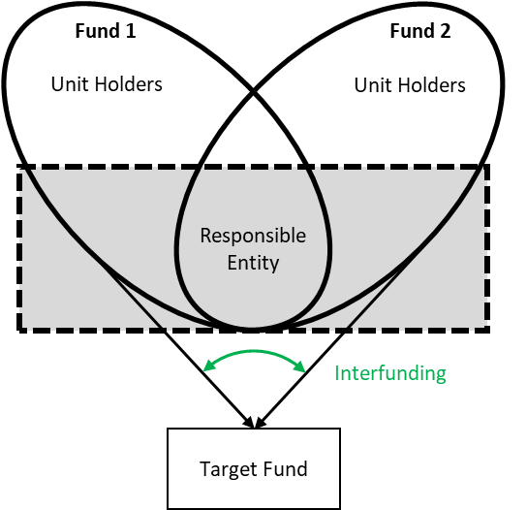

***Diagram 1– section 40A(2)(c)(i):*** *an interfunding transaction where the acquirer (the responsible entity), is the responsible entity of both the acquiring fund and the selling fund.*

1. The acquisition is made from a related body corporate of the acquirer. That is, the seller is a related body corporate of the responsible entity or RSE licensee of the acquiring fund. This provides for transactions that involve a transfer of legal interests between different entities within the same interfunding group of funds, however it does not require the seller to meet the criteria in paragraph 40A(2)(a).

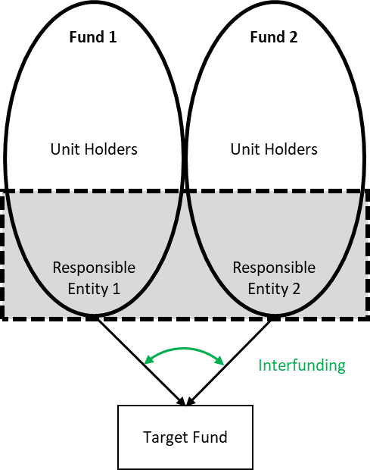

***Diagram 2 – section 40A(2)(c)(ii):*** *an interfunding transaction where the acquirer is in the same interfunding group of funds as the seller. While the target fund is external to the interfunding group of funds, the acquisition is still eligible for the intefunding exemption as the legal interest in the target fund remains within the same group of funds.*

1. The responsible entity or the RSE licensee of the target fund is a related body corporate of the acquirer. This provides for transactions where interests in securities are acquired from any seller but where the interests are being brought into an interfunding group of funds to which the responsible entity or the RSE licensee of the target fund already belongs.

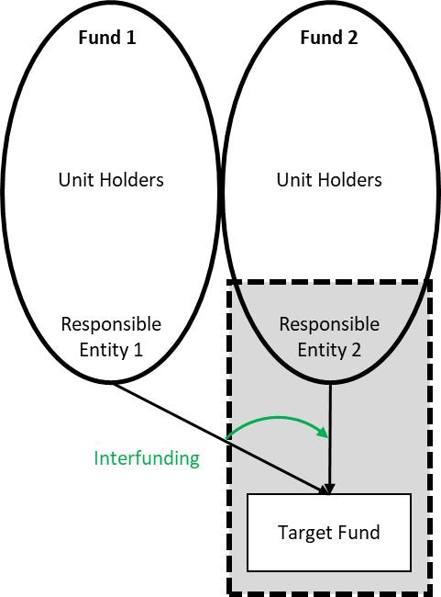

***Diagram 3 – section 40A(2)(c)(iii):*** *an interfunding transaction where the acquirer is in the same interfunding group of funds as the responsible entity or the RSE licensee of the target fund. The seller is not within the interfunding group of funds and does not need to meet the criteria in paragraph 40A(2)(a).*

There are some transactions that will not meet this requirement for the interfunding exemption. This could occur if the transaction illustrated in Diagram 3 were reversed, or in situations where the responsible entities or the RSE licensees of the seller, acquirer, and target were in three separate interfunding groups of funds.

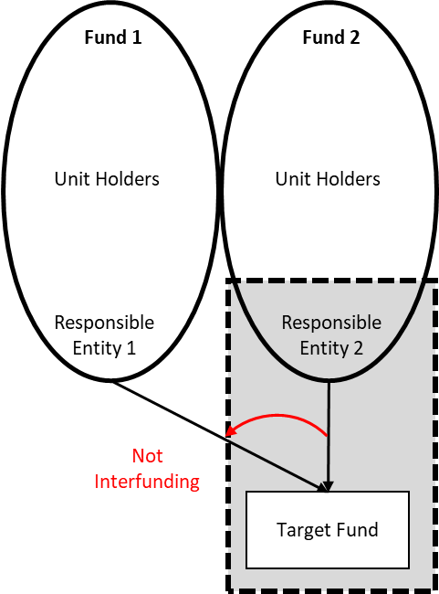

***Diagram 4:*** *a transaction which is* ***not*** *eligible for the interfunding exemption because the acquirer is not within the same interfunding group of funds as the target fund or the seller.*

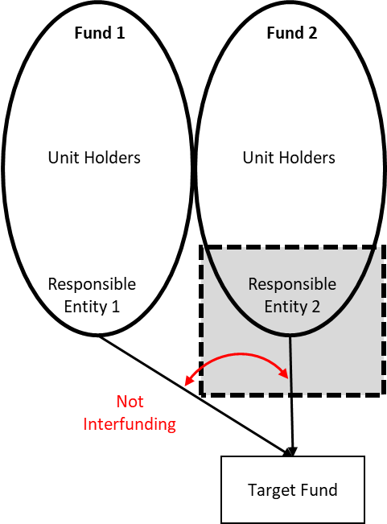

***Diagram 5:*** *transactions which are* ***not*** *eligible for the interfunding exemption because the responsible entity or the RSE licensee of the acquirer (Responsible Entity 1 or Responsible Entity 2, depending on direction of the interest being transferred) is not within the same interfunding group of funds as either the target fund or the seller (Responsible Entity 2 or Responsible Entity 1).*

*Requirement 4: Purpose of acquisition*

Paragraph 40A(2)(d) provides that the acquisition must be made for the purpose of either achieving transactional efficiency or giving effect to an investment strategy of the acquiring fund that has been communicated to the members of that fund. This ensures the exemption only includes acquisitions that align with common outcomes pursued through interfunding transactions while other transactions between related funds (such as internal reorganisations) do not benefit from the exemption. Specifically:

* Achieving transactional efficiency, as required by subparagraph 40A(2)(d)(i), recognises that interfunding transactions are used to lower transaction costs and provide greater operational certainty to fund managers. Fund managers may rely on interfunding for certainty that they will be able to acquire particular assets while reducing transaction costs. This contrasts with internal transactions for other purposes such as restructuring debt or reducing tax liabilities.
* Implementing an investment strategy, as required by subparagraph 40A(2)(d)(ii), recognises that interfunding transactions are often the ordinary course of business to execute or implement an investment mandate communicated to members of an acquiring fund in advance. The intent is that the acquisition aligns and is identifiable with the investment strategy of the acquiring fund, for example an index tracking investment strategy, that has been committed to in advance of the acquisition being made.

While the Regulations do not prescribe how the investment mandate may be communicated to holders of securities, a common way to satisfy this requirement would be through a detailed description of the investment strategy on the fund’s website or for a registrable superannuation entity, through its governing rules. Interfunding does not need to be specifically mentioned in the communication, but does need to support the communicated investment strategy.

*Requirement 5: Regularity of acquisitions of a similar kind*

Paragraph 40A(2)(e) provides that corporations in the interfunding group of funds (that is, as mentioned above, funds whose responsible entities or RSE licensees are related bodies corporate, or the same body corporate) must make, or be likely to make, on a regular and repeatable basis, acquisitions of a similar kind to the acquisition subject to the exemption. This reflects that interfunding transactions are routine, often occurring multiple times per day and distinguishes interfunding from other transactions internal to the group which are more likely to occur intermittently or as one-off actions such as a debt restructures or reorganisations to reduce tax liabilities. Interfunding acquisitions should be of a similar kind to or represent a pattern of acquisitions that have occurred recently or are likely to occur on a regular basis within the group.

Internal reorganisations, as defined in section 41 of the *Foreign Acquisitions and Takeovers Fees Imposition Regulations 2020*, are generally one-off actions taken by a corporation to restructure debt or to reduce tax liabilities. Internal reorganisations are a fee concept only and the new exemption is not intended to apply to actions only on the basis of eligibility for such fee treatment.

**Items [3] and [5] – register notice obligations for pro-rata issues**

Section 130ZU of the Act allows the Principal Regulations to prescribe circumstances in which a person specified in the Principal Regulations must give a register notice to the Registrar, and section 37 allows the regulations to provide for exemptions from the Act or from specified provisions of the Act.

Section 41(1) exempts actions from being notifiable actions under the Act where a person acquires an interest in securities under any of the following, as provided by subsection 41(2):

* a rights issue within the meaning of the *Corporations Act 2001*;
* a rights issue within the meaning of a foreign country, if that issue is regulated by a law of a foreign country; or
* an issue that is similar to a rights issue within the meaning of the *Corporations Act 2001* and is provided for under an instrument made by the Australian Securities Investment Commission (ASIC) under the *Corporations Act 2001*.

Section 41 covers circumstances where a foreign person acquires an additional interest in an entity under a pro-rata rights issue. Pro-rata rights issues are rights issues in which existing shareholders acquire additional rights in proportion to their existing shareholdings. These are rights, but not obligations, to buy new shares which may sometimes be assigned (sold) to a third party.

Division 4 already provides exemptions from registration obligations for certain kinds of interests. Item 6 inserts section 58KA into Division 4 to provide that Part 7A of the Act does not apply in relation to the acquisition of an interest in securities in an entity in the circumstances outlined in subsection 41(2). Item 3 inserts a note after section 41 to clarify that Part 7A of the Act (which contains requirements and other provisions relating to the Register of Foreign Ownership of Australian Assets (the Register) does not apply to these circumstances. That is, a foreign person is not required to give a register notice to the Registrar of an interest acquired through a rights issue which does not change their existing shareholding.

The effect of this amendment is to limit the range of interests in securities that must be registered on the Register under the Act to only the interests that are most important and sensitive. This means foreign persons do not have to bear the regulatory burden of reporting most pro-rata rights issues to the Registrar. Where a foreign person has reasonable grounds to believe that their holding will increase following the pro-rata rights issue, the exemption in section 41 will not apply and they may be required to give notice to the Registrar (and the Treasurer of the proposed action).

**Items [4] and [5] – register notice obligations for foreign custodian corporations**

Section 130ZU of the Act allows the Principal Regulations to prescribe circumstances in which a person specified in the Principal Regulations must give a register notice to the Registrar, and section 37 allows the regulations to provide for exemptions from the Act or from specified provisions of the Act.

Section 30 provides an exemption from significant and notifiable actions under the Act for the acquisition of interests by foreign custodian corporations in their capacity as custodians. Further, subsection 41A(1) exempts actions from being notifiable actions under the Act when an entity becomes a foreign person by virtue of a foreign custodian corporation holding an interest in the entity in the course of providing custodian services as outlined in subsection 41A(2).

Custodians provide a range of services for their clients, who are generally institutional investors, money managers and broker/dealers. These services typically include: settlement of trade and safekeeping of financial assets on behalf of the client; collection of income arising from portfolios; application of entitlements to reduce rates of withholding tax at source and reclaiming tax withheld; and notification and dealing with corporate action.

Generally, custodians only exercise voting rights attached to their holdings under direct instruction from their client and do not normally exercise influence independent of their client.

Division 4 already provides exemptions from registration obligations for certain kinds of interests. The exemption in section 41A reflects the fact that actions taken by persons which are only foreign persons because of an interest held in them by one or more foreign custodian corporations generally pose a lesser risk to the national interest. However, since the commencement of the Register, some of these entities have been subject to register notice obligations under Part 7A of the Act, creating a discrepancy between the current exemptions from notifications and register notice obligations.

Item 6 inserts section 58KB into Division 4 to also provide that Part 7A of the Act does not apply in relation to the actions taken by a foreign person as outlined in subsection 41A(2). Item 4 inserts a note at the end of subsection 41A(1) to clarify that Part 7A of the Act (which contains requirements and other provisions relating to the Register) does not apply to actions taken by persons which are only foreign persons because of an interest held in them by one or more foreign custodian corporations.

The effect of the amendments is to remove the requirement to register on the Register for acquisitions of interests that are not likely to significantly increase risks that the foreign investment framework seeks to address.

**Item [6] - Application**

The amendments made by Items 1 to 4 of these Regulations will apply in relation to an action taken on or after the commencement of the Regulations (noting the Regulations commence the day after registration – see Item 2).

The amendments made by item 5 of these Regulations will apply in relation to an action taken on or after the commencement of the *Foreign Acquisitions and Takeovers Amendment (Register of Foreign Ownership and Other Matters) Regulations 2023* (2023 Regulations), being 1 July 2023. Retrospective application is appropriate in these circumstances as the amendments made by item 6 correct an oversight in the 2023 Regulations and therefore should apply from when those Regulations commenced. This ensures that any failure occurring after 1 July 2023 to notify the types of actions that are now exempt from notification because of the amendments made by Item 5 will not be liable for an offence under the Principal Regulations. It is expected that no entities are likely to be detrimentally affected by the retrospective application of the amendments.

**ATTACHMENT B**

### Statement of Compatibility with Human Rights

*Prepared in accordance with Part 3 of the Human Rights (Parliamentary Scrutiny) Act 2011*

### Foreign *Acquisitions and Takeovers Amendment (Interfunding Exemption) Regulations 2024*

This Legislative Instrument is compatible with the human rights and freedoms recognised or declared in the international instruments listed in section 3 of the *Human Rights (Parliamentary Scrutiny) Act 2011*.

### Overview of the Legislative Instrument

The *Foreign Acquisitions and Takeovers Act* *1975* (the Act) establishes a regime for the notification, review and approval of foreign investment in Australia. The purpose of the *Foreign Acquisitions and Takeovers Amendment (Interfunding Exemption) Regulations 2024* (the Regulations) is to amend the *Foreign Acquisitions and Takeovers Regulation 2015* (Principal Regulations) to exempt a particular category of lower-risk and passive investment activities, known as ‘interfunding’, from mandatory notification and reporting requirements and fees under the Act.

Generally, interfunding refers to transactions between investment entities (such as unit trusts) that are managed by the same responsible entity or a related responsible entity. Interfunding transactions may be used by investors to achieve investment objectives, reduce risk, and provide operational and cost efficiencies.

The amendments made by the Regulations will result in interfunding transactions that satisfy certain requirements no longer being significant actions, notifiable actions, or notifiable national security actions under the Act, however they will continue to be reviewable national security actions. This reduces the regulatory burden for foreign investors while providing the Government with appropriate oversight.

The Regulations also make minor technical updates to the Principal Regulations to ensure that existing exemptions relating to certain interests held by foreign custodian corporations and pro rata rights issues continue to operate as intended. That is, that a foreign person is not required to give a register notice to the Registrar to be recorded on the Register of Foreign Ownership of Australian Assets (the Register) for the following circumstances:

* an interest acquired through a rights issue which does not change their existing shareholding; or
* actions taken by persons who are only foreign persons because of an interest held in them by one or more foreign custodian corporations.

This ensures that the acquisitions of interests that must be recorded on the Register are limited to those that are most important and sensitive and that do not significantly increase risks that the that the foreign investment framework seeks to address.

### Human rights implications

The Regulations engage the following rights:

* the right to protection from arbitrary or unlawful interference with privacy under Article 17 of the International Covenant on Civil and Political Rights (ICCPR);
* the right to equality and non-discrimination under Articles 2, 16 and 26 of the ICCPR; and
* the right to no discrimination on the basis of race under Articles 2 and 5 of the International Convention on the Elimination of All Forms of Racial Discrimination (ICERD).

Right to protection from arbitrary or unlawful interference with privacy

Article 17 of the ICCPR prohibits arbitrary or unlawful interference with a person’s privacy, family, home or correspondence, and prohibits unlawful attacks on their honour and reputation. It also provides that everyone has the right to the protection of the law against such interference or attacks.

An interference with privacy will not be considered arbitrary or unlawful if it is provided for by law, for a reason consistent with the ICCPR, and reasonable in the particular circumstances. The UN Human Rights Committee has interpreted the requirement of ‘reasonableness’ to imply that an interference with privacy must be proportional to the end sought and be necessary in the circumstances of the case.

Part 5B of the Act establishes the Register. The Commissioner of Taxation is the Registrar responsible for administering the Register, under the *Commonwealth Registers (Appointment of Registrars) Instrument 2021*. The Register records foreign interests in Australian land, water, businesses and other assets. Foreign persons, or people acting on their behalf, must provide notice to the Registrar of their acquisition of a relevant interest, as well as of certain changes in the percentage held or the disposal of that interest. Section 130ZU of the Act allows the Principal Regulations to prescribe circumstances in which a person specified in the Principal Regulations must give a register notice to the Registrar.

The requirement to provide information to the Registrar for inclusion on the Register engages a foreign person’s right to privacy under Article 17 of the ICCPR, as some of the information required may be personal information such as name.

The Regulations remove certain actions from the scope of the registry regime given these actions do not significantly increase risks that the foreign investment framework seeks to address. This positively engages the right to protection from arbitrary or unlawful interference as information for these actions will not need to be provided to the Registrar and ensures that information is only recorded on the Register where Government oversight is proportional and necessary to achieving the objective of protecting national security.

Rights to equality and non-discrimination

The right to equality and non-discrimination in Articles 2, 16 and 26 of the ICCPR obliges Australia to refrain from discriminating or eroding equality, and protect and advance the fulfilment and enjoyment of the rights to equality and non-discrimination for all people.

The right to no discrimination on the basis of race in Articles 1, 2 and 5 of the ICERD obliges Australia to refrain from discriminating on the basis of race, colour descent, or national or ethnic origin and to prohibit and eliminate such forms of discrimination.

The Regulations engage Articles 2, 16 and 26 of the ICCPR and Articles 2 and 5 of ICERD because the requirements imposed or made exempt by the Regulations relate to a ‘foreign person’. While an Australian citizen who is not ordinarily resident in Australia may be a foreign person for the purposes of the Act and Principal Regulations, it is anticipated that the majority of individuals who are directly affected by the Regulations will not be Australian citizens. Foreign persons will primarily be corporations or individuals who are citizens of countries other than Australia.

While differential treatment is applied to foreign persons in relation to Australian assets, this does not amount to prohibited discrimination, consistent with the Human Rights Committee’s comments. Foreign persons are prescribed in objective and reasonable criteria embedded in publicly available legislation (the Act and the Principal Regulations). Further, there is a legitimate purpose for the differential treatment which is consistent with international law. Namely, to enhance Government visibility of foreign ownership of Australia assets and prevent foreign persons from taking an interest in or acquiring influence that would pose a national security risk or be contrary to national interest.

Furthermore, the Regulations seek to reduce the scope of existing obligations under the foreign acquisitions and takeovers regime by clarifying concepts that represent lower risk to national interests and broadening the exemptions from the relevant notification provisions under the Act, including by removing some actions from the scope of the regime.

As such, the Regulations are consistent with the principles of the ICCPR and the ICERD.

**Conclusion**

The Regulations are compatible with human rights because they either promote the protection of human rights, or to the extent they limit human rights, those limitations are reasonable, necessary, and proportionate to the objective of protecting the national interest.