

Public Health (Tobacco and Other Products) Amendment (On‑Product Health Messages and Other Measures) Regulations 2024

I, the Honourable Sam Mostyn AC, Governor‑General of the Commonwealth of Australia, acting with the advice of the Federal Executive Council, make the following regulations.

Dated 12 December 2024

Sam Mostyn AC

Governor‑General

By Her Excellency’s Command

Mark Butler

Minister for Health and Aged Care

Contents

1 Name 1

2 Commencement 1

3 Authority 1

4 Schedules 1

Schedule 1—Amendments 2

Public Health (Tobacco and Other Products) Regulations 2024 2

1 Name

This instrument is the *Public Health (Tobacco and Other Products) Amendment (On-Product Health Messages and Other Measures) Regulations 2024*.

2 Commencement

(1) Each provision of this instrument specified in column 1 of the table commences, or is taken to have commenced, in accordance with column 2 of the table. Any other statement in column 2 has effect according to its terms.

| Commencement information | | |
| --- | --- | --- |
| Column 1 | Column 2 | Column 3 |
| Provisions | Commencement | Date/Details |
| 1. The whole of this instrument | The day after this instrument is registered. | 13 December 2024 |

Note: This table relates only to the provisions of this instrument as originally made. It will not be amended to deal with any later amendments of this instrument.

(2) Any information in column 3 of the table is not part of this instrument. Information may be inserted in this column, or information in it may be edited, in any published version of this instrument.

3 Authority

This instrument is made under the *Public Health (Tobacco and Other Products) Act 2023*.

4 Schedules

Each instrument that is specified in a Schedule to this instrument is amended or repealed as set out in the applicable items in the Schedule concerned, and any other item in a Schedule to this instrument has effect according to its terms.

Schedule 1—Amendments

Public Health (Tobacco and Other Products) Regulations 2024

1 Section 4 (paragraph beginning “Chapter 3”)

Omit “and the health promotion inserts in Schedule 8,”, substitute “the health promotion inserts in Schedule 8, and the on‑product health messages in Schedule 10,”.

2 Section 5

Insert:

***on‑product health message***: see subsection 114A(2).

3 Paragraph 20(2)(c)

Omit “or a health promotion insert”, substitute “, a health promotion insert or an on‑product health message”.

4 Section 30 (at the end of paragraph (f))

Add “(including the display of on‑product health messages on cigarettes)”.

5 Part 3.12 (heading)

After “**Tobacco products**”, insert “**and tobacco product accessories**”.

6 Section 113

Omit “This Division”, substitute “Unless otherwise stated, this Division”.

7 After section 114

Insert:

114A On‑product health messages on certain cigarettes

(1) A cigarette that contains a filter must display a single on‑product health message, in full, in accordance with this section.

Note: The single on‑product health message is displayed twice on the cigarette because it must be duplicated on opposite sides of the filter: see paragraph (5)(b).

(2) An ***on‑product health*** ***message*** is a message set out in the text of an image identified as such in a clause of Schedule 10.

Location and dimensions

(3) The full on‑product health message must appear, as set out in clause 9 of Schedule 10, within a white rectangular background:

(a) located on the imitation cork tip of the paper casing of the cigarette; and

(b) the dimensions of which comply with the following requirements:

(i) height—be 6 mm;

(ii) length—be at least 24 mm; and

(c) the right border of which is the same distance from the end of the cigarette that is not designed to be lit as the left border is from the tobacco column end of the paper casing covering the filter.

Note: If the white rectangular background is the same length as the paper casing covering the filter, the distance mentioned in paragraph (c) of this subsection will be 0 mm.

(4) The text of the on‑product health message must appear such that, as set out in clause 9 of Schedule 10:

(a) each row of text:

(i) is 2.1 mm in height; and

(ii) does not exceed 22 mm in length; and

(b) the left margin of the text is 1 mm from the left border; and

(c) the right margin of the text is at least 1 mm from the right border; and

(d) the top margin and bottom margin of the text are equidistant from the top border and bottom border respectively.

Orientation

(5) The on‑product health message must:

(a) be oriented perpendicular to the end of the cigarette; and

(b) be duplicated on directly opposite sides of the filter.

Application

(6) The on‑product health message must:

(a) be printed in black directly onto the paper casing covering the filter using a matt finish; and

(b) be plainly visible and readable.

(7) The on‑product health message must not:

(a) be distorted in any way; or

(b) be obscured or obliterated in any way, or obscure or obliterate any other mark required or permitted under this Part; or

(c) be etched, embossed, debossed or applied otherwise than in accordance with paragraph (6)(a); or

(d) be removable; or

(e) be likely to be erased or damaged when the cigarette is handled.

Meaning of terms used in this section

(8) For the purposes of this section, when a cigarette is oriented such that the on‑product health message is upright and readable:

(a) the leftmost border of the white rectangular background in which the on‑product health message is displayed is the ***left border***; and

(b) the rightmost border of that background is the ***right border***; and

(c) the upper border of that background is the ***top border***; and

(d) the lower border of that background is the ***bottom border***.

Note: For an example image of a cigarette oriented in accordance with this subsection, see Figure 10.1 in clause 9 of Schedule 10.

114B Secretary may approve file containing on‑product health messages

(1) The Secretary may approve one or more electronic files containing images for use in applying on‑product health messages to cigarettes for the purposes of this Part.

(2) If such a file has been approved, the on‑product health message displayed on a cigarette must:

(a) be sourced from the file; and

(b) use the same resolution as the file.

(3) The Secretary must make a file approved under subsection (1) available to a person on request, free of charge, if the Secretary is reasonably satisfied that the person is involved in manufacturing cigarettes.

114C On‑product health messages to be displayed equally

For each brand name and variant name (if any) of cigarettes containing a filter, each on‑product health message must be displayed as nearly as possible in equal numbers on the cigarettes manufactured in:

(a) the calendar year beginning on 1 January 2025; and

(b) each subsequent calendar year.

8 Subsection 120(3)

Omit “A filter tip”, substitute “For the purposes of paragraph 124(1)(c) of the Act, a filter tip”.

9 Section 121 (table item 5, column headed “Ingredient”, after paragraph (b))

Insert:

(ba) for cigarettes—apply the on‑product health message required by section 114A; or

10 At the end of the instrument

Add:

Schedule 10—On‑product health messages

Note: See section 114A.

1 On‑product health message 10.1

The words TOXIC ADDICTION in capital letters

2 On‑product health message 10.2

The words POISONS IN EVERY PUFF in capital letters

3 On‑product health message 10.3

The words CAUSES 16 CANCERS in capital letters

4 On‑product health message 10.4

The words DAMAGES YOUR LUNGS in capital letters

5 On‑product health message 10.5

The words DAMAGES DNA in capital letters

6 On‑product health message 10.6

The words WHO IS THIS HARMING? in capital letters

7 On‑product health message 10.7

The words WHAT IS THIS COSTING YOU? in capital letters

8 On‑product health message 10.8

The words SHORTENS YOUR LIFE in capital letters

9 Location and dimensions of on‑product health message

Figure 10.1 shows the location and dimensions of the white rectangular background and text of the on‑product health message.

Figure 10.1: Location and dimensions of on‑product health message

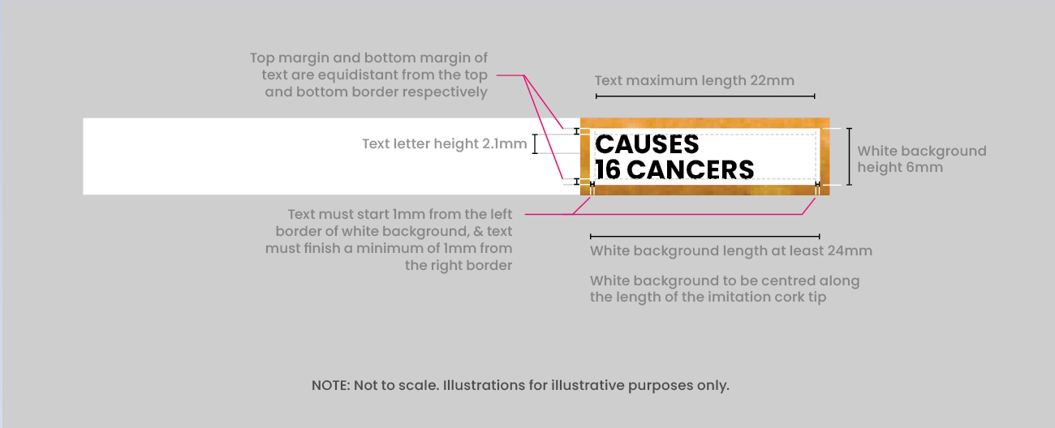

Note 1: If the white rectangular background is the same length as the paper casing covering the filter, there will be no imitation cork filter paper visible to the left and right of that background.

Note 2: The duplicate of the on‑product health message on the opposite side of the filter must be displayed such that, when it is upright and readable, the location and dimensions of the white rectangular background and text of the message are as illustrated in Figure 10.1.