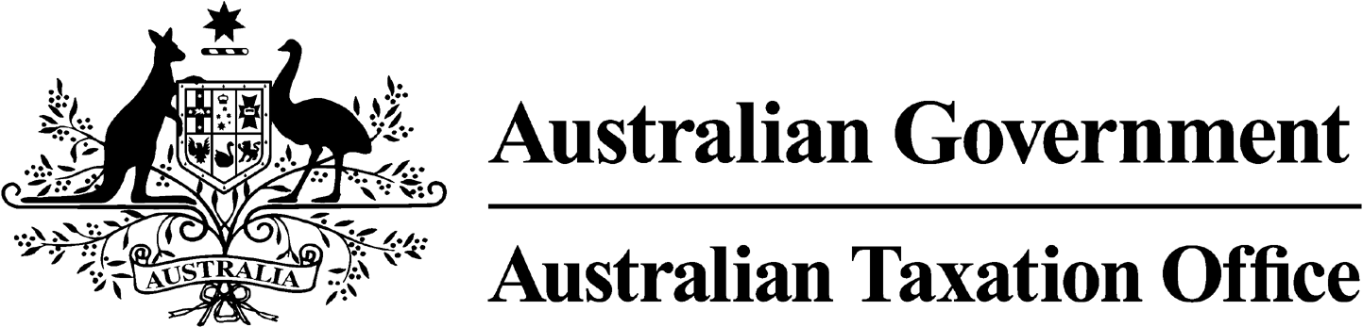

**NOTICE OF CONFIRMATION OF DISQUALIFICATION – PAULA HARRISON - 12 February 2024**

*Superannuation Industry (Supervision) Act 1993*

To:

Paula Harrison

NAMBOUR QLD 4560

I, Andrew Orme, a delegate of the Commissioner of Taxation, give you notice as required by subsection 344(6) of the *Superannuation Industry (Supervision) Act 1993* (SISA), that I have made a decision under subsection 344(4) of the SISA to confirm the disqualification notice issued to you on 23 November 2023.

The disqualification takes effect on the day on which it is made.

Dated: 16 February 2024

**Andrew Orme**

Deputy Commissioner of Taxation

Per Pauline Cotter

Note 1:

Under subsection 126A(7) of the SISA, details of this disqualification notice will be published as a *Notifiable Instrument* in the Federal Register of Legislation.

Note 2:

Under section 126K of the SISA, it is an offence for a disqualified person, who knows that he or she is a disqualified person, to be, or act as a:

* trustee, investment manager or custodian of a superannuation entity
* responsible officer or a body corporate that is a trustee, investment manager or custodian, of a superannuation entity

The maximum penalty for committing this offence is two years jail.

Note 3:

Under subsection 126A(5) of the SISA, we may revoke this disqualification on our own initiative or on your written application.