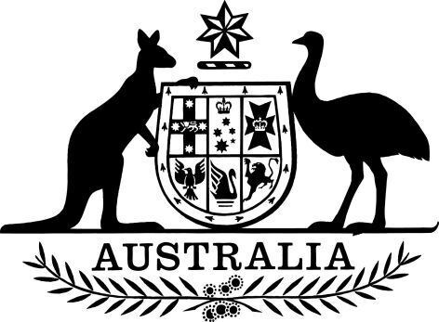

Australian Bureau of Statistics (Australian Statistics Advisory Council Members) Appointment (No. 1) 2024

I, Andrew Leigh, Assistant Minister for Competition, Charities and Treasury, under subsection 19(2) of the *Australian Bureau of Statistics Act 1975*, appoint Paul Donegan, Michael Andrews and Sarah Hunter as members of the Australian Statistics Advisory Council, each on a part-time basis and each for a period of three years beginning on the day after this instrument is registered on the Federal Register of Legislation.

Dated 28 February 2024

Dr Andrew Leigh

Assistant Minister for Competition, Charities and Treasury

Parliamentary Secretary to the Treasurer