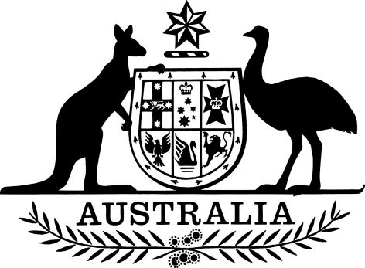

Public Health (Tobacco and Other Products) Commencement Proclamation 2024
I, General the Honourable David Hurley AC DSC (Retd), Governor-General of the Commonwealth of Australia, acting with the advice of the Federal Executive Council and under item 2 of the table in subsection 2(1) of the Public Health (Tobacco and Other Products) Act 2023, fix 1 April 2024 as the day on which sections 3 to 185 of that Act commence.
Signed and Sealed with the
Great Seal of Australia on
14 March 2024
David Hurley
Governor-General
By His Excellency’s Command
Mark Butler
Minister for Health and Aged Care

