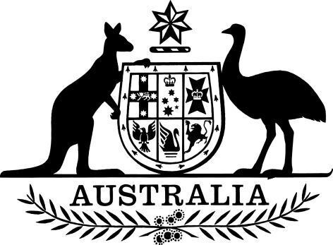

Inspector-General of Taxation Appointment (No. 1) 2024

I, General the Honourable David Hurley AC DSC (Retd), Governor-General of the Commonwealth of Australia, acting with the advice of the Federal Executive Council, and under subsection 28(1) of the *Inspector-General of Taxation Act 2003*, appoint Ruth Owen as the full-time Inspector-General of Taxation, for a period of five years beginning on 15 July 2024.

Dated 12 June 2024

David Hurley

Governor‑General

By His Excellency’s Command

Stephen Jones

Assistant Treasurer and Minister for Financial Services