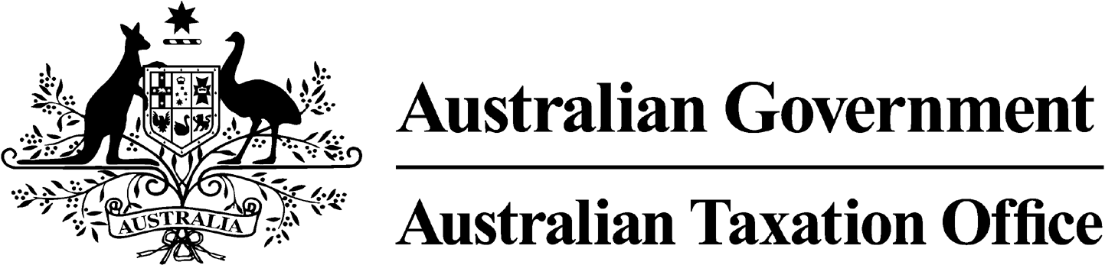
NOTICE OF CONFIRMATION OF DISQUALIFICATION – PETAR PECER - 29 July 2024

Superannuation Industry (Supervision) Act 1993

To:

PETAR PECER

MCKINNON VIC 3204

I, Andrew Orme, a delegate of the Commissioner of Taxation, give you notice as required by subsection 344(6) of the Superannuation Industry (Supervision) Act 1993 (SISA), that I have made a decision under subsection 344(4) of the SISA to confirm the disqualification notice issued to you on 6 November 2023.

The disqualification takes effect on the day on which it is made.

Dated: 29 July 2024

Andrew Orme
Deputy Commissioner of Taxation

Per Manisha Karre

Note 1:
Under subsection 126A(7) of the SISA, details of this disqualification notice will be published as a Notifiable Instrument in the Federal Register of Legislation.
Note 2:
Under section 126K of the SISA, it is an offence for a disqualified person, who knows that he or she is a disqualified person, to be, or act as a:
- trustee, investment manager or custodian of a superannuation entity
- responsible officer or a body corporate that is a trustee, investment manager or custodian, of a superannuation entity
The maximum penalty for committing this offence is two years jail.

