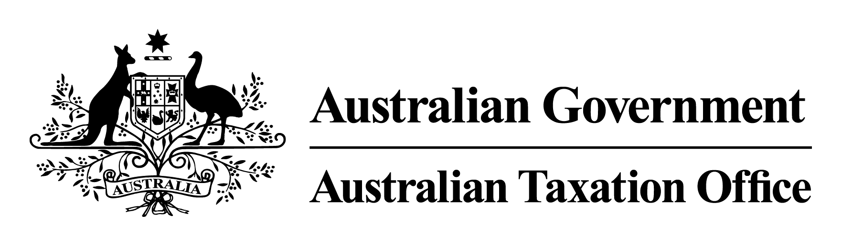

**Notice of Rulings 31 July 2024**

The Commissioner of Taxation, Rob Heferen, gives notice by notifiable instrument under subsection 358-5(4) of Schedule 1 to the *Taxation Administration Act 1953* of the following public rulings, copies of which can be obtained from [ato.gov.au/law](http://ato.gov.au/law)

|  |  |  |
| --- | --- | --- |
| NOTICE OF RULINGS | | |
| Ruling number | Subject | Brief description |
| CR 2024/45 | Prestal Holdings Limited – return of capital and dividends | This Ruling sets out the income tax consequences for shareholders of Prestal Holdings Limited who received the return of capital on 24 May 2024 and dividends on 11 March and 22 July 2024.  This Ruling applies to shareholders specified in the Ruling from 1 July 2023 to 30 June 2025. |
| PR 2024/12 | Utmost Silk Life Plan – Singapore | This Ruling sets out the income tax consequences for entities in connection with a Silk Life Plan issued by Utmost International Isle of Man Limited.  This Ruling applies to entities specified in the Ruling from 1 July 2024. |