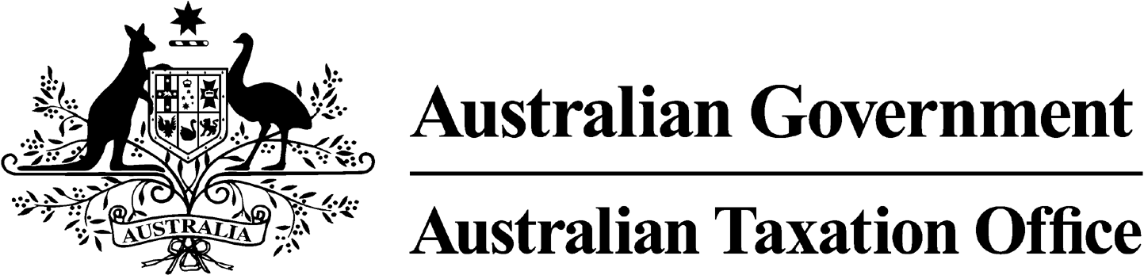
NOTICE OF CONFIRMATION OF DISQUALIFICATION – BELINDA PATTERSON - 31 July 2024

Superannuation Industry (Supervision) Act 1993

To:

BELINDA PATTERSON

RINGWOOD VIC 3134

I, Andrew Orme, a delegate of the Commissioner of Taxation, give you notice as required by subsection 344(6) of the Superannuation Industry (Supervision) Act 1993 (SISA), that I have made a decision under subsection 344(4) of the SISA to confirm the disqualification notice issued to you on 12 October 2023.

The disqualification takes effect on the day on which it is made.

Dated: 31 July 2024

Andrew Orme
Deputy Commissioner of Taxation
Per Manisha Karre

Note 1:
Under subsection 126A(7) of the SISA, details of this disqualification notice will be published as a Notifiable Instrument in the Federal Register of Legislation.
Note 2:
Under section 126K of the SISA, it is an offence for a disqualified person, who knows that he or she is a disqualified person, to be, or act as a:
- trustee, investment manager or custodian of a superannuation entity
- responsible officer or a body corporate that is a trustee, investment manager or custodian, of a superannuation entity
The maximum penalty for committing this offence is two years jail.
Note 3:
Under subsection 126A(5) of the SISA, we may revoke this disqualification on our own initiative or on your written application.

