

Australian Radiation Protection and Nuclear Safety (Form of Identity Card) Notifiable Instrument 2024

I, Gillian Hirth, Chief Executive Officer of the Australian Radiation Protection and Nuclear Safety Agency, make the following notifiable instrument.

Dated 9 August 2024

[Signed]  
  
Gillian Hirth

Chief Executive Officer

Contents

1 Name 1

2 Commencement 1

3 Authority 1

4 Definitions 1

5 Identity cards – approved form 1

1 Name

This instrument is the *Australian Radiation Protection and Nuclear Safety (Form of Identity Card) Notifiable Instrument 2024.*

2 Commencement

This instrument commences on the day after it is registered.

3 Authority

This instrument is made under subsection 62(3A) of the Act.

4 Definitions

In this instrument:

***Act*** means the *Australian Radiation Protection and Nuclear Safety Act 1998.*

5 Identity cards – approved form

(1) This section is made for the purposes of subsection 62(1) of the Act and sets out the approved form of the identity card to be issued to each inspector appointed under subsection 62 of the Act.

(2) The identity card must contain the following elements on the front of the card:

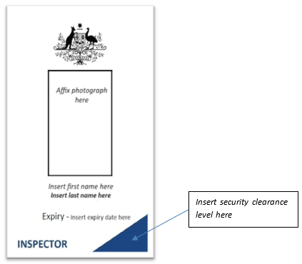

(3) The identity card must contain the following elements on the back of the card:

