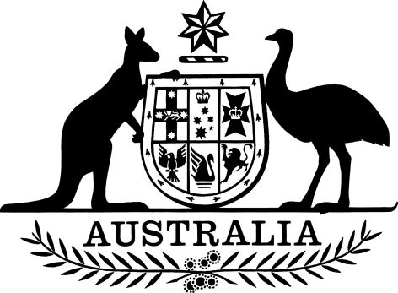

PB 105 of 2024

National Health (October 2024 Flow on price reductions for brands of combination items) (Exercise of Ministerial discretion) Determination 2024
I, Nikolai Tsyganov, as delegate of the Minister for Health and Aged Care, make the following Determination.
Dated 26 September 2024

NIKOLAI TSYGANOV
Assistant Secretary
Pricing and PBS Policy Branch
Technology Assessment and Access Division
Health Resourcing Group
Department of Health and Aged Care

1 Name
(1) This instrument is the National Health (October 2024 Flow on price reductions for brands of combination items) (Exercise of Ministerial discretion) Determination 2024.
(2) This instrument may also be cited as PB 105 of 2024.
2 Commencement
This instrument commences 1 October 2024.
3 Authority
This instrument is made under subsection 99ADHB(6) of the Act.
4 Definition
Note: A number of expressions used in this instrument are defined in Part VII the Act,

In this instrument:

Act means the National Health Act 1953.
5 Brand of pharmaceutical item with approved ex-manufacturer price not reduced
I determine under subsection 99ADHB(6) of the Act that, for the purposes of subsection 99ADHB(2), the approved ex-manufacturer price, and each of the claimed prices (if applicable) of each brand of pharmaceutical item specified in column 2 in the table in Schedule 1 is not reduced on 1 October 2024.

Schedule 1— Brand of pharmaceutical item with approved ex-manufacturer price reduced not reduced

Column 1 | Column 2
Item | Brand of Pharmaceutical Item
 | Drug | Form | Manner of administration | Brand
1 | Tenofovir with emtricitabine and efavirenz | Tablet containing tenofovir disoproxil maleate 300 mg with emtricitabine 200 mg and efavirenz 600 mg | Oral | Tenofovir Disoproxil Emtricitabine Efavirenz Viatris 300/200/600

