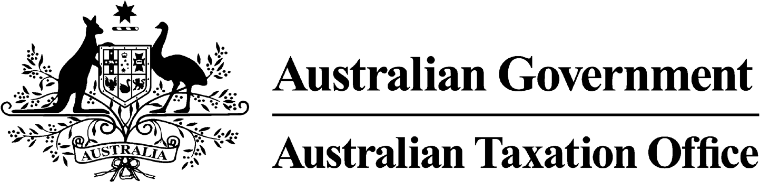

**NOTICE OF REVOCATION OF DISQUALIFICATION – Sean B Drury - 15 October 2024**

*Superannuation Industry (Supervision) Act 1993*

To:

Sean Bruce Drury

Sydney NSW 2000

I, Emma Rosenzweig, a delegate of the Commissioner of Taxation, I have made a decision on 27 September 2024 to revoke the disqualification notice dated 24 January 2024, pursuant to subsection 43(6) of the Administrative Appeals Tribunal Act 1975 (in effect as at date of decision).

The revocation of the disqualification order takes effect on 27 September 2024.

Dated: 15 October 2024

**Emma Rosenzweig**

Deputy Commissioner of Taxation

Per Paul Delahunty

Note 1:

Under subsection 126A(7) of the SISA, details of this disqualification notice will be published as a *Notifiable Instrument* in the Federal Register of Legislation.