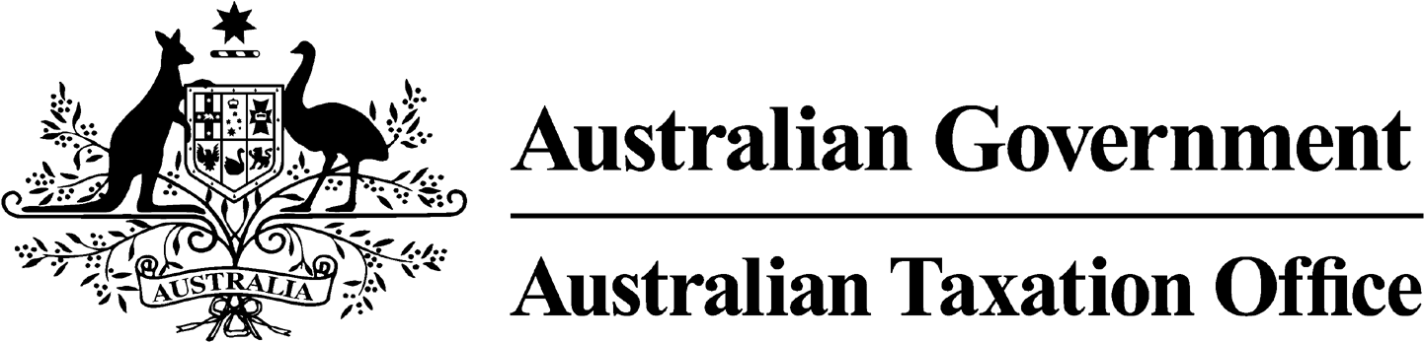

**NOTICE OF REFUSAL TO REVOKE DISQUALIFICATION -** **Mr Darryl L Panes -** 20 November 2024

*Superannuation Industry (Supervision) Act 1993*

To:

Mr Darryl L Panes

South Australia 5018

I, Emma Rosenzweig, a delegate of the Commissioner of Taxation, give you notice as required by subsection 126A(6) of the *Superannuation Industry (Supervision) Act 1993* (SISA), that I have refused to revoke your disqualification under subsection 126A(5) of the SISA.

I have refused to revoke your disqualification as I am satisfied that you are not a fit and proper person to be a trustee or a responsible officer of a body corporate that is a trustee, of a superannuation entity for the purposes of the SISA.

Dated: 20 November 2024

**Emma Rosenzweig**

Deputy Commissioner of Taxation

Per Diptie Achal

Note 1:

Under subsection 126A(7) of the SISA, details of this disqualification notice will be published as a *Notifiable Instrument* in the Federal Register of Legislation.

Note 2:

Under section 126K of the SISA, it is an offence for a disqualified person, who knows that he or she is a disqualified person, to be, or act as a:

* trustee, investment manager or custodian of a superannuation entity
* responsible officer or a body corporate that is a trustee, investment manager or custodian, of a superannuation entity

The maximum penalty for committing this offence is two years jail.