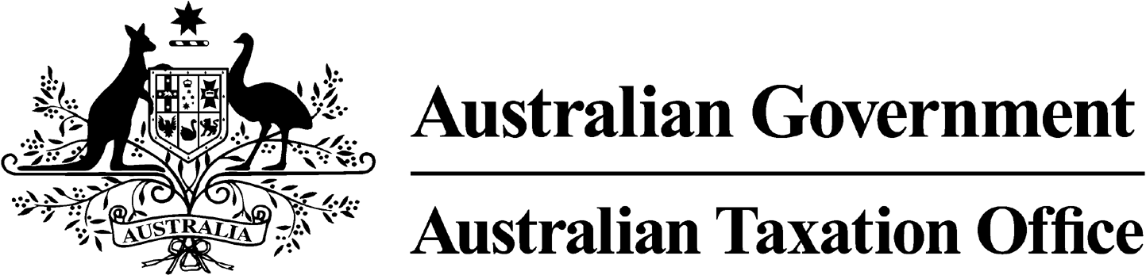

**NOTICE OF REVOCATION OF DISQUALIFICATION – Kay Saunders – 18 March 2025**

*Superannuation Industry (Supervision) Act 1993*

To:

Kay Saunders

Lara VIC 3004

I, Emma Rosenzweig, a delegate of the Commissioner of Taxation, have made a decision on 13 February 2025 to revoke the disqualification notice dated 12 October 2023, pursuant to subsection 108(2) of the *Administrative Review Tribunal Act 2024*.

The revocation of the disqualification order takes effect on 12 October 2023.

Dated: 18 March 2025

**Emma Rosenzweig**

Deputy Commissioner of Taxation

Per Alison Webster

Note 1:

Under subsection 126A(7) of the SISA, details of this revocation of disqualification notice will be published as a *Notifiable Instrument* in the Federal Register of Legislation.